ANTIBIOTICS

**The improbable chain of events that led Alexander Fleming to discover penicillin in 1928 is the stuff of which scientific myths are made. Fleming, a young Scottish research scientist with a profitable side practice treating the syphilis infections of prominent London artists, was pursuing his pet theory — that his own nasal mucus had antibacterial effects — when he left a culture plate smeared with Staphylococcus bacteria on his lab bench while he went on a two-week holiday.**

|  |
| --- |
|  |
|  |
| |  | | --- | |  | | Alexander Fleming in 1952 at London's Wright Fleming Institute | |

**When he returned, he noticed a clear halo surrounding the yellow-green growth of a mold that had accidentally contaminated the plate. Unknown to him, a spore of a rare variant called *Penicillium notatum* had drifted in from a mycology (fungus) lab one floor below. Luck would have it that Fleming had decided not to store his culture in a warm incubator, and that London was then hit by a cold spell, giving the mold a chance to grow. Later, as the temperature rose, the Staphylococcus bacteria grew like a lawn, covering the entire plate — except for the area surrounding the moldy contaminant. Seeing that halo was Fleming's "Eureka" moment, an instant of great personal insight and deductive reasoning. He correctly deduced that the mold must have released a substance that inhibited the growth of the bacteria.**

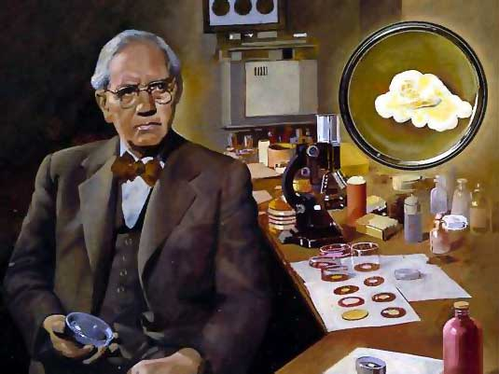

**It was a discovery that would change the course of history. The active ingredient in that mold, which Fleming named penicillin, turned out to be an infection-fighting agent of enormous potency. When it was finally recognized for what it was — the most efficacious life-saving drug in the world — penicillin would alter forever the treatment of bacterial infections. By the middle of the century, Fleming's discovery had spawned a huge pharmaceutical industry, churning out synthetic penicillins that would conquer some of mankind's most ancient scourges, including syphilis, gangrene and tuberculosis.**

### What are antibiotics?

**Antibiotics are medicines that help your body fight bacteria and viruses, either by directly killing the offending bugs or by weakening them so that your own immune system can fight and kill them more easily. The vast majority of antibiotics are bacteria fighters; although there are millions of viruses, we only have antibiotics (antivirals) for half-a-dozen or so of them.**

**A bacterium is a living, reproducing life form. A virus is just a piece of** [**DNA**](http://science.howstuffworks.com/cell4.htm) **(or RNA) encapsulated in a protein coat (capsid). A virus injects its DNA into a living cell and has that cell reproduce more of the viral DNA. With a virus there is nothing to "kill," so antibiotics are not easily developed to work on them. Bacteria, on the other hand, are more complex (while viruses must "live" in a "host" (us), bacteria can live independently) and as a result bacteria are easier to kill.**

[**Bacteria**](http://science.howstuffworks.com/cell1.htm) **are single-celled prokaryotic organisms. Prokaryotic cells are smaller than Eukaryotic cells and they lack a true nucleus and membrane-bound organelles. If bacteria make it past our cutaneous (skin) and mucous membranes and escape the initial response of our immune system, they will start reproducing inside our bodies to cause disease. Certain bacteria produce chemicals/toxins that damage or disable parts of our bodies. In an ear infection, for example, bacteria have invaded the inner ear. The body is working to fight the bacteria, but the immune system's natural processes produce inflammation. Inflammation in your ear is painful. Your immune system has a complex arsenal of germ fighting cells and chemicals it will use to fight this infection. Sometimes our immune systems are slow to respond or weakened for various reasons, to help fight the infection we will start antibiotics.**

**An antibiotic is a selective poison. It has been chosen so that it will kill the desired bacteria, but not the cells of your body (as those are eukaryotic). Each different type of antibiotic affects different bacteria in different ways. For example, an antibiotic might inhibit a bacterium's ability to turn glucose into energy by targeting an enzyme specific to that species of bacteria. A different antibiotic may target metabolic reactions that play an important role in the construction of the prokaryote’s cell wall. When this happens, the bacterium dies instead of reproducing.**

### Kinds of Antibiotics

**There are now so many different antibiotics on the market that it's hard for us to keep track of them all.**

#### A) Penicillins and Cephalosporins

**In the early 20th century, Alexander Fleming discovered that a mold called** ***Penicillium* produces chemicals which kills most of the bacteria nearby. He was able to isolate these chemicals, which are now known as "penicillins". Sometime later, another mold was found which produced a bacteria-killing chemical, and this chemical's molecule was found to be very similar to the penicillin molecule; this chemical and its cousins were called "cephalosporins" after the mold it came from. The vast majority of antibiotics are either penicillins or cephalosporins; chemical changes have been made to the molecules over the years to improve their bacteria-fighting abilities and to help them overcome breakdown and "immunity" of resistant bacteria.**

**Most bacterial cells have double layers on their outside. The outermost layer -- the "cell wall" -- is similar to the outer layer of plant cells, but is missing in human and animal cells. This wall must grow along with the cell, or the growing cell will eventually become too big for the wall and burst and die. Penicillins and cephalosporins kill bacteria by messing up the wall-building system. Since we don't have cell walls, and plants have a different wall-building system, neither we, nor animals, nor plants are affected by the medicine.**

**There are a very few bacteria that don't have cell walls, either. These bugs are immune to penicillins and cephalosporins for the same reasons we are. Most bacteria do have cell walls, but many have changed their wall-building systems so that penicillins can't interfere, or have come up with ways to break down the medicines before the medicines can work. When we first started using penicillin in the 40's and 50's, most bacteria could be killed by plain penicillin. Now, because we have used penicillins and cephalosporins so often (and, in many** **cases, when we really shouldn't have), there are many bacteria that can't be killed any more by plain penicillin or even by the "super-penicillins" and "super-cephalosporins".**

**Penicillins and cephalosporins usually don't cause many problems for a patient. Like all antibiotics, they can cause mild side effects like diarrhea. Less common side effects include rashes (which may or may not imply a true allergy) and hives (which usually means you're allergic to the medicine). The rarest -- and scariest -- side effect is "anaphylactic" allergy, in which your airway swells up when you take a dose of the medicine, sometimes to the point where you can't breathe. Although the reaction can be treated if you are close to help, the safest thing if you are that allergic to the medicine is never to take it at all. (In cases where you have an anaphylactic allergy to penicillin or cephalosporins and *must* have it to** **treat an infection, doctors can "desensitize" you temporarily, using very small doses that are given frequently and in increasing amounts. That is almost always done in a hospital.)**

### B) Macrolides (Erythromycin and its Relatives)

**Erythromycin is another antibacterial produced by a mold. There are a couple of new relatives of erythromycin (azithromycin and clarithromycin) that work the same way, but kill more bugs and have slightly fewer side effects. The erythromycin-like antibiotics are also known as *macrolides.***

**Erythromycin works by blocking the bacterial cell's machinery for making new proteins – Inhibiting Protein Synthesis. Since proteins both make up much of the cell's structure and make the enzymes that direct all the cell's chemical reactions, blocking protein manufacturing makes the cell unable to function. Erythromycin in low doses will stop bacteria from growing and multiplying, but you need a higher concentration to kill the bacteria. However, if you can stop growth until your immune system kicks in, that will help you get rid of the infection.**

**Since all protein making is affected, erythromycin can slow down or kill any bacteria, even those without cell walls. Because of this, we use the erythromycins for several diseases, including bacterial bronchitis, chlamydia, and whooping cough, that penicillins and cephalosporins can't touch.**

**Erythromycin and its cousins don't have anything like the allergy problems we see with the penicillins and cephalosporins, although there are rare people who** **have reactions to it. The biggest problem with these medicines is that they can irritate the stomach. *Always* take erythromycin with food or milk. (The same goes for clarithromycin. Azithromycin doesn't irritate the stomach nearly as much as the others.)**

### C) Sulfas

**The sulfas (more properly "sulfanilamides" or "sulfonamides") were the first antibiotics to be developed; they are actually completely man-made. They interfere with certain "manufacturing" systems in the bacterial cell, including ones that bacteria use to produce new DNA for new bacteria. Sulfas can stop bacteria from growing, but they cannot actually kill the bacteria.**

**When they were first used, sulfas worked against many kinds of bacteria. Unfortunately, as with penicillin, the more we used the sulfas the more bacteria became resistant to it. Sulfas also have a tendency to produce allergic reactions -- different than those we see with the penicillins, for the most part, but including some that are rare but life-threatening. Because of this we don't use sulfas nearly as much we used to, and most often when we use sulfas it's in combination with another drug which attacks a different part of the bacteria (an attack on two fronts is usually better than an attack on one). One frequent use of "plain" sulfas is in antibiotic eyedrops used for conjunctivitis ("pink eye").**

### D) Trimethoprim-Sulfamethoxazole

**Trimethoprim (TMP) is another man-made antibiotic. Like the sulfas, trimethoprim blocks an important step in the bacteria's system for making new DNA -- but it's a different step. By itself, TMP can kill bacteria, but very slowly. Usually, though, we use TMP in combination with sulfamethoxazole (SMX), and the combination of TMP and a sulfa kills bugs better. In fact, bacteria that are partly resistant to either TMP or SMX can still be killed by the combination of the two. The side effects of the combination are the same as those of the two separate components.**

**Methods Of Taking Antibiotics  
  
1. Orally :** **2. Intravenously**

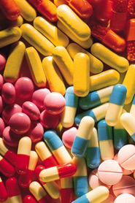 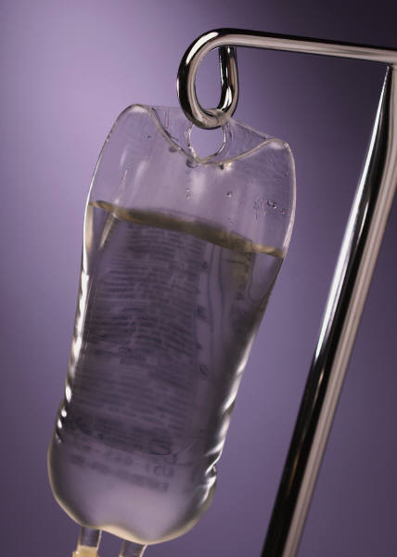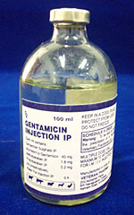

**2. Topically via ointment or drops:**

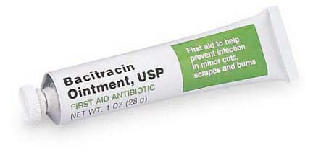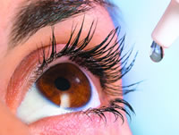

### Antibiotic Resistance

**Bacteria (and viruses) aren't particularly intelligent. However, it is possible -- and unfortunately all too common -- for bacteria and some viruses to "learn" how to survive even with antibiotics around.**

**There are several ways that bacteria can become resistant. All of them involve changes in the bacteria's genes.**

* Bacterial genes *mutate* (change), just like the genes of larger organisms (including humans) mutate. Some of these changes happen because of chemical or radiation exposure; some just happen randomly, and no one's sure quite why. If bacteria with a changed gene is less susceptible to an antibiotic, and that antibiotic is around, the less susceptible (and more resistant) version of the bacteria is more likely to survive the antibiotic and continue to multiply. This is particularly likely to happen if the amount of antibiotic around isn't quite enough to kill all of the bacteria quickly -- as can happen if you don't take enough of the antibiotic to keep its level in your body high, or if you stop taking the antibiotic too early. This is why ***when you are prescribed an antibiotic you MUST take it exactly as prescribed, and for as long as it was prescribed***: you may feel better after only a short time, but you may still have some bacteria left in you -- not enough to make you feel bad, but enough to come back -- and those bacteria left include the ones that are partly resistant to the antibiotic already and likely to become more resistant. It's also why we don't (or shouldn't) give you an antibiotic for an illness like a cold that isn't likely to be bacterial: the antibiotic will kill off the susceptible bacteria, leaving bacteria that are resistant to that antibiotic.
* Although there are many different species of bacteria, some bacteria can "trade" genes with other bacteria. If you have a relatively harmless bacteria in you -- say, in your mouth or your intestines (both places are chock full of bacteria) -- and you've used (or overused or misused) antibiotics some of those harmless bacteria will become resistant to the antibiotics you've (over-, mis-)used. They can then give the resistance genes they have developed to other, harmful bacteria.
* There are viruses around that attack bacteria rather than plants, animals, or people. Most of these viruses just kill the bacteria, but sometimes the viruses can copy genes -- like the antibiotic resistance genes -- from one kind of bacteria to another.