**Practice Quiz – Joints KEY**

1. **A “Fibrous” joint is the more common name for which category of Joint/Articulation?**

[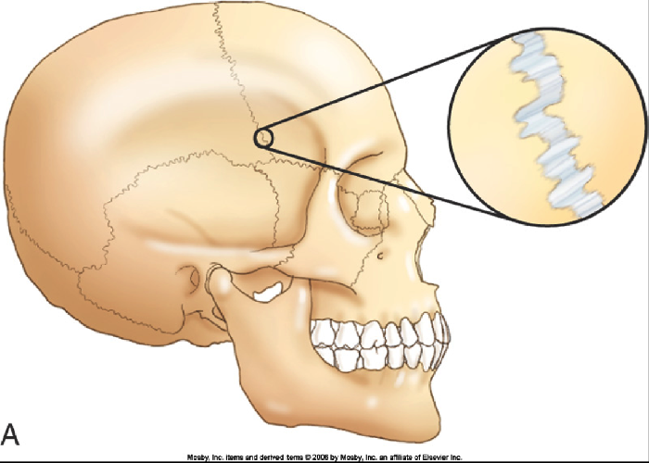](https://www.google.ca/url?sa=i&rct=j&q=&esrc=s&source=images&cd=&cad=rja&uact=8&ved=0ahUKEwju5tD_9K3QAhVD2GMKHTU3AZwQjRwIBw&url=https%3A%2F%2Fwww.thinglink.com%2Fscene%2F766989159029014530&psig=AFQjCNHeBdgC7dYi7VAfi2HNRR78MkVhdw&ust=1479407615982790)

1. **Synarthrotic C) Amphiarthrotic**
2. **Diarthrotic D) Synovial**
3. **What type of connective structure is used to lash/fasten a bone to another bone?**
4. **Tendon**
5. **Ligament**
6. **Cartilage**
7. **Endosteum**
8. **Which of the following is NOT a type of Diarthrotic Joint.**
9. **Hinge**
10. **Ball and socket**
11. **Suture**
12. **Elipsoid/Condyloid**
13. **Saddle**
14. **Which is NOT part of a typical DIARTHROTIC joint?**
15. **Synovial Membrane**
16. **Articular Cartilage**
17. **Ligaments**
18. **Joint Cavity**
19. **All of the above are typically found in a Diarthrotic Joint**
20. **The picture below best represents what specific type of Synovial Joint?**

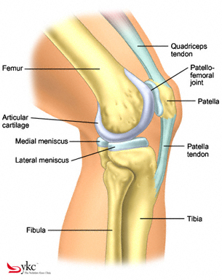

1. **Ball and socket**
2. **Hinge**
3. **Elipsoid (Condyloid)**
4. **Saddle**
5. **What specific type of synovial joint is located between the thumb’s metacarpal and the carpal it sits on (the Trapezium)?**
6. **Elipsoid C) Saddle**
7. **Hinge D) Ball and Socket**
8. **Gliding**
9. **The articulation shown below is best classified as:**

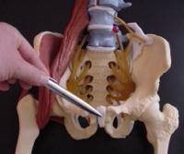

1. **Diarthrotic**
2. **Synarthrotic**
3. **Synovial**
4. **Amphiarthrotic**
5. **The specific joint movement being illustrated below (Starting with position A and ending in Position B) is properly termed….**

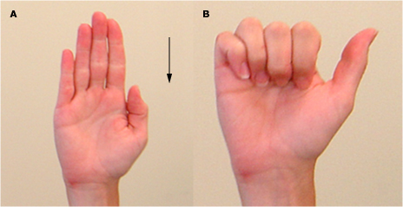

1. **Abduction**
2. **Adduction**
3. **Flexion**
4. **Extension**
5. **Circumduction**
6. **In the picture below, the big arrow represents what type of Synovial Joint?**

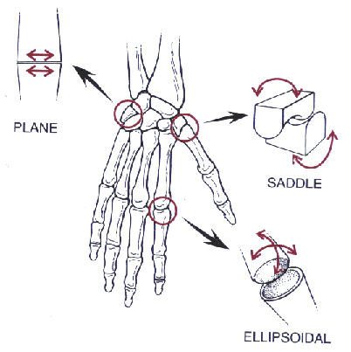

1. **Ellipsoid (Condyloid)**
2. **Hinge**
3. **Ball and socket**
4. **Pivot**
5. **When a sac-like structure that is filled with synovial fluid becomes inflamed. This specific medical condition would be diagnosed.**
6. **Arthritis C) Spondilitis**
7. **Bursitis D) Cartilagitis**
8. **The shoulder joint is best described as a ...**
9. **Hinge C) Pivot**
10. **Gliding D) Elipsoid**
11. **Ball and Socket**
12. **The way the Atlas articulates with the Axis is best described as...**
13. **Gliding joint**
14. **Pivot**
15. **Ellipsoid**
16. **Ball and Socket**
17. **Saddle**
18. **The type of movements seen at a Knee Joint would include:**
19. **Flexion and Extension**
20. **Abduction and Adduction**
21. **Rotation and Circumduction**
22. **Both A and B would occur at a typical knee joint.**
23. **Doing jumping jack exercises would mostly incorporate**
24. **Flexion and Extension**
25. **Abduction and Adduction**
26. **Rotation and Circumduction**
27. **Saddling and Unsaddling**