BASIC CHEM QUIZ
- Chemistry is the study of matter, what is matter?

- List three (3) basic states/phases of matter.

- Which of the following is a COMPOUND?
- WATER C) HYDROGEN
- OXYGEN D) NITROGEN
E) None of the above are a COMPOUND

- Without looking, what is the chemical symbol for SODIUM?

- Which of the following is a subatomic particle of an atom and has a positive charge?
- Cation C) Anion
- Electron D) Neutron
E) Proton

- What determines an atom’s atomic number . Example C^{#6}
- How many electrons it has
- How many protons it has
- How many neutrons it has
- How many protons and neutrons combined
- How many anions it has

- If a Carbon (#6) atom is electrically neutral, how many electrons must it have?

- Which of the following is ORGANIC?
- H₂O -Water C) CO₂ - Carbon Dioxide
- NH₃ - Ammonia D) C₆H₁₂O₆ - Glucose
E) None of the above are organic

- What does the “Octet Rule” state?

- What does a buffer do?

- Which of the following best describes an IONIC compound?
- When a metal joins with another metal
- When a non-metal joins with another non-metal
- When a metal joins with a non-metal.
- Both A and B are correct

ANSWERS:
- Matter is anything that has mass and occupies space (volume)

- Three basic states of matter are : Solid, Liquid and Gas.
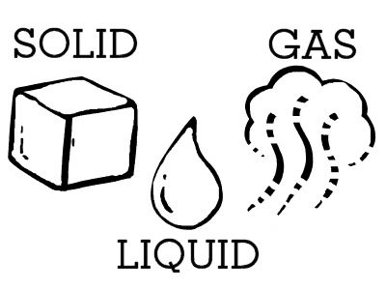
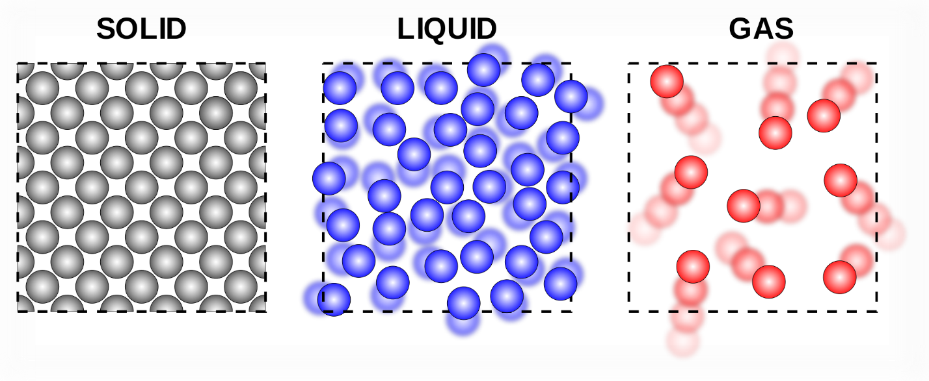

- Both elements and compounds are pure substances, but elements consist of only one type of atom. Compounds consist of at least two or more different types of atoms. Example : Elements Carbon (C), Gold (Au), Nitrogen (N₂), Oxygen (O₂) Compounds Water (H₂O), Carbon Dioxide (CO₂).
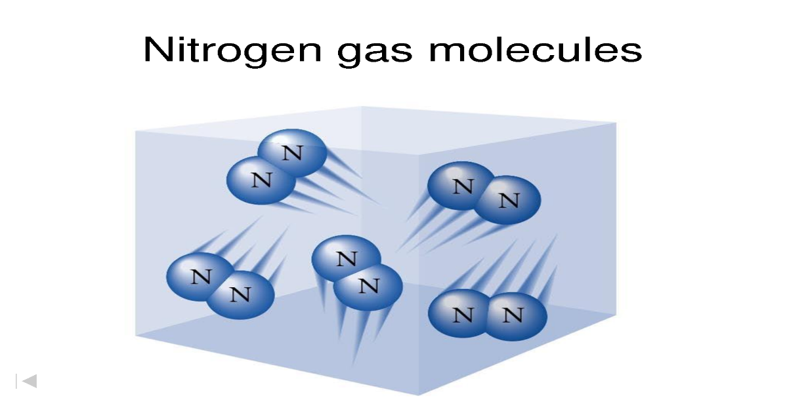
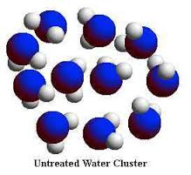
- WATER = H₂O
- The symbol for Sodium is “Na” from the Latin word for sodium which is NATRIUM.

- The three basic subatomic particles of an atom are : Electron (-), Proton (+) and a Neutron (neutral – no charge)
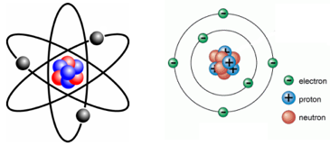
- PROTON

- An atomic number of an atom is determined by the number of PROTONS that atom contains.
C)The amount of PROTONS it has

- If Carbon is electrically neutral, the number of electrons must equal the number of protons. Therefore, Carbon must have 6 electrons when it is neutral.

- To be organic, a molecule must possess Carbon and Hydrogen – The answer is D) – Glucose C₆H₁₂O₆

- The “Octet Rule” states that atoms are most stable when they possess 8 electrons in their outermost shell. Therefore some atoms will want to get rid of a couple to go back down to their stable shell, while others may want to accept a couple more to bring their electron number in their outer valence up to 8.

- A buffer is a substance that helps prevent a change in the pH of a solution, neutralizes a pH change.

- C – When a metal joins to a non-metal, an ionic compound has formed.

The difference between an ionic bond and a covalent bond is that when a metal bonds with a non-metal, the metal will donate electrons to the non-metal. When this happens the metal loses its electrons and becomes positively charged as it meets the octet rule, meanwhile the non-metal gains electrons to become negatively charged while satisfying the Octet rule. As a result the positive metal and negative non-metal are drawn together to form an ionic bond.

When a non-metal and another non-metal bond, each wants to gain electrons, neither wants to donate. To meet the octet rule, they end up sharing their outer valence electrons. For example. Nitrogen has 5 outer electrons, When one Nitrogen bonds with another one of the nitrogens will get a turn having three electrons from the other Nitrogen; reaching the octet rule. Then that Nitrogen will lend those 3 electrons back to the other nitrogen along with 3 electrons of its own.
