Blood Vessel Assignment
PART A – Multiple Choice
- Which type of Vessel is defined as always carrying blood AWAY from the heart?
A) Capillaries
B) Arteries
C) Veins
- What is the name for the very small tiny vessels that are a subcategory of Arteries?
- Capillaries
- Venules
- Lymphedemas
- Arterioles
- Atherosclerosis
3. Which blood vessels have a thin enough wall to allow blood and the tissue fluid of your tissues to exchange materials?
A) Capillaries
B) Venules
C) Arterioles
D) Arteries
E) Veins
4. In which blood vessels would you find VALVES?
A) Arteries
B) Capillaries
C) Veins
D) Valves are only found in the heart
5. Which of the following would correctly describe the passage that blood would travel from the time it leaves the heart goes out to the body and then returns to the heart?
A) Heart Arteriole Artery Venule Vein Capillary Heart
B) Heart Artery Venule Capillary Arteriole Vein Heart
C) Heart Vein Venule Capillary Arteriole Artery Heart
D) Heart Artery Arteriole Capillary Venule Vein Heart
6. Which of the following vessels will have the lowest blood pressure against its wall?
A) Jugular Vein
B) Mesenteric Artery
C) Pulmonary Capillary
D) Aorta

7. Which blood vessel will have blood moving at its slowest speed/velocity?
A) Jugular Vein
B) Mesenteric Artery
C) Pulmonary Capillary
D) Aorta

PART B - DIAGRAMS – Use the word banks to label the key vessels that we need to know
DIAGRAM #1 : Major ARTERIES– Use the word bank below to identify the specific #'d vessels below the Diagram 1.
WORD BANK:
AORTIC ARCH
SUBCLAVIAN ARTERY
CAROTID ARTERY
HEART
BRACHIAL ARTERY
THORACIC AORTA
COMMON ILIAC ARTERY
FEMORAL ARTERY
RENAL ARTERY
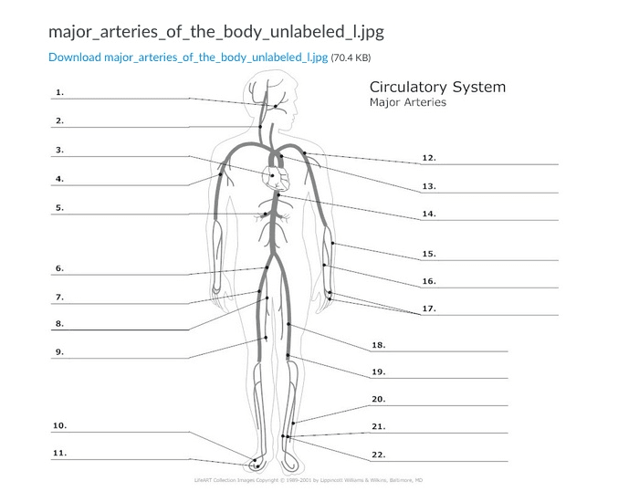
IDENTIFY THE FOLLOWING: (Omit 1,7,8,9,10,11 15,16,17,19,20,21,22)
2.
3.
4.
5.
6.
12.
13.
14.
18.
DIAGRAM #2 : Major VEINS – Use the word bank below to identify the specific #'d vessels below the Diagram 2.
WORD BANK
SUBCLAVIAN VEIN
GREAT SAPHENOUS VEIN
COMMON ILIAC VEIN
BRACHIAL VEIN
JUGULAR VEIN
INFERIOR VENA CAVA
SUPERIOR VENA CAVA
RENAL VEIN
FEMORAL VEIN
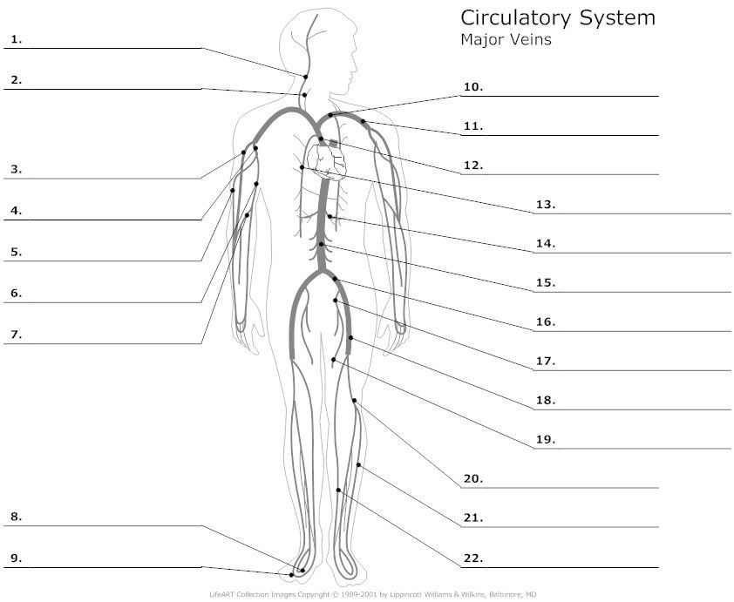
IDENTIFY THE FOLLOWING: (Omit 2,4,5,6,7,8,9,11,13,17,18,19,21)
1.
3.
10.
12.
14.
15.
16.
20.
22.

DIAGRAM #3 : Major Vessels Around the HEART – Use the word bank below to identify the specific #'d vessels below the Diagram 3.
WORD BANK:
INFERIOR VENA CAVA
LEFT PULMONARY ARTERY
SUPERIOR VENA CAVA
RIGHT PULMONARY VEINS
LEFT PULMONARY VEINS
AORTA (AORTIC ARCH)
RIGHT PULMONARY ARTERY
LEFT SUBCLAVIAN ARTERY
BRACHIOCEPHALIC ARTERY
PULMONARY TRUNK
LEFT CAROTID ARTERY
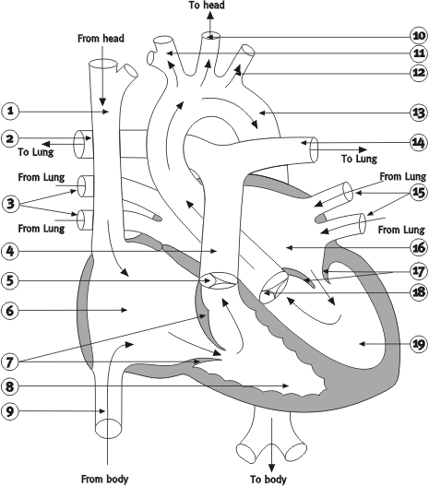
IDENTIFY THE FOLLOWING: (Omit 5,6,7,8, 16, 17,18,19,21)
1.
2.
3.
4.
9.
10.
11.
12.
13.
14.
15.
PART D -MATCHING - For each description at the bottom (#1 9), match the blood vessel (letters A I) that matches that function.
- MESENTERIC ARTERY
- HEPATIC VEIN
- JUGULAR VEIN
- HEPATIC PORTAL VEIN
- RENAL ARTERIES
- BRACHIAL ARTERY
- CAROTID ARTERY
- CORONARY ARTERIES
- ILIAC VEIN
Take the correct letter from above and place it beside each description:
- Blood Vessel that carries blood from the heart to the KIDNEYS :
- Blood Vessel that carries blood from the heart to the SMALL INTESTINE:
- Blood Vessel that carries blood from the SMALL INTESTINE over to the LIVER:
- Blood Vessel that carries blood from the LIVER back into the SUPERIOR VENA CAVA:
- Blood Vessel that carries blood from bottom of the neck up to the HEAD:
- Blood Vessel that carries blood from the thigh back up to ABDOMEN:
- Blood Vessel that carries blood from the Aorta down to the HEART MUSCLE:
- Blood Vessel that carries blood from the shoulder down to the ARM
- Blood Vessel that carries blood from the head down through the NECK

