Place the letter of the body regions (front side) onto the appropriate location on the diagrams below:

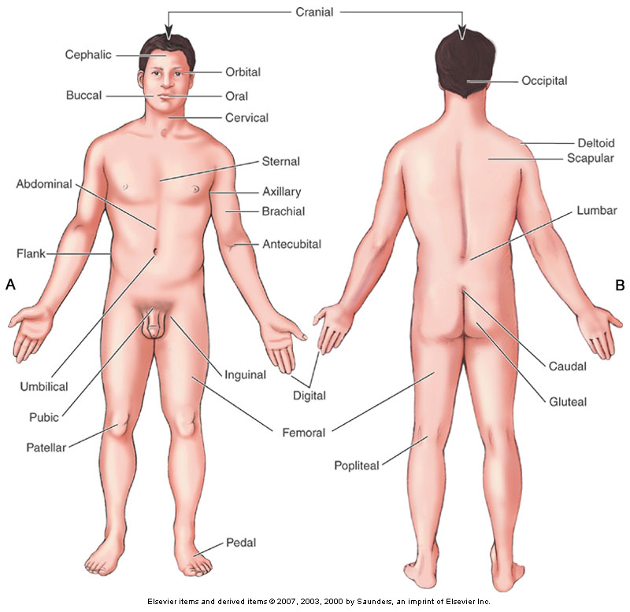

N

K
O
M
L
J
I
H
G
F
E
D
C
B
A
ANSWER KEY

