Bone Anatomy Practice
- Label the following diagram:
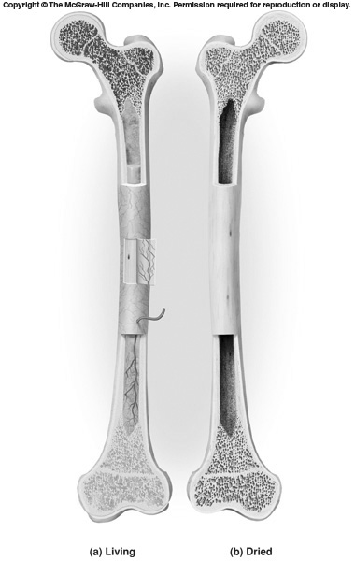
L
K
G
J
I
H
F
E
D
C
B
A
- _______________________ (Specify as proximal or distal)
- _______________________
- _______________________ (Specify as being proximal or distal
- _______________________ (Assume that growth is still occurring)
- _______________________ (type of bone tissue found inside bone)
- _______________________ (Name given to connective tissue covering heads of
bone at joints)
- ______________________ (Fibrous membrane lining bone cavity)
- ______________________ (name given to inner bone cavity)
- ______________________ (Type of bone tissue that form solid outer casing of bone)
- ______________________ (Type of inactive connective tissue filling bone cavity)
- ______________________ (Fibrous membrane covering around outside of the bone)
- ______________________ (Needle-like threads of spongy bone)
Compact Bone Anatomy: - Label the following:
- 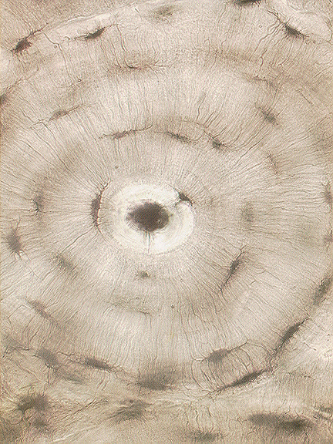
F
E
D
C
B
A

- A) ___________________ (Entire Structural Unit)

- B) __________________

- C) ___________________ (Chamber that Holds Bone Cell)

- D) __________________ (Proper name for bone cell)

- E) ___________________ (Small channels that carry blood to bone
cells
- F) __________________ (Concentric layers of calcified matrix)

