Bone Anatomy Practice KEY
- Label the following diagram:
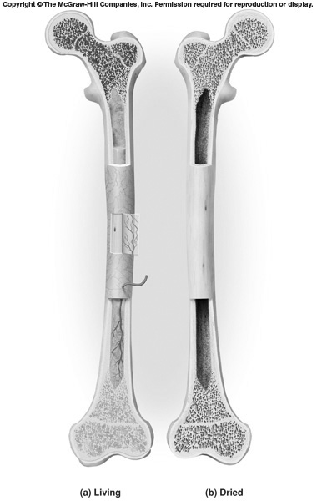
L
K
G
J
I
H
F
E
D
C
B
A
- PROXIMAL EPIPHYSIS (Specify as proximal or distal)
- DIAPHYSIS
- DISTAL EPIPHYSIS (Specify as being proximal or distal
- EPIPHYSEAL PLATE (Assume that growth is still occurring)
- SPONGY (Cancellous) BONE (type of bone tissue found inside bone)
- ARTICULAR CARTILAGE (Name given to connective tissue covering heads of
bone at joints) ** See picture below
- ENDOSTEUM (Fibrous membrane lining bone cavity)
- MEDULLARY CAVITY (name given to inner bone cavity)
- COMPACT (Dense) BONE (Type of bone tissue that form solid outer casing of bone)
- YELLOW BONE MARROW (Type of inactive connective tissue filling bone cavity)
- PERIOSTEUM (Fibrous membrane covering around outside of the bone)
- TRABECULAE (Needle-like threads of spongy bone)
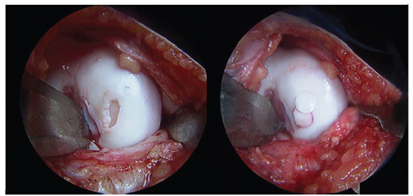

Compact Bone Anatomy: - Label the following:
- 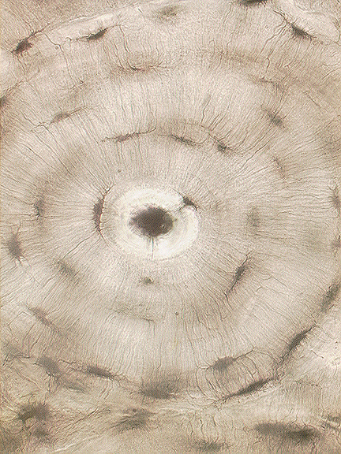
F
E
D
C
B
A

- A) OSTEON (Entire Structural Unit)

- B) HAVERSIAN (Central) CANAL

- C) LACUNA (Chamber that Holds Bone Cell)

- D) OSTEOCYTE (mature cell) (Proper name for bone cell)

- E) CANALICULI (Small channels that carry blood to bone cells)

- F) LAMELLA - Lamellae –plural (Concentric layers of calcified matrix)

