Name: ______________________
Date: ______________
Bone And Joint Injuries – Treatment

1 – Fractures: A fracture is any break or crack in a bone.

- There are two main categories of fractures:

A) Open (Compound) Fracture : A break in the bone that causes a break in the skin and the bone ends may protrude.

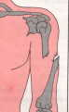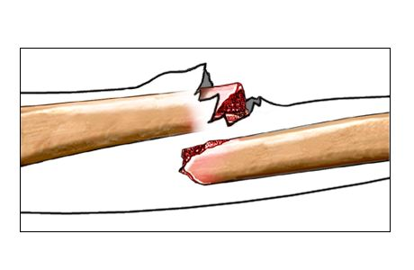
Compound
Fracture of
The Humerus

B) Closed (Simple) Fracture: A break in the bone that does not cause a break in the skin.
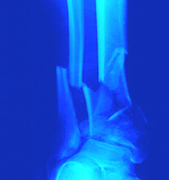
A Simple fracture of the tibia and fibula of the left leg.

2. Joint Injuries: Usually involve ligament damage or dislocation.

A) Sprain: A complete or partial tearing or stretching of the ligaments around a joint. Ligaments are the supporting connective tissues that connect bones to one another at a joint.
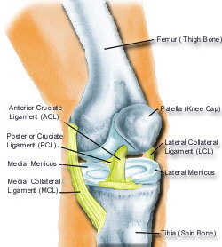
One common sprain is the knee, often the MCL or ACL can be stretched or torn
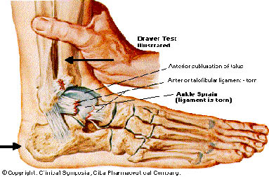
Other common sprains would include wrist and ankle sprains. These sprains often result in long-term damage due to the excessive use and force placed on these joints.

B) Dislocations: A displacement of one or more bone ends at a joint so that their surfaces are no longer in proper contact.

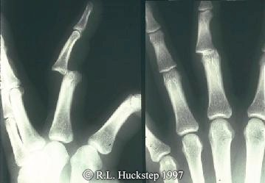
Like most other injuries, dislocations can range in the degree of severity.

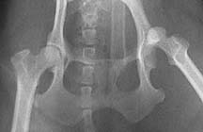
Hip Dislocation

3. Symptoms of Bone and Joint Injuries:
- Swelling and discolouration.
- Deformity and irregularity.
- Inability to use limb.
- Intense pain.
- Tensing up of muscles to guard against further damage.
- Severe injuries may result in shock due to (internal/external) bleeding.

4. Treatment
- For injuries with severe bleeding, controlling the bleeding takes first priority.
- For all other injuries, the treatment involves 4 main steps:

R. I. C. E.

R -Rest, prevent casualty from moving.

I - Immobilize/Ice fracture with splint, always immobilize in the position found.
- Splint should run long enough to extend beyond the joints inferior and superior to the fracture
- Cold pack to reduce swelling and to control pain.
C - Compression (bandage)
- Gentle compression on sprain to support joint and reduce inflammation.

E - Elevate injured part if possible.

- Seek help from professionals.
Fracture to forearm bone(s) must be supported past elbow and wrist

5. Healing Of Fractured Bones
- For complete healing, bones must be set properly and kept immobilized for an adequate period of time.
- A process similar to normal bone growth (endochondral ossification) takes place during the healing of a broken bone.
