Carbohydrate Review - KEY
1. State at least 3 important functions of good nutrition:
A) Energy to produce ATP
B) Growth and cell division
C) Tissue Repair
** Immunity/Health

2. Name six major nutrients: (Green = Macronutrients, Blue = Micronutrients)
A) Protein
B) Carbohydrates
C) Fats
D) Vitamins
E) Minerals
F) Water (Macro but does not yield calories)
3. Which of the above are known as our macronutrients?
Carbohydrates, Fats, and Proteins – Water as well
4. If you ate one gram of pure carbohydrate
how many kcal of energy will be released? 4.1 kcal = 4.1 Calories
Protein = 4.1 Calories, While Fats = 9.3 Calories

5. Name the two categories of metabolic reactions that take place in our cells.
A) Catabolic (break down) B) Anabolic (build up)

6. When we take glucose molecules and react them with oxygen molecules, to form carbon dioxide, water and a release of energy; what type of metabolic reaction would that be?
CATABOLIC
7. A calorie is a very small measure of energy, so nutritionist and food companies prefer to use Calories of kcals. How many calories are in a Calorie?
1000 calories = 1 Calorie = 1 kcal

8. Why do males tend to have higher metabolic rates than females?
In general, males have more muscle mass, and muscle cells burn lots of calories. Every one pound of muscle will burn 50 Calories per day on its own.

9. When we consume carbohydrates whether they are simple or complex, we digest them into various monosaccharides, but eventually our cells convert all of these monosaccharides into one type of monosaccharide; name it. GLUCOSE

10. When blood glucose levels get too high, a process called “glycogenesis” takes place. What is glycogenesis and what hormone triggers this process.
As blood glucose goes up, insulin is put out by the pancreas. This insulin stimulates cells to take up the glucose and bind them together to form Glycogen.
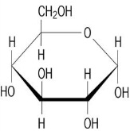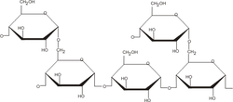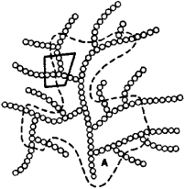
11. What two bodily organs/tissues are primarily responsible for storing glycogen?
A) Liver Cells B) Muscle Cells

12. Carbohydrate consumption should make up ___% of your daily calories.
55 – 65%
Dieticians suggest that only about 10% of those should be of the High GI (simple sugar) variety.

13. What is a carbohydrate’s “Glycemic Index”?
A number that gives the rate at which a carbohydrate is digested, absorbed and transformed into free glucose in the blood.
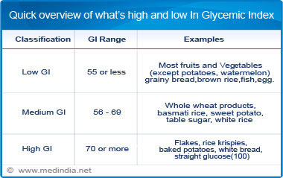
14. Name two foods for each:
a) High glycemic indexes: White Bread - Potato
b) Moderate glycemic indexes:
Brown Rice – Orange Juice
C)Low glycemic indexes:
Apple – Multigrain Bread
15. Which type of glycemic foods would be most beneficial for consumption during each situation?
- Post-Exercise: Moderate to High GI
- Pre–Exercise (a few hours in advance) : Low to Moderate

16. Explain how diets rich in high glycemic carbohydrates could lead to each:
A) Obesity : As glucose concentrations go up, glucose gets converted to glycogen. To make room for more glycogen, existing glycogen is turned into fat.
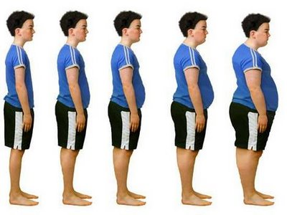
B) Type II Diabetes : As glucose concentrations go up, the body responds by pumping out big surges of Insulin. Over years, the receptors on cells become desensitized to the Insulin.
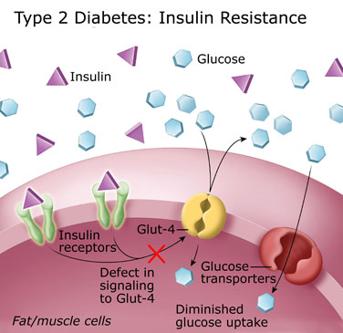

- Colon Cancer : Complex carbohydrates (like cellulose/fiber) found in low glycemic/unrefined carbs act to help keep the intestinal cells healthy. Fiber also helps remove dietary cholesterol from absorption into the blood. Also some cancers like colorectal and most types of breast cancer consist of cells that have high concentrations of insulin receptors. So these cells are very responsive to insulin and pump in Glucose and fuel their growth and division at a faster rate.
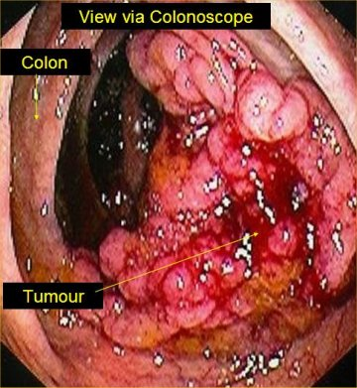

17. Describe what “Carbo-loading” is.
In an effort to store as much Glycogen as possible in the body prior to an endurance event, an athlete will deplete their glycogen reserves by exercising all out while limiting carbohydrate intake, then a couple of days prior to the event they will load up on carbohydrates while resting.

