Chapter 15 - Classification Systems- KEY

15-1
1. Scientists have identified more than 2.5 million kinds of organisms. It is estimated that there may be another 20 million or so unidentified species on Earth.

15-2
2. The names have been based by using Latin or ancient Greek words.

3. Binomial Nomenclature is the naming system, which uses a two-name system for giving a scientific name to an organism. This naming system was developed by Carolus Linnaeus a Swedish botanist.

4. a) Common Name: Red Maple
b) Scientific Name: Acer rubrum
c) Genus name: Acer
d) Species name: rubrum

5. a) rubrum is Latin for RED, and it is has a RED leaf.
b) palmatum is Latin for hand/palm, and this tree has a leaf that looks like a human hand.

6. When writing the scientific name for an organism, one must remember that the first letter in the genus name must be capitalized, while the first letter in the species name must be lower-case. Ex. Acer rubrum
AND IT SHOULD BE ITALISIZED !

7. For Humans, the best is D) – Homo sapien
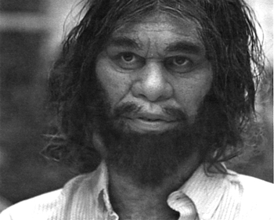
8. A spotted skunk is correctly termed a Spilogale putorius. This name translates as follows:
a) Spilogale: Spotted Weasel
b) putorius : Smelly
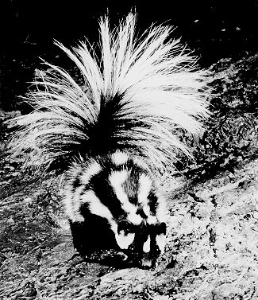
9. "Putrid" means decomposed rotten and foul smelling.

10. Taxonomy is the science of naming organisms and assigning them to groups. – Classifying LIFE

11. A taxon is a group/category into which organisms can be classified. The smallest (most specific) taxon is the species.

12. The seven main taxa are as follows:
MOST
GENERAL 1) Kingdom
2) Phylum
3) Class
4) Order
5) Family
MOST 6) Genus
SPECIFIC 7) Species

13. Mnemonic for the 7 Taxa of classification:

King Phillip Came Over For Green Stockings
Kings Play Calgary On Friday, Gretzky Scores

14. In figure 15-5
a) KINGDOM Animalia : Fox, Black Bear, Starfish, Squirrel, Polar Bear, Rattle Snake an Alaskan Brown Bear

b) In PHYLUM Chordata, the starfish has been deleted because it does not contain a backbone with spinal cord.

c) In CLASS Mammalia, the rattlesnake has been deleted because it is cold-blooded, lays eggs, and lacks hair or fur.

d) A carnivore is an animal that only eats meat. In the ORDER Carnivora, the squirrel has been deleted as it is not a carnivore.

e) The black bear, the polar bear and the Alaskan brown bear all belong to the FAMILY Ursidae (bear).

f) The Latin name for each constellation is, Ursa Major and Ursa Minor. Those constellations look a bit like bears, one larger than the other.

g) The scientific name for the Alaskan brown bear is "Ursus arctos". * Other scientific names:
Polar bear = Ursus maritimus
Black bear = Ursus americanus
Grizzly bear = Ursus horribilus

15. All wild and domestic cats belong to the family: Felidae. More commonly people use the word "feline"

15-3
16. Taxonomists consider three things when grouping organisms according to their evolutionary relationships:
a) Their homologous structures/morphology
b) Their embryonic stage similarities
c) The fossil record.
- Now the focus has shifted to DNA analysis.

17. According to the similarities in Cytochrome c molecules the closest evolutionary relationship is that between a Rattlesnake and a Tuna.
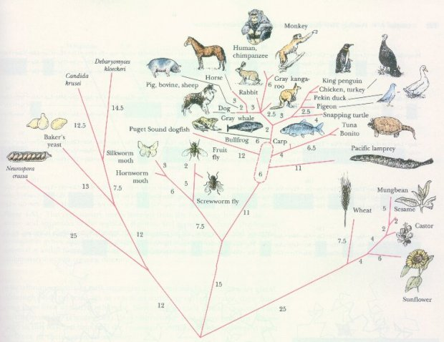

15-4
18. Most modern taxonomic systems use SIX Kingdoms.

19. The six kingdoms:
A) – Archaebacteria
B) – Eubacteria
C) – Protista
D) – Fungi
E) – Plantae
F) – Animalia

20. Prokaryotic cells are only found in Arachaebacteria and Eubacteria.
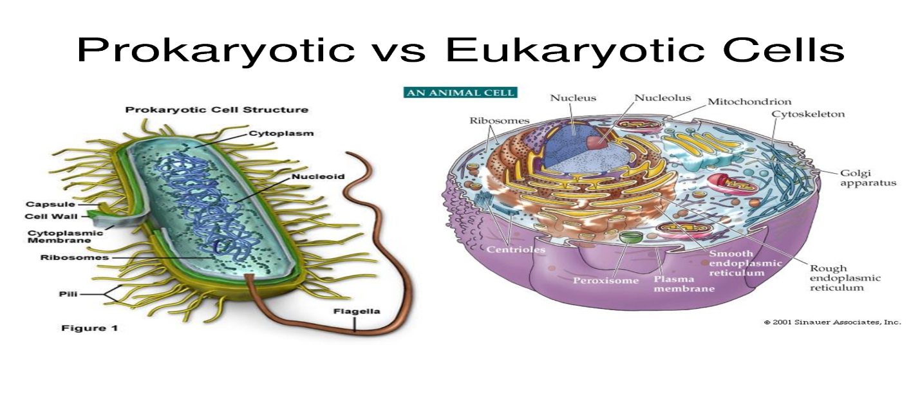21. Kingdom Protista
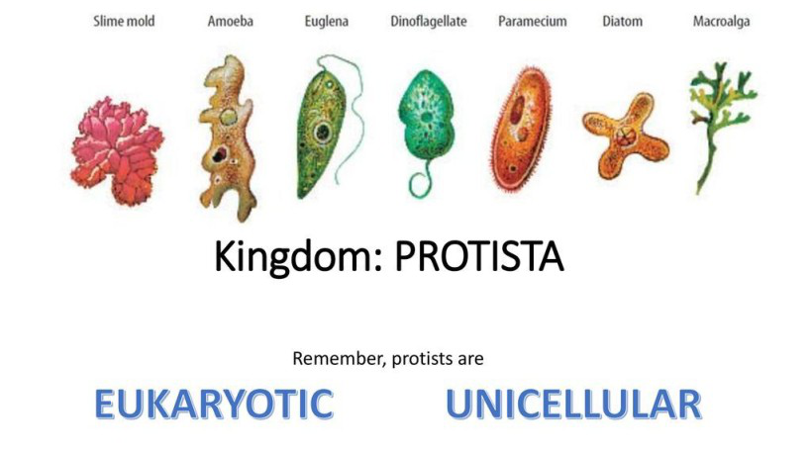

22. Mushrooms and yeast etc are organism with those characteristics and they belong to Kingdom Fungi
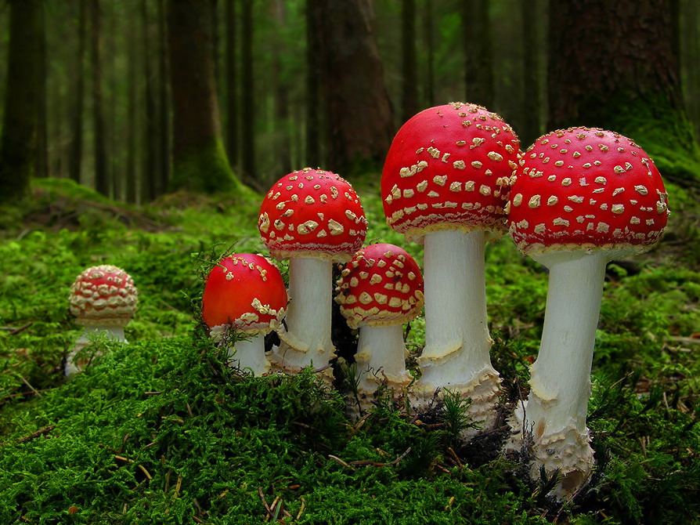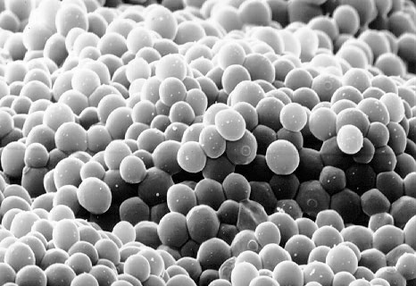

23. Kingdom PLANTAE

24. Kingdom ANIMALIA
