Chapter 25 Review #1 Q’s
LO – D-0 – DNA Intro
- DNA is normally found wrapped around small spherical proteins called Histones. This ropey structure is known as CHROMATIN.
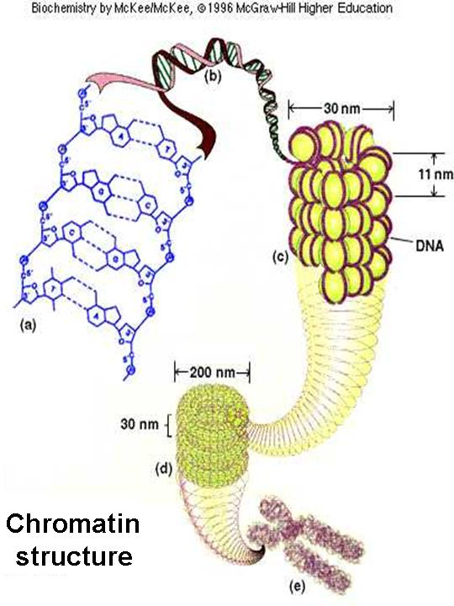
- Histones help protect the delicate DNA, and also help condense the DNA so that it is wrapped up tightly.
- Prior to cell division (mitosis), the DNA must copy itself through a process called REPLICATION, then it condenses down to chromosomes.
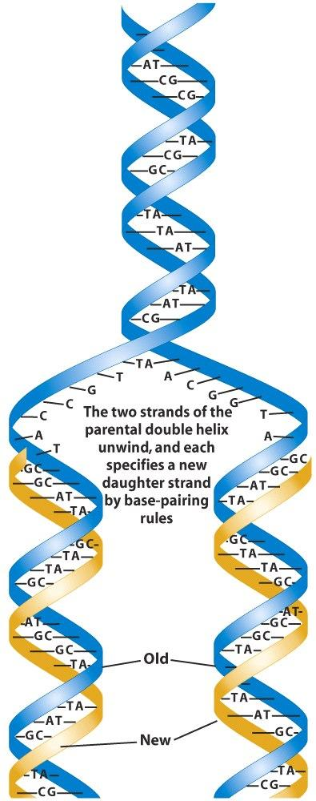

- GENES are segments along the DNA that contain specific base sequencing that tells your protein factories what order to place Amino Acids to build the perfect primary structure for a given protein.
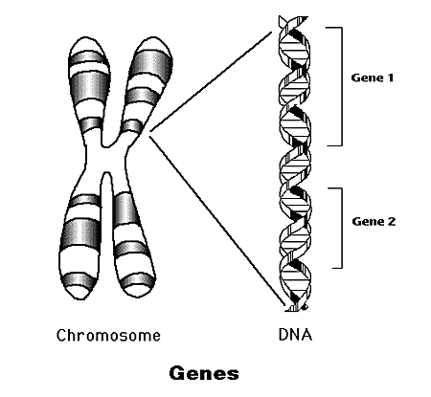
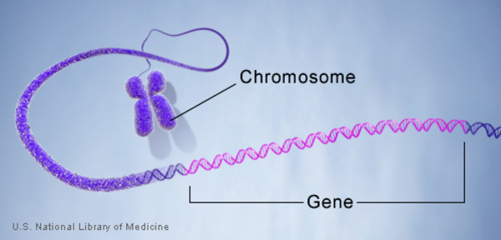
LO – D-1 – DNA Structure
- The basic molecule (building block) of DNA/RNA is a NUCLEOTIDE.
- Each nucleotide must contain three key structures: - A Phosphate Group
- A 5-Carbon Sugar (pentose)
- A Nitrogenous Base.

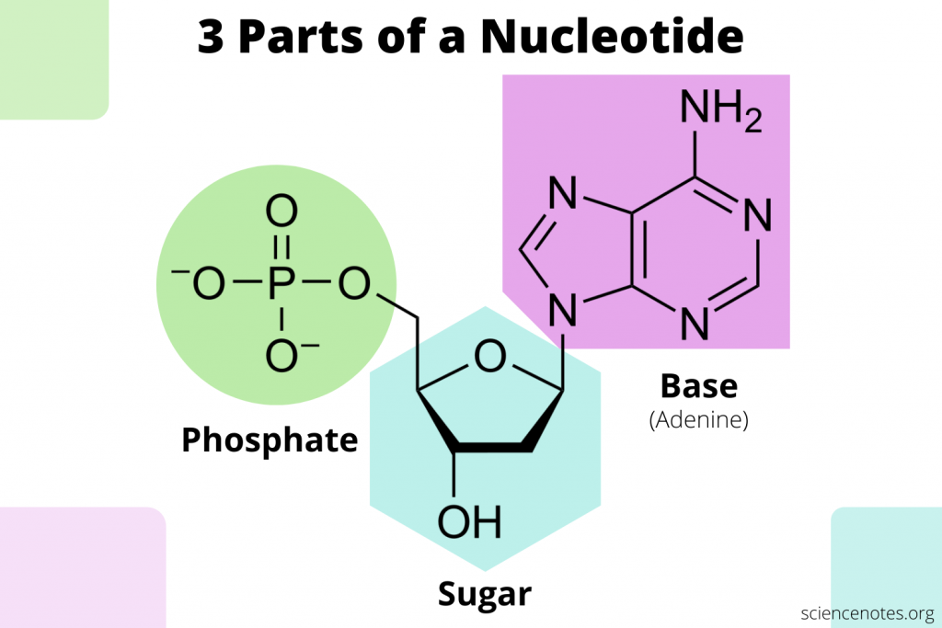
- All DNA nucleotides use the same pentose sugar, it is called DEOXYRIBOSE. It's formula is C₅H₁₀O₄
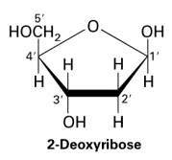

- The two main types/categories of bases that are found in DNA are PURINES and PYRIMIDINES.
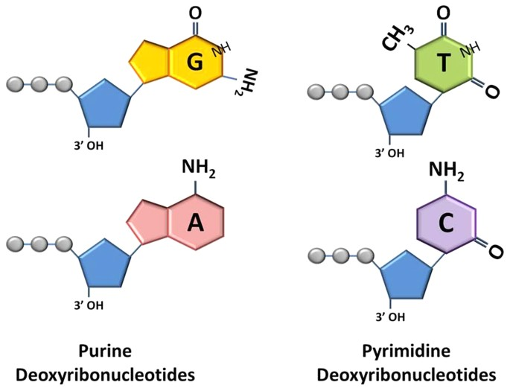

- Purines are double-ringed bases, while Pyrimidines are single-ringed bases.
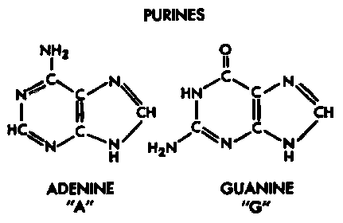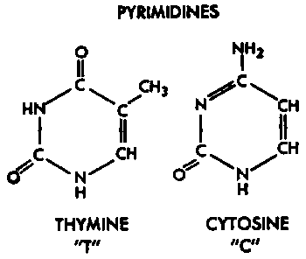

- It takes place between the sugar of one nucleotide and the phosphate of another.
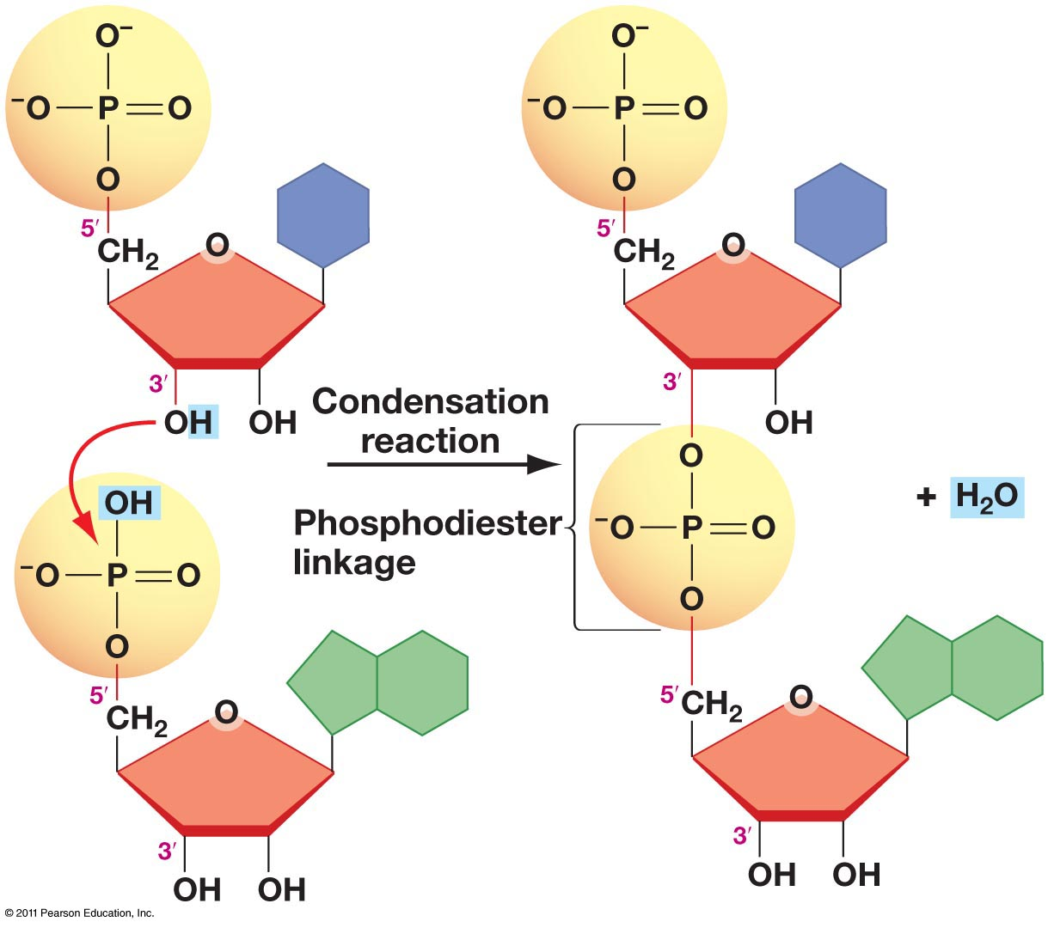
- The rails are made out of Deoxyriboses and Phosphates.
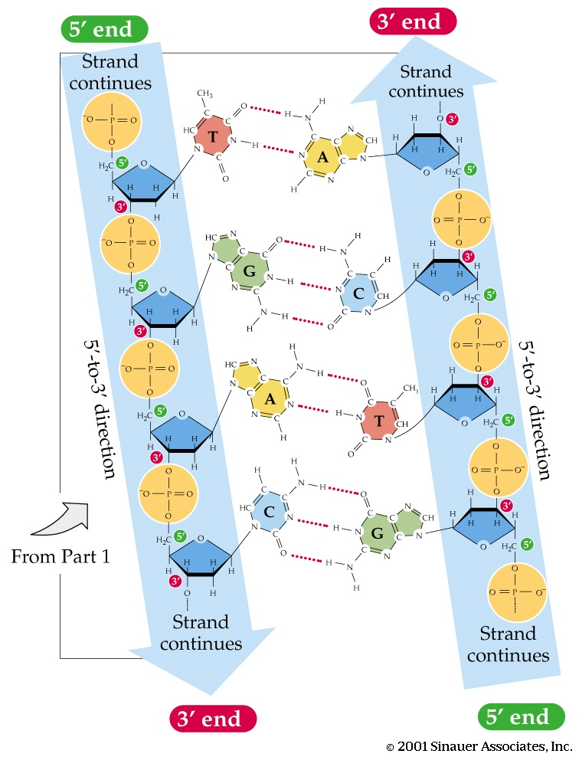

- The rungs/steps or cross-bridges are made out of the Bases that pair together.
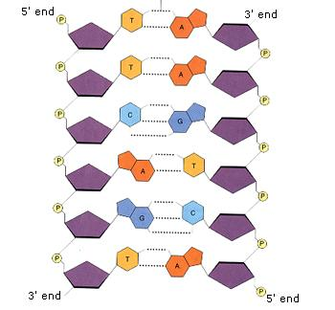
- DNA normally spirals upward and because there are two strands the shape is described as being a "DOUBLE HELIX".

- The two complimentary strands are held together by weak Hydrogen Bonds between the bases.

- Thymine always joins to ADENINE with 2 H-bonds.

- Cytosine always bonds to GUANINE with 3 H-bonds

- REPLICATION
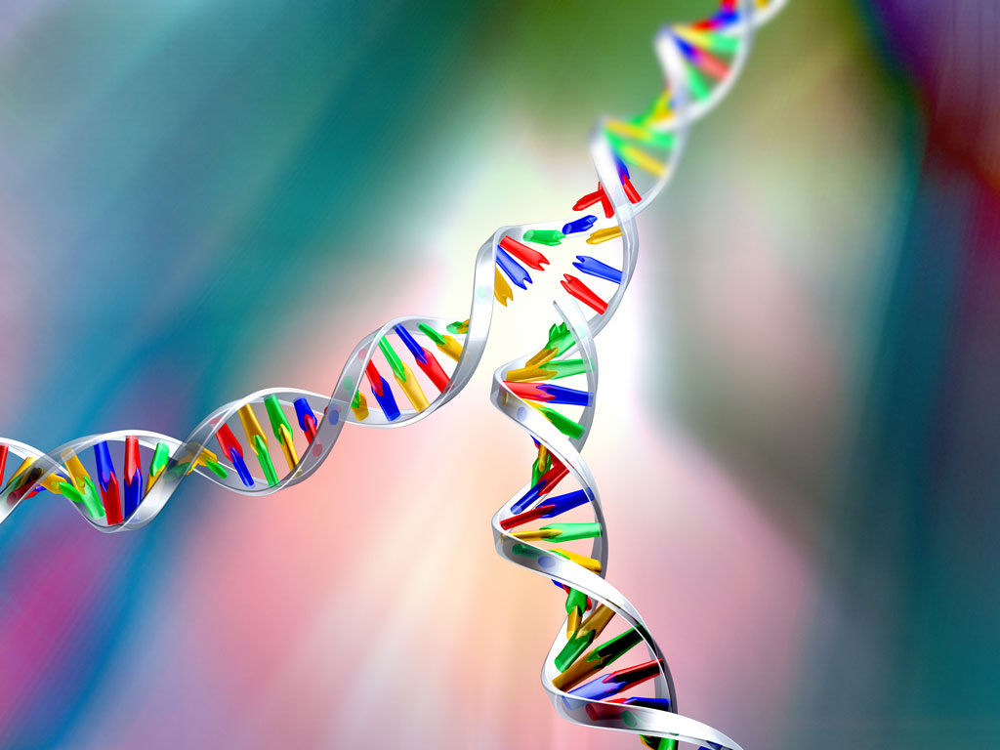

- mRNA forms from DNA then the mRNA is translated into primary sequencing of a given polypeptide – PROTEIN Synthesis as Amino Acids join to form a polypeptide.

LO – D-2 DNA REPLICATION
- During Semi-conservative Replication each of the strands in a DNA double helix split apart to act as a template to build a brand new complimentary strand. The final result is two DNA double helixes each of which has a strand from the original double helix.
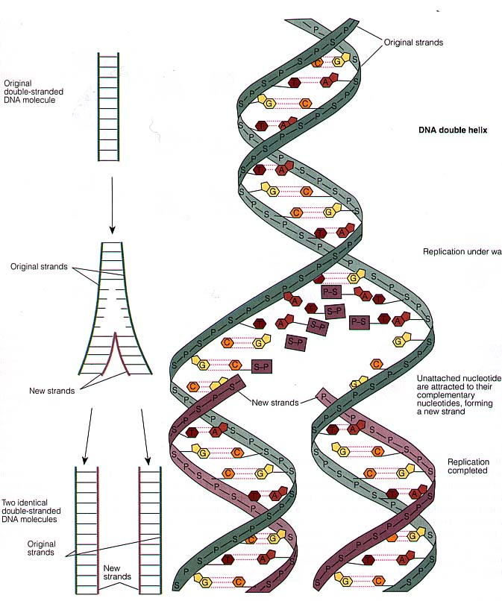

- A couple of key enzymes are required for replication, an enzyme called DNA HELICASE enzymes helps unwind and unzip the H-Bonds between the two DNA strands , so that DNA POLYMERASE enzymes can guide the rest of the replication processes.

- The unzipping of DNA means that the Hydrogen bonds between complimentary bases are broken apart.

- As the strands are freed up, new free-floating DNA nucleotides in the nucleus come in to complimentary base pair. The base on the new Nucleotide H-bonds to the base on the existing (original) strand of DNA.

- As the new bases are held in place, dehydration synthesis occurs between the phosphate group of one nucleotide and the Deoxyribose of an adjacent nucleotide.
See Picture
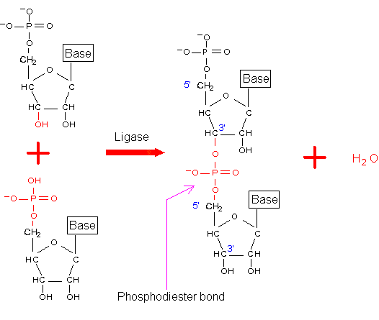
- Replication must occur in organisms because the full set of DNA must be passed onto each new daughter cell during mitosis.
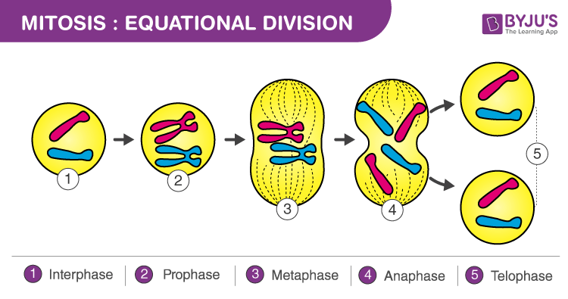

- A MUTATION occurs.

