Unit E – Review #2 Q’s KEY

- GENES
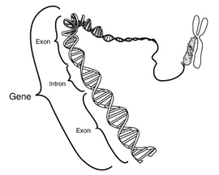
- Transcription and Translation

- Transcription involves the using of a DNA gene as a template to build a molecule of RNA. This specific type of RNA is known as mRNA (messenger RNA). See Picture
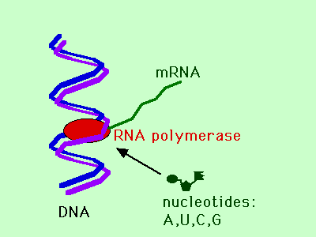
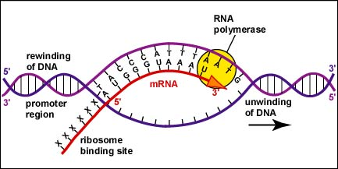
- TRANSLATION involves the processes of de-coding the sequence of mRNA into the proper sequencing of Amino Acids when building a polypeptide/protein.

- Translation occurs out in the cytoplasm at a RIBOSOME. See Picture Below
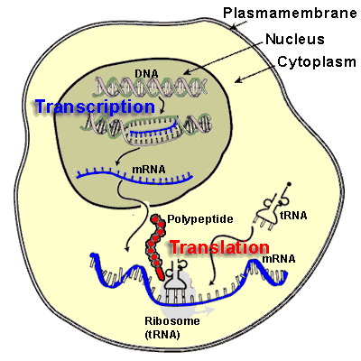
- Codons are triplets of mRNA bases that code for a specific amino acid. See Picture
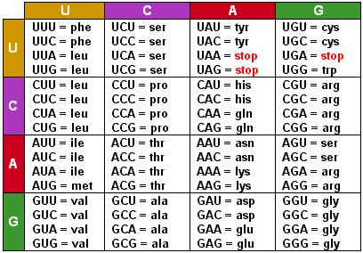
- There are a total of 64 possible ways of putting 4 RNA Bases together in triplets.

- Although there are 64 possible ways of combining the 4 RNA bases into triplet codes, there are only 20 different Amino Acids

- This property of the genetic code is called DEGENERACY. The benefits of degeneracy stem from the fact that if a mistake is made during replication or during transcription, if the codon is slightly different than what it was intended to be, it may still code for the proper amino acid. Ex. GCU GCC GCA and GCG all code for ALANINE. This provides a certain amount of protection against some mutations.

- The term TEMPLATE means that something is acting as mold/guide to make something else from that template.
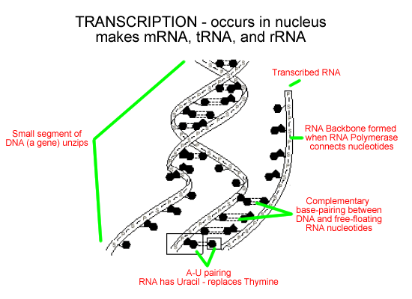
- Because mRNA is mobile and can exit the nucleus and travel to a ribosome; whereas, DNA cannot leave the nucleus.

- Primary mRNA must be processed (Spliceosomes have to cut out the Introns and splice together the Exons) and then a polyadenine tail must be added on prior to it leaving the nucleus.

- SPLICEOSOMES
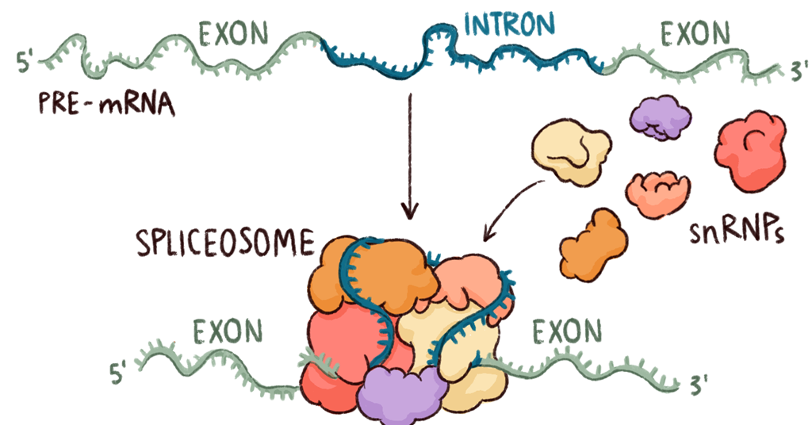
- Ribosomes
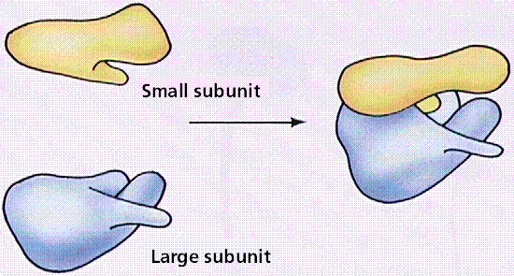
- rRNA along with proteins are used to build Ribosomes.

- tRNA is used to bind onto specific amino acids and then deliver these specific amino acids to the correct spot along the mRNA.
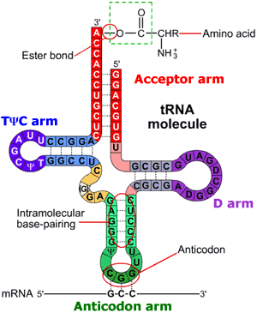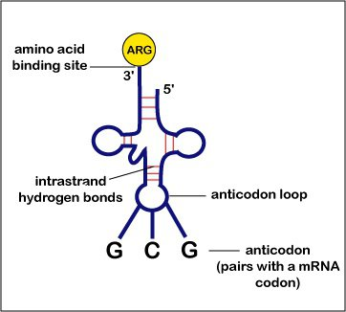
- TRANSCRIPTION

- TRANSLATION

- TRANSLATION

- Amino Acids

- A polysome/polyribosome is a cluster of ribosomes that are all sliding along and translating a same piece of mRNA. See Picture Below
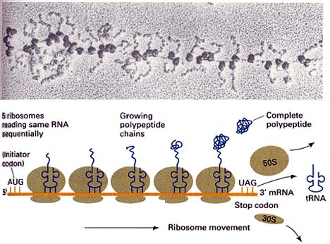
- During translation, when a Ribosome hits a STOP codon, a release factor arrives and the ribosome splits into its subunits and releases the fully formed polypeptide. This is called TERMINATION.

- An INTRON is a useless sequence of RNA that must be cut out of the mRNA, EXONS (exit and get expressed) contain the important part of the gene that must carry their information to the ribosome.

- Proteins – See animation on right, where ribosomal subunit has purple and yellow proteins embedded in pink rRNA
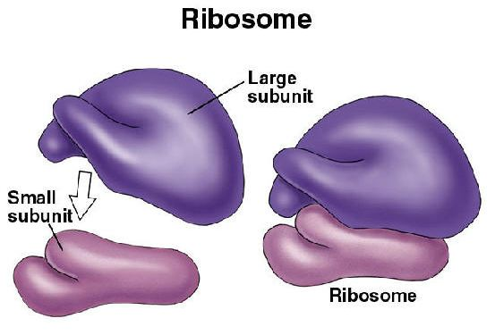
- ANTICODON
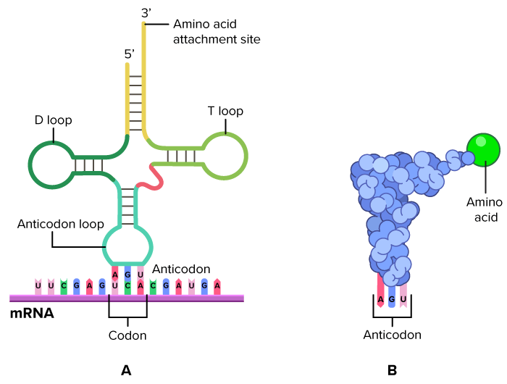
- The polyadenine tail is attached onto the mature mRNA to protect it and keep it functional out in the cytoplasm.

- Eventually when enough of a particular poplypeptide/protein is produced, the polyadenine tail at the end of the mRNA will be cut off; this signals the Ribosomes to stop attaching onto the given mRNA. The mRNA strand will eventually be hydrolyzed (broken down with water) by enzymes.

PRACTICE QUIZ:
- The new strand would be :
GUC UUG GGC UUU GCC CC
Val - Leu - Gly - Phe – Ala
B
- B-
Amylase "ASE" ending is a dead give away that this is an enzyme. Enzymes are proteins. So this is really asking us "Where are proteins synthesized?"

- C If the DNA is AGT – the complimentary RNA to this must be UCA

- Asp – Thr – Pro
Codons must be: GA__ AC__ CC__
So the DNA must be
CT__ TG__ GG__
Answer is A
- B – TRANSCRIPTION is DNA mRNA
- B - DNA = AGT
mRNA = UCA
tRNA = AGU
- A mRNA to tRNA – Both are RNA so any answer with T-Thymine can be tossed out.
A = U with Two Hydrogen bonds will work
U does not complimentary base pair with G

- C 4 1 5 2 3 works best
- C 2 1 3 5 4

- D – mRNA is "messenger RNA" it carries a counterfeit copy of the DNA out to the Ribosomes.

