Chapter 25 Review #3 KEY
Learning Outcome E-3
- They occur on their own just by accident, there was no mutagenic agent (like radiation, chemicals etc) responsible for the mistake.

- A mutagen is any environmental factor that causes a mutation.
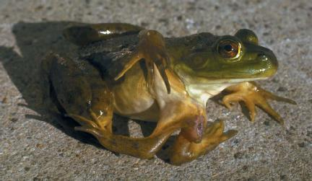

- CARCINOGEN

- Environmental Mutagens are : A) Chemical or B) ENERGY - Radiation

- Four Chemical Mutagens would include: Herbicides, Pesticides, Heavy Metals, Drugs, Food additives and some other Toxins.

- Suspected mutagens are tested on bacteria simple animals (insects) simple mammals primates.

- Radiation is so dangerous because it is invisible.
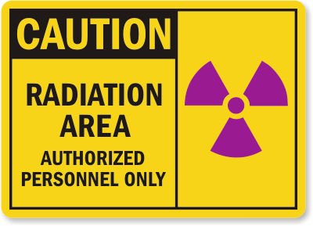
- Some examples of radiation mutagens are : most very short wavelengths, Gamma Rays, X-Rays, Ultra-Violet Rays.
X-Ray tech with Lead Apron on.
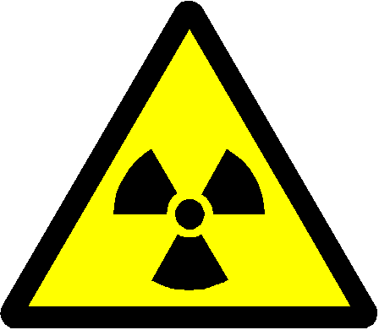

LO – E-4
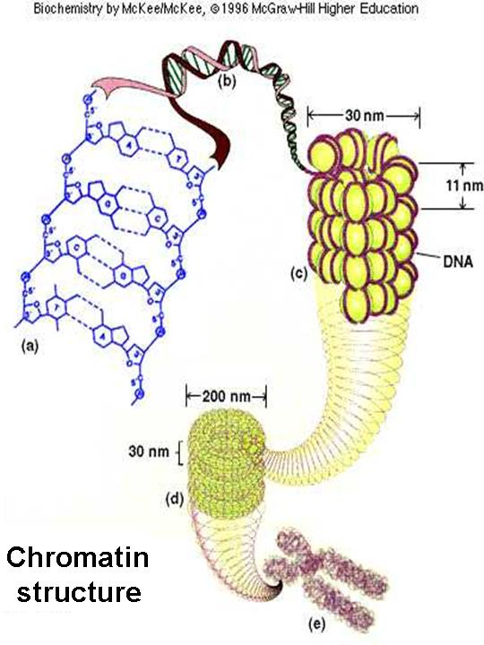
- Gene mutations are mutations that affect one gene. A chromosomal mutation affects a portion of chromosome, therefore many genes are affected during a chromosomal mutation.

- A “FRAMESHIFT” gene mutation requires that a base has been deleted or added into the gene. This causes all codons beyond that point to be re-arranged.
- A) “FRAMESHIFT – Addition” gene mutation. Ex Insert “T”
THE CAT ATE THE RAT
THE TCA TAT ETH ERA T
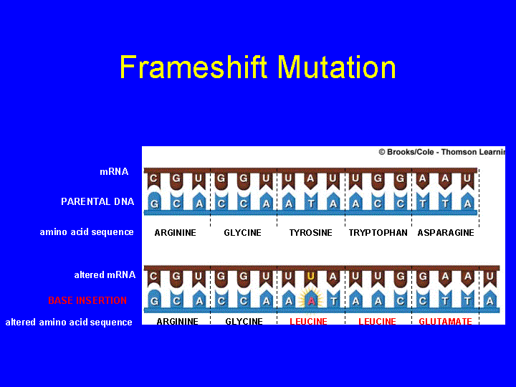
B) A "Frameshift Deletion" gene mutation
THE CAT ATE THE RAT
THE ATA TET HER AT
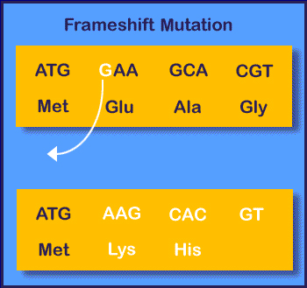

- When a single base is substituted for another we classify it as a “POINT” substitution gene mutation.
- May be SILENT – if codon still gives proper AA.
- May be MIS-SENSE – if new codon gives rise to wrong AA, but protein is built fairly close to normal.
- May be NONSENSE – If new codon is a stop codon. Translation is terminated.

- Chromosomal mutations are more serious as many genes are affected.
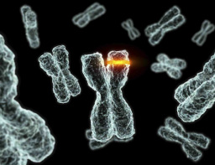
- When one part of one chromosome breaks off and relocates to a NON-HOMOLOGOUS chromosome we classify this as “TRANSLOCATION”
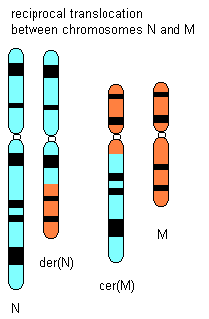

- When two sets of genes are found on one Chromosome, it is classified as a DUPLICATION Chromosomal Mutation.
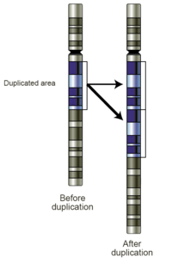

- INVERSION chromosomal mutation.
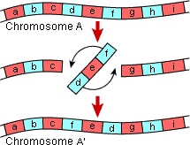

- DELETION chromosomal mutation.
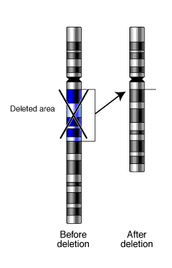
- A somatic mutation is one that occurs to a normal BODY cell. These can be fairly harmful if they take place during early embryonic development, or as an infant.

- A germinal mutation is one that occurs during Meiosis to a germ(sex) cell. Ex to an egg or a sperm. Very detrimental if the mutant sex cell is used to create the zygote (first cell in conception).

- There are two causes to Down Syndrome, the majority of DS is caused by non-disjunction of the 21st pair of chromosomes during meiosis. But about 5% of DS is caused by a Translocation on the 21st chromosome.
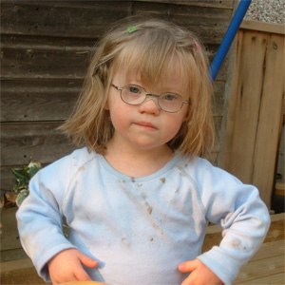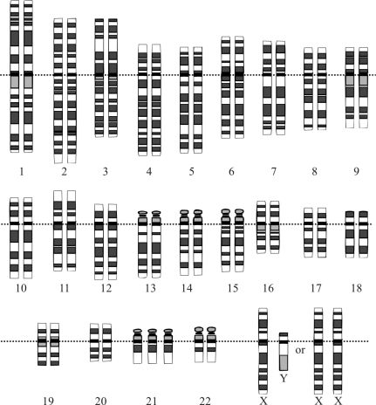
The karyotype (chromosome set) above shows that there is an extra chromosome #21, as the pair of 21 in the cell did not separate into different sex cells.

- Hemophilia is usually a germinal mutation of a chromosome or gene that originally occurred to a Germ Cell. Lack a specific clotting factor.

Identify each type of mutation illustrated below: Be as specific as possible
1.
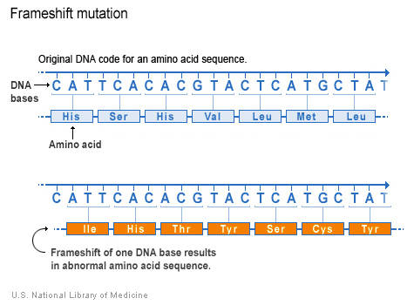
- FRAMESHIFT deletion as the sequence still looks the same but the reading of the codons is shifted. Example CAT TCA above is now ATT CAC in the mutated version
2.
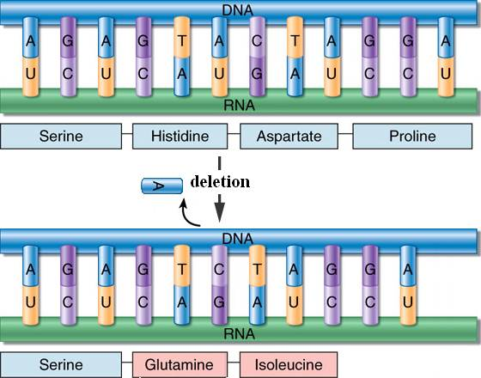
2. FRAMESHIFT deletion as well, all codons past the deleted Adenine, will be affected as is seen here

3.
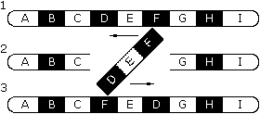
3.Chromosomal Inversion. Sequence D-E-F is spliced in as F-E-D. It is inserted upside-down.

4.
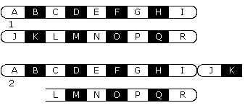
4. Chromosomal Translocation: ABCDEFGHI chromosome should not crossover with JKLMNOPQR chromosome, as they are non-homologous

