CHAPTER 5 – SKELETAL SYSTEM REVIEW GUIDE - KEY
Complete the following questions on a separate piece of paper:
- List five main functions of the Skeletal System.
- For structure and support
- For protection, rib cage and skull
- For movement at joints
- For hematopoiesis – blood cell formation from red bone marrow
- For storing and releasing key minerals like calcium and phosphorous
- For each bone listed – state the bone shape it possesses:
- Patella - SESAMOID C) Atlas - IRREGULAR E) Capitate (Carpal) - SHORT
- Femur - LONG D) Gladiolus of sternum - FLAT
- Define the following Long Bone Anatomical Structures:
- Diaphysis The diaphysis is the main or midsection (shaft) of a long bone. It is made up of cortical bone and usually contains bone marrow and adipose tissue (fat).
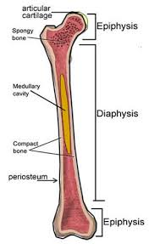
- Epiphysis : The epiphysis is the rounded end of a long bone, at its joint with adjacent bone(s). Between the epiphysis and diaphysis (the long midsection of the long bone) lies the metaphysis, including the epiphyseal plate (growth plate).
- Epiphyseal Plate: is a hyaline cartilage plate in the metaphysis at each end of a long bone. It is the part of a long bone where new bone growth takes place; that is, the whole bone is alive, with maintenance remodeling throughout its existing bone tissue, but the growth plate is the place where the long bone grows longer.

- Medullary Cavity: The medullary cavity (medulla, innermost part) is the central cavity of bone shafts where red bone marrow and/or yellow bone marrow (adipose tissue) is stored; hence, the medullary cavity is also known as the marrow cavity.
- Articular Cartilage: the smooth, white tissue that covers the ends of bones where they come together to form joints. Healthy cartilage in our joints makes it easier to move. It allows the bones to glide over each other with very little friction.
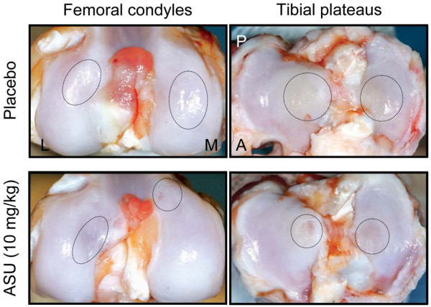
- Endosteum: is a thin vascular membrane of connective tissue that lines the inner surface of the bony tissue that forms the medullary cavity of long bones.

- Periosteum: dense fibrous membrane covering the surfaces of bones, consisting of an outer fibrous layer and an inner cellular layer (cambium). The outer layer is composed mostly of collagen and contains nerve fibers that cause pain when the tissue is damaged.

- Trabeculae: are the thin columns and plates of bone that create a spongy structure in a cancellous bone, which is located at the ends of long bones and in the pelvis, ribs, skull, and vertebrae.
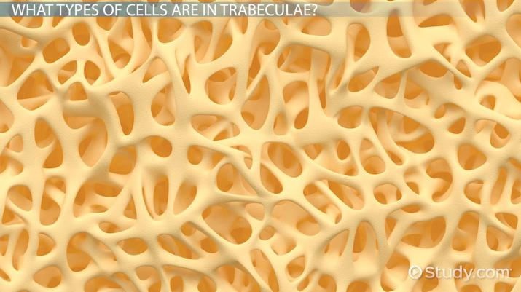
I) Cancellous Bone: also known as spongy bone or trabecular bone, is a very porous type of bone found in animals. It is highly vascularized and contains red bone marrow. Spongy bone is usually located at the ends of the long bones

- Compact bone anatomy – Define each anatomical structure:
- Osteon: are cylindrical/concentric structures that contain a mineral matrix and living osteocytes connected by canaliculi, which transport blood. They are aligned parallel to the long axis of the bone in compact/dense bone tissue.
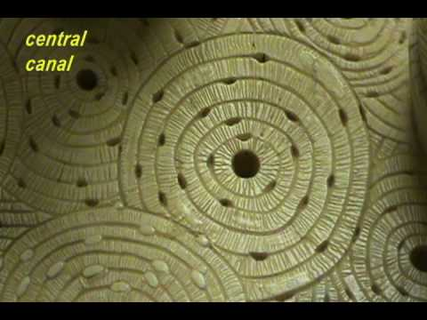
OSTEON
Haversian
Canals
- Haversian Canal: a series of microscopic tubes in the innermost region of osteons, they allow blood vessels and nerves to travel through them. Each haversian (central) canal generally contains one or two capillaries and nerve fibers.
- Lamellae: ring-like layers of calcified bone matrix which contain collagen fibers in a nearly parallel array, and rich amounts of calcium, phosphorous and magnesium.
D) Lacunae: a number of oblong spaces/chambers situated between the lamellae. In an ordinary microscopic section, viewed by transmitted light, they appear as dark opaque spots. Each lacuna is occupied during life by an osteocyte
F) Canaliculi : Are microscopic canals between the lacunae of ossified bone and the central/haversian canal of an osteon. These canals create a passageway for blood to flow to the bone cells.
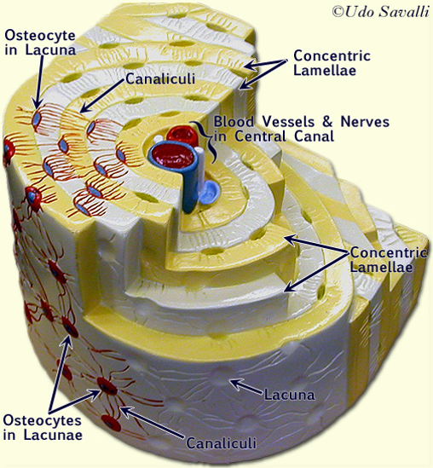
- Define each:
- Endochondral Ossification: the process by which growing cartilage is systematically replaced by bone to form the growing skeleton.
- Osteoblast: large cell responsible for the synthesis and mineralization of bone during both initial bone formation and later bone remodeling – bone-building
- Osteoclast: a type of bone cell that breaks down bone tissue matrix. This function is critical in the maintenance, repair, and remodeling of bones and releasing minerals into the bloodstream.
- Osteocyte: a mature bone cell that lies within the substance of fully formed bone. It occupies a small chamber called a lacuna.

- Write down the following subtitles and leave two lines between each category :
- Cranial Bones (5) : Sphenoid, Temporal, Occipital, Frontal and Parietal
- Facial Bones (4) : Mandible, Maxilla, Zygomatic and Nasal
- Shoulder Girdle Bones (2) : Clavicle and Scapula
- Upper Extremity Bones (6) : Humerus, Radius, Ulna, Carpals, Trapezium/(Carpal), Metacarpal.
- Lower Extremity Bones (9) : Femur, Patella, Tibia, Fibula, Calcaneus, Talus, Tarsals, Metatarsal, Distal Phalanx -foot
- Rib Cage/Sternum Bones (5): Gladiolus, Xiphoid Process, Manubrium, True Rib, Floating Rib
- Spinal Column Bones/Regions (7): Atlas, Axis, Sacrum, Coccyx, Lumbar #4, C1 C7, T1 T12
- Pelvic Girdle Bones (4): Coxal, Ilium, Ischium and Pubis
- Tongue Support Bone (1): Hyoid
Then take each bone listed below and write its name beside the category (A, B, C H) that it belongs to
- Atlas - Occipital - Metacarpal - Tarsals
- Patella - Maxilla - Distal Phalanx foot - Gladiolus
- Sphenoid - Sacrum - Metatarsal - C1 C7
- Mandible - Ilium - T1 T12 - Tibia
- Manubrium - Zygomatic - Ischium - Lumbar #4
- Humerus - Frontal - Axis - Ulna
- Trapezium - Xyphoid Process - Clavicle - Pubis
- Fibula - Coccyx - Parietal - Scapula
- Calcaneus - Talus - Radius - Nasal
- Temporal - Hyoid - True Rib - Floating Rib
- Coxal - Femur - Carpals

- What are ossicles? Name each ossicle and state how many total ossicles you possess?
The three bones in either middle ear that are among the smallest bones in the human body. They serve to transmit sounds from the air to the fluid-filled labyrinth (cochlea)
There are a total of 6 – three in each ear. The Hammer, the Anvil and the Stirrup.

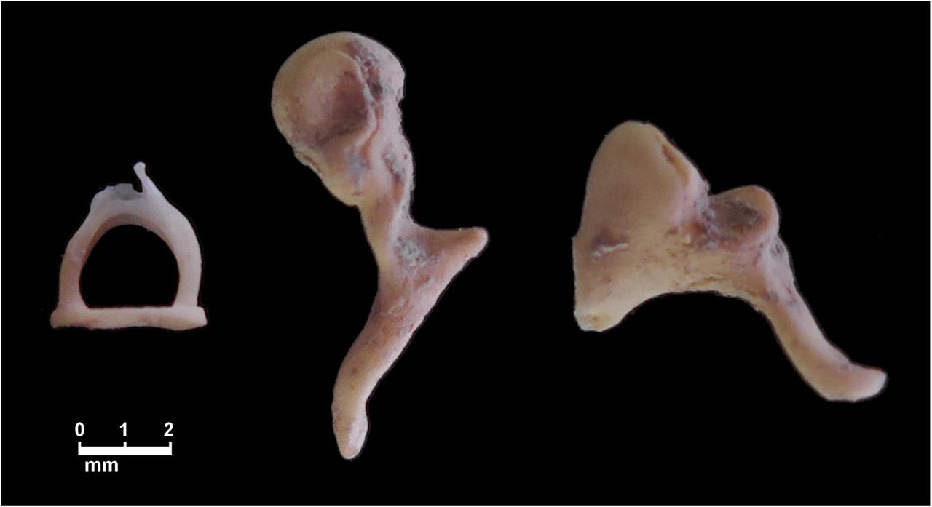
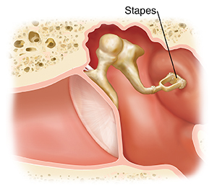
Stirrup
Anvil
Hammer

- Describe the difference between the Axial Skeleton and the Appendicular Skeleton.
The axial skeleton makes up our central axis and consists of the following bones: skull, vertebrae, ribs and sternum. The appendicular skeleton consists of the limbs and girdles. The girdles are the attachment points for the limbs.
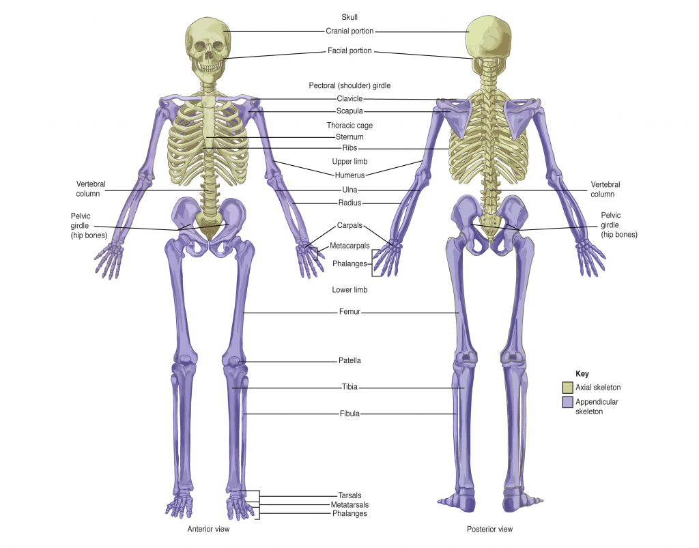

- Be able to identify the following – Spinous Process, Vertebral Body, Superior Articular Processes, Transverse Processes, Vertebral Foramen and Inferior Articular Processes.

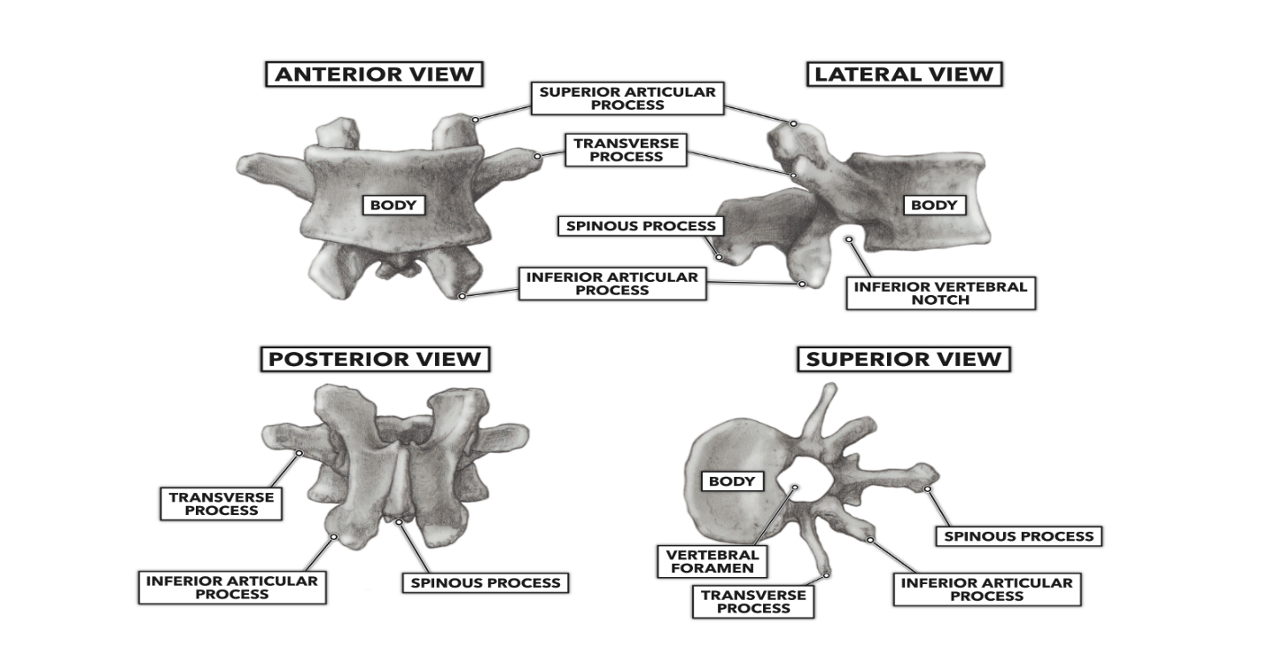
- Compare and contrast the three main categories of skeletal articulations.
- SYNARTHROTIC JOINTS: a type of joint which permits very little or no movement under normal conditions. Most synarthroses joints are fibrous. The sutures between bones of the skull is an example of synarthrosis
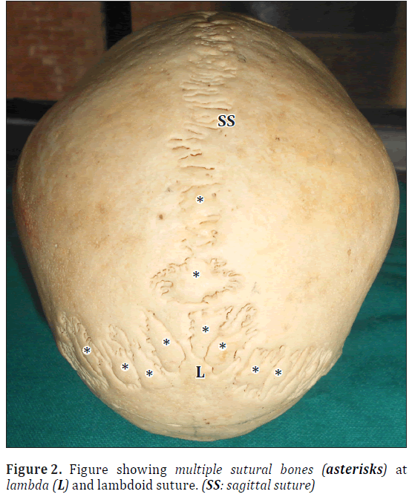
- AMPHIARTHROTIC JOINTS: a joint that has limited mobility. An example of this type of joint is the cartilaginous joint that unites the bodies of adjacent vertebrae. Filling the gap between the vertebrae is a thick pad of fibrocartilage called an intervertebral disc.
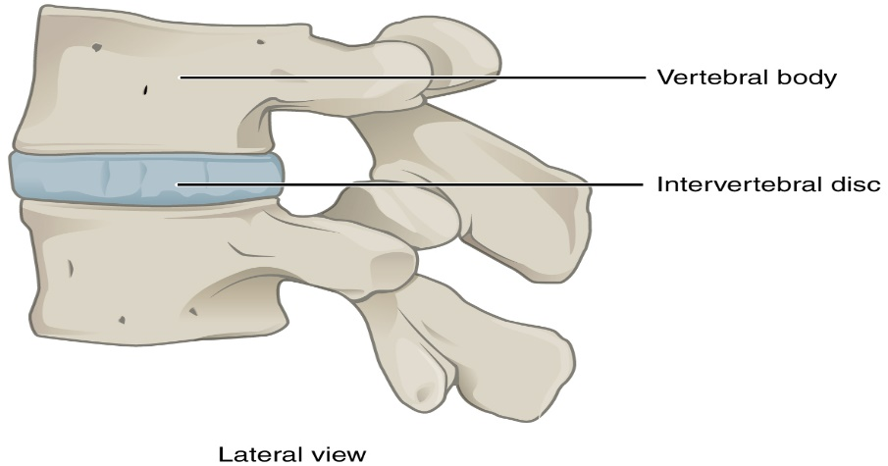
- DIARTHROTIC JOINTS: A freely mobile joint is classified as a diarthrosis. These types of joints include all synovial joints of the body.

- For each synovial joint – state a specific location in the body where you could find it.
- HINGE : Knee and fingers
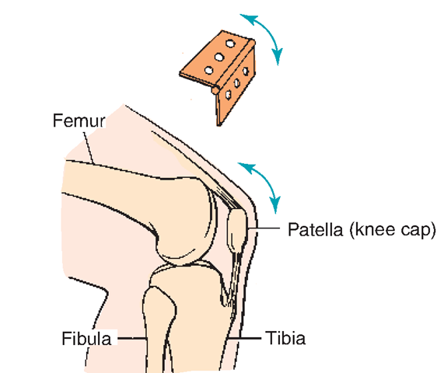
- SADDLE : Where thumb's metacarpal meets trapezium carpal
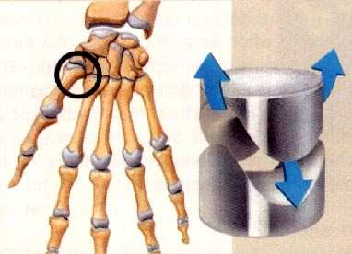
- BALL AND SOCKET : Shoulder and Hip
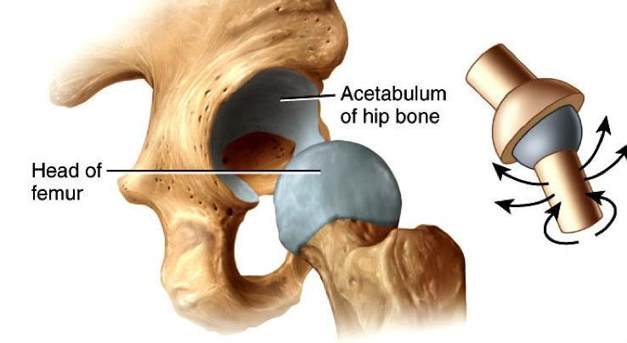
- ELLIPSOID/CONDYLOID : Where metacarpal meets proximal phalanx and where Radius meets carpals (Lunate and Scaphoid)
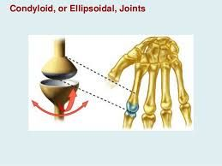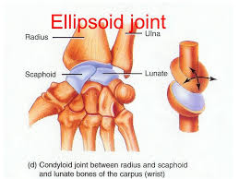
- PIVOT : Atlas (C1) on the Axis (C2) also between the proximal ends of the Radius and Ulna to allow pronation and supination
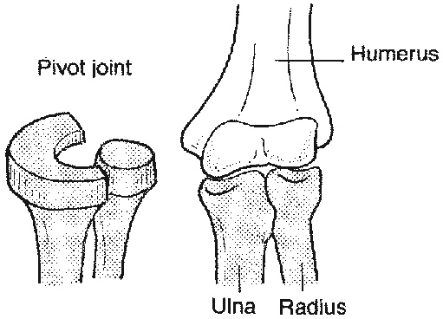
- GLIDING/PLANE: Some are found between some of the carpals as well as between some of the tarsals
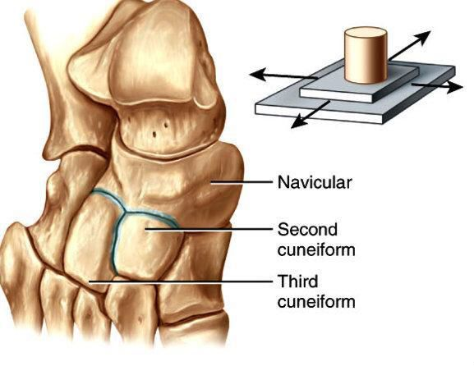

- Describe each joint movement:
- Flexion – Closing down the degree of angle at a joint
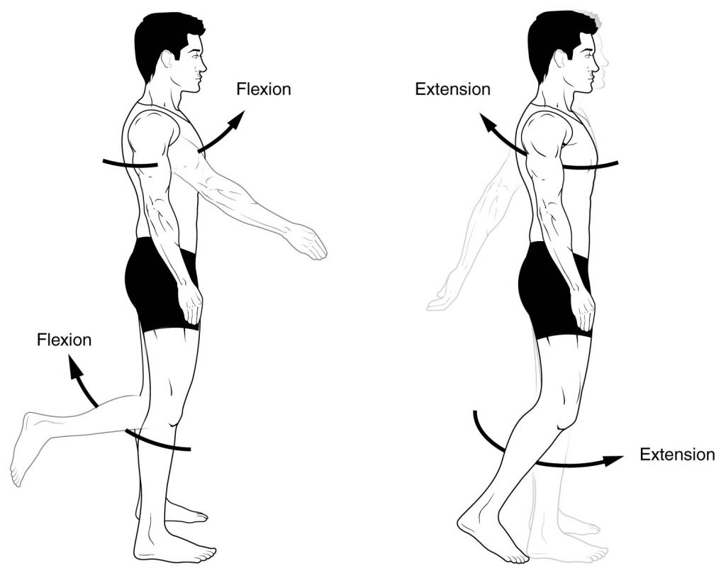
- Circumduction
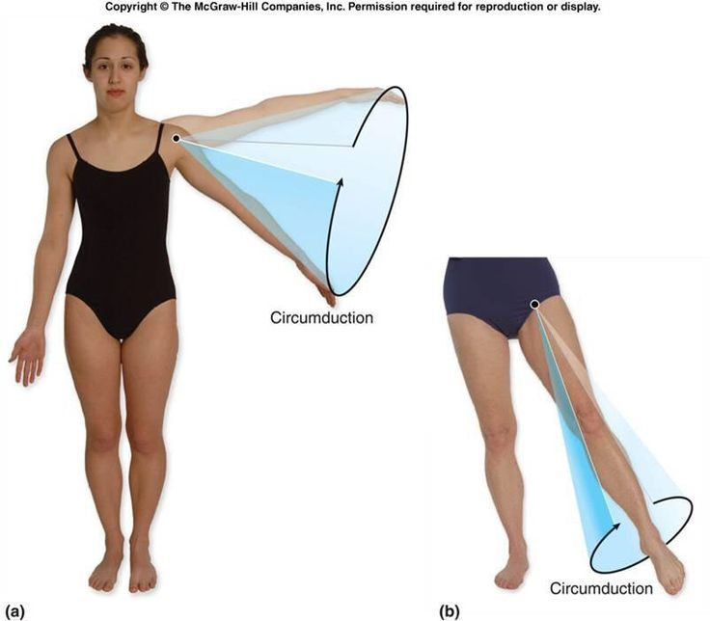
- Abduction
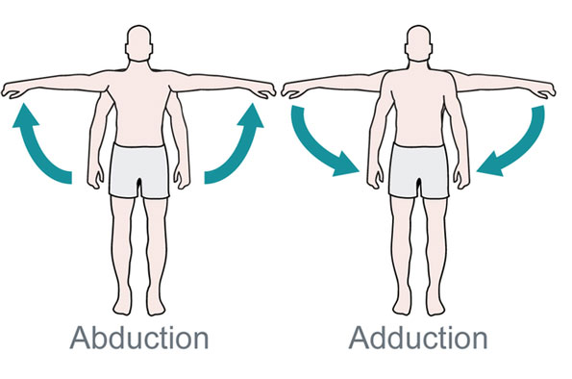

- Extension – Opening up the degree of angle at a joint
- Supination
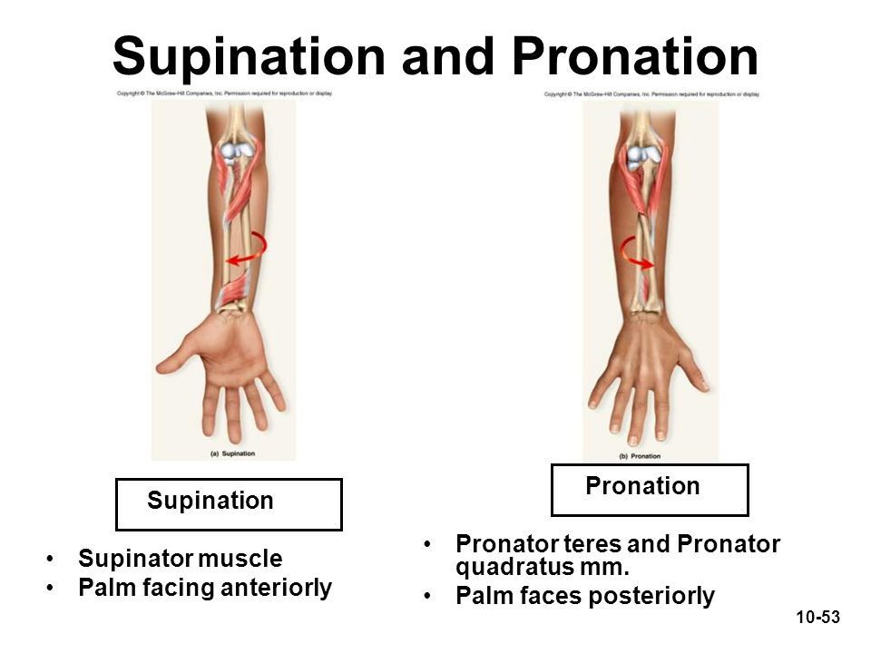
- Rotation
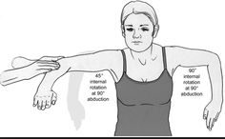
- Adduction
- Plantar Flexion
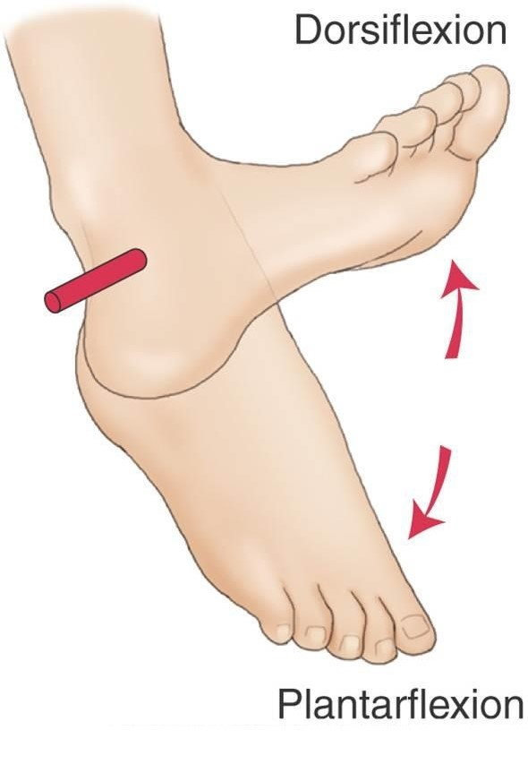
- Pronation
- Dorsiflexion

- *** Be able to label the following structures on a diagram:
- Anterior Cruciate Ligament E) Lateral Collateral Ligament
- Medial Collateral Ligament F) Lateral Meniscus
- Medial Meniscus G) Lateral Femoral Condyle
- Posterior Cruciate Ligament H) Medial Tibial Condyle
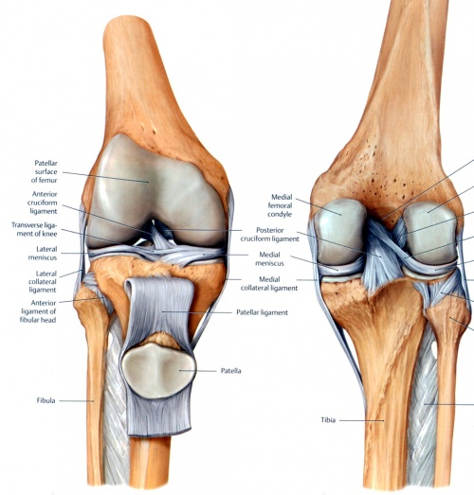

- How many total bones are in the human skeleton? 206
- Identify the following curvatures:
- Scoliosis
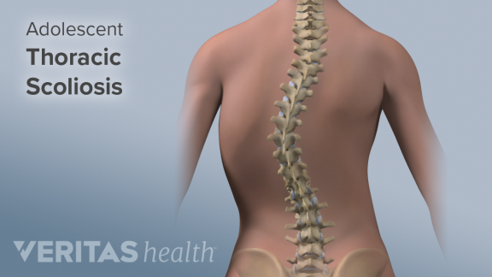

- Lordosis
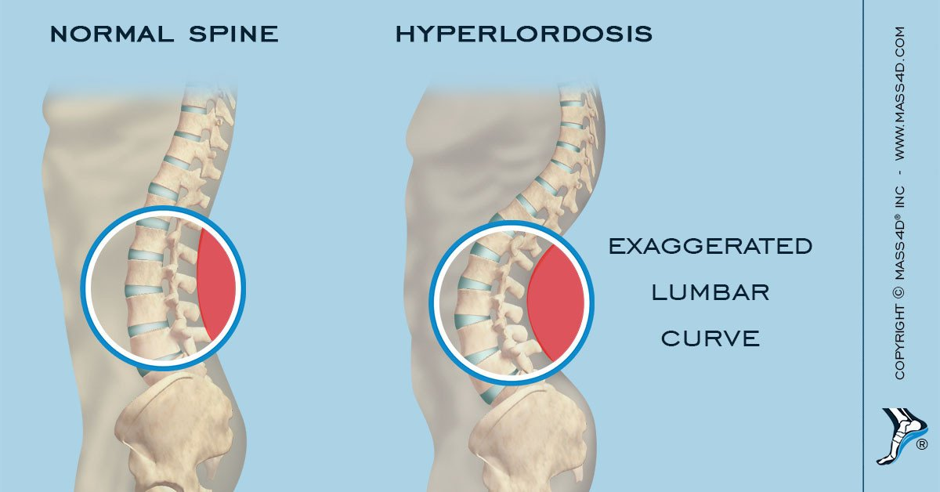
- Kyphosis
