CHAPTER TWO REVIEW WORKSHEET
CYTOLOGY
- Define/Describe each:
- Fluid Mosaic Model E) Microvilli
- Cilia F) Centrioles
- Flagellum G) Ribosomes
- Mitochondria H) Lysosomes
CANCER
- Define/Describe each:
- Neoplasm J) Immunotherapy
- Contact Inhibition K) Anaplasia
- Metastasis L) Dysplasia
- Malignant Neoplasm M) Biopsy
- Benign Neoplasm N) Palliative Care
- Internal Radiotherapy O) Leukemia (highest rate/person =Canada)
- External Radiotherapy P) Radiotherapy Dosimetrist
- Carcinogen Q) Chemotherapy
- Oncology R) Oncogene
S) Apoptosis

- List 7 fairly common warning signs associated with Cancer …. (Hint – W.S. B.U.T.I.N.)
HISTOLOGY
- List the 4 main CATEGORIES of tissue types

- Describe the difference between SIMPLE epithelials and STRATIFIED epithelials

- Identify each EPITHELIAL and site a location where it could be found in the body:

- 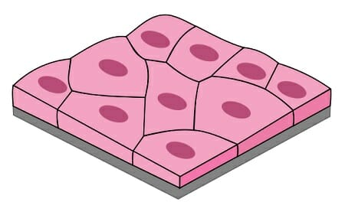 Name: _______________________________
LOCATION in body : _____________________________
- 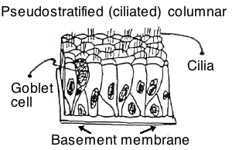
NAME : ________________________________
LOCATION : ____________________________________
- 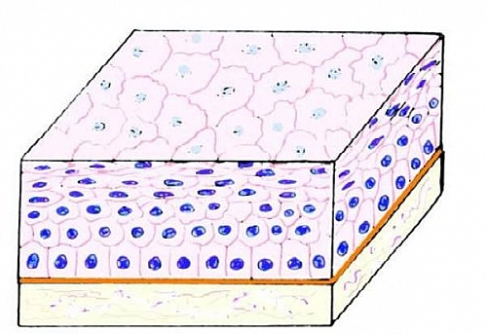
NAME : ______________________________________________
LOCATION : ______________________________________________

- 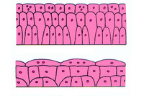
Tissue when stretched
Tissue when relaxed
NAME : ________________________________
LOCATION : __________________________________
- IDENTIFY each CONNECTIVE TISSUE:
- 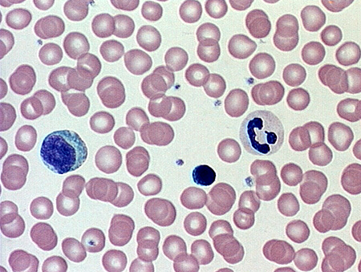 NAME : __________________

- 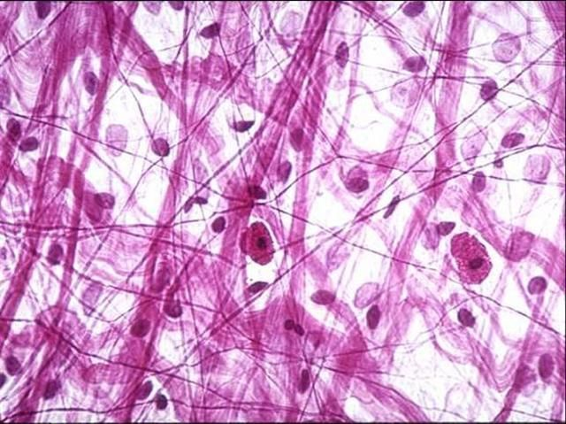 NAME : __________________

- 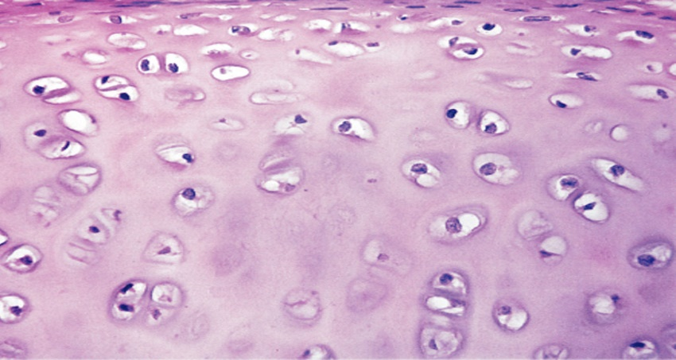 NAME: ___________________

- 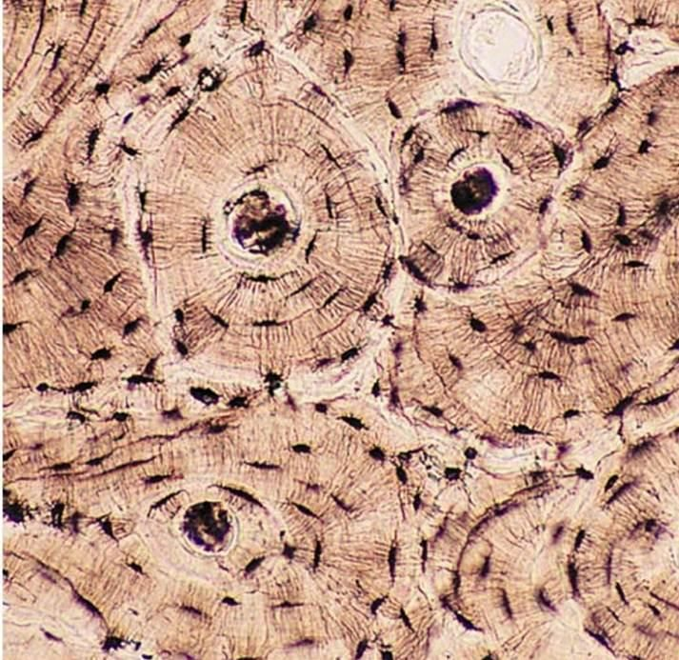 NAME : _________________
- IDENTIFY each MUSCLE Tissue:
- 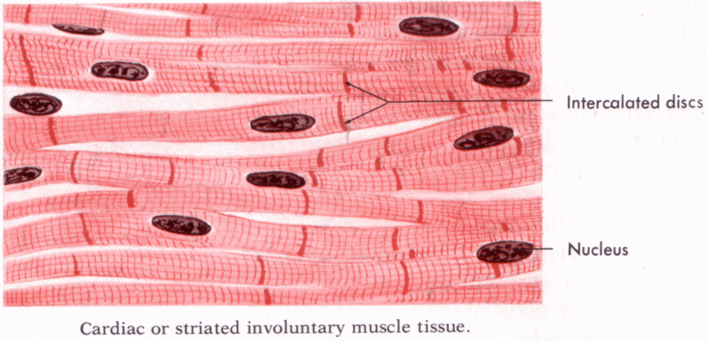NAME: __________________
- 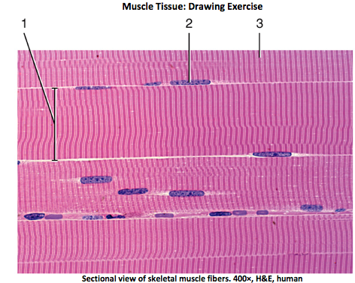NAME: _____________________
- 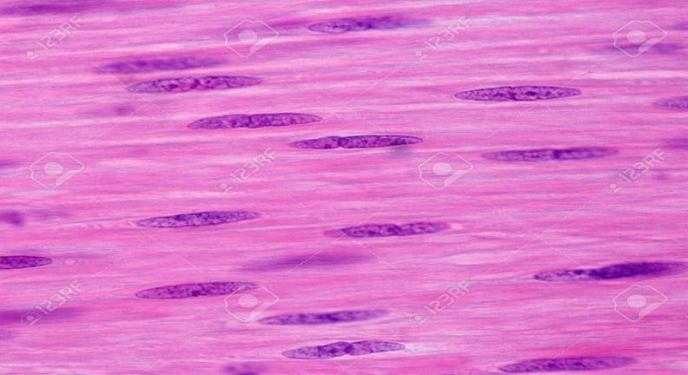 NAME : ______________________

MICROSCOPY – Review by reading over all parts of your "Viewing Tissues Lab"

