CHAPTER TWO REVIEW WORKSHEET - KEY
CYTOLOGY
- Define/Describe each:
- Fluid Mosaic Model : The fluid mosaic model describes the structure of the plasma membrane as a mosaic of components —including phospholipids, cholesterol, proteins, and carbohydrates—that gives the membrane a fluid character.
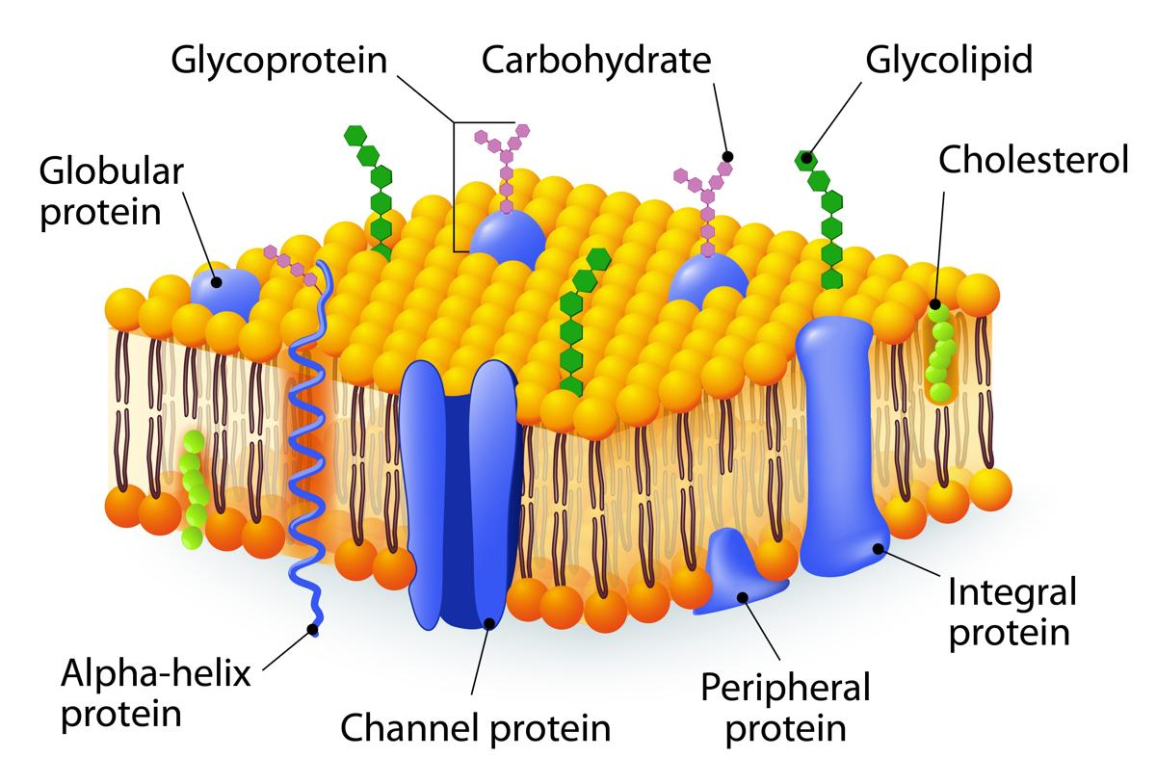
- Cilia : A cilium (plural cilia) is an organelle found in eukaryotic cells. Cilia are slender protuberances that contain microtubules and motor arms that project from the much larger cell body. Most types of cilia sweep back and forth to create movement over top of the cell, often sweeping mucous. 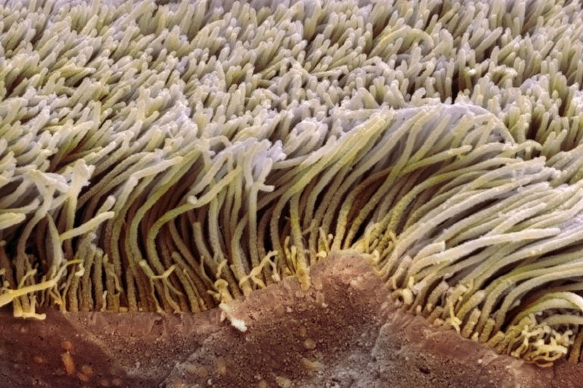

- Flagellum: A flagellum is a whip-like appendage that protrudes from the cell body of certain bacteria and some eukaryotic cells, like a human sperm cell. They allow the cell to be mobile.
- Mitochondria : Rod-shaped organelles that can be considered the power generators of the cell, converting oxygen and nutrients into adenosine triphosphate (ATP). ATP is the chemical energy "currency" of the cell that powers the cell's metabolic activities
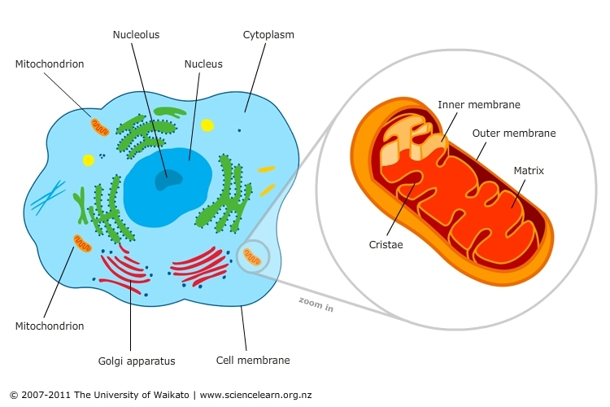
- Microvilli : Microvilli (singular: microvillus) are microscopic cellular membrane protrusions that increase the surface area for diffusion and minimize any increase in volume, and are involved in a wide variety of functions, including absorption, secretion and cellular adhesion.
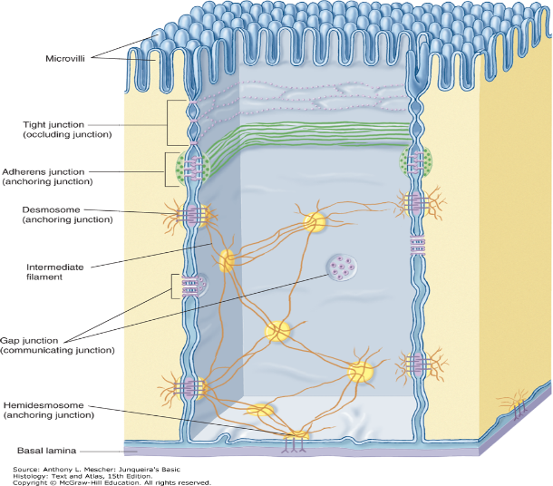
- Centrioles : Centrioles are paired barrel-shaped organelles located in the cytoplasm of animal cells near the nuclear envelope. Centrioles possess a 9 + 0 arrangement of 27 microtubules and they play a role in organizing microtubules that serve as the cell's skeletal system. They help determine the locations of the nucleus and other organelles within the cell.
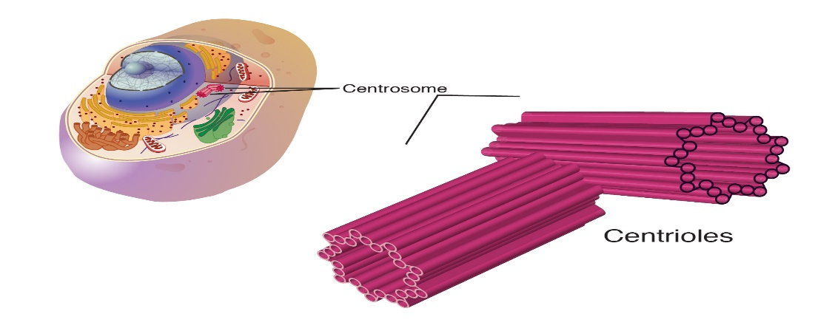
- Ribosomes : Ribosomes are minute organelles consisting of RNA and associated proteins that function to synthesize proteins. Proteins are needed for many cellular functions such as repairing damage or directing chemical processes. Ribosomes can be found floating within the cytoplasm or attached to the endoplasmic reticulum as Rough ER
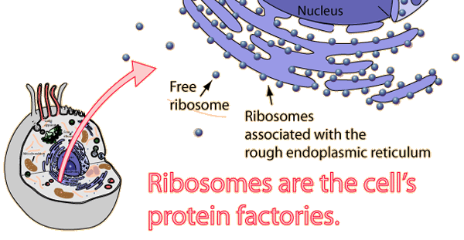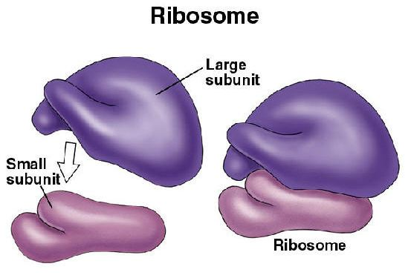
- Lysosomes: A membrane-bound organelle found in many animal cells.^{[1]} They are spherical vesicles that contain hydrolytic enzymes that can break down many kinds of biomolecules.
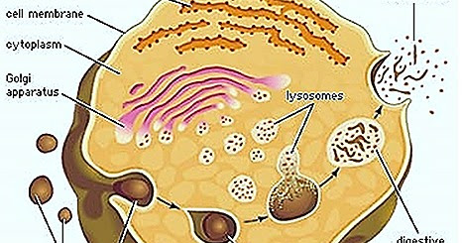
CANCER
- Define/Describe each:
- Neoplasm: An abnormal mass of tissue that results when cells divide more than they should or do not die when they should. Neoplasms may be benign (not cancer), or malignant (cancer). Also called tumor.
- Contact Inhibition : Contact inhibition of movement is here defined simply as the stopping of the continued locomotion/growth of a cell in the direction which has produced a collision/contact with another cell.
- Metastasis : The spread of cancer cells from the place where they first formed to another part of the body. In metastasis, cancer cells break away from the original (primary) tumor, travel through the blood or lymph system, and form a new tumor in other organs or tissues of the body.

- Malignant Neoplasm : A malignant neoplasm is a cancerous tumor, an abnormal growth that can grow uncontrolled and spread (metastasize) to other parts of the body.

- Benign Neoplasm: Benign neoplasm is the mass of slow growing localized tumor. The property of metastasis, example, to invade surrounding tissues and spread to the distant sites is ABSENT in a benign neoplasm. Therefore, it is said to be non- cancerous.

- Internal Radiotherapy: Also called brachytherapy or seed implantation — is a type of cancer treatment. It delivers a high dose of radiation directly to the tumor and helps spare nearby tissues. With internal radiation therapy, the oncologist implants or inserts radioactive materials at the site of your cancer.

- External Radiotherapy: Also called External beam therapy (EBT), it is a method for delivering a beam or several beams of high-energy x-rays to a patient's tumor. Beams are generated outside the patient (usually by a linear accelerator) and are targeted at the tumor site.

- Carcinogen: Any substance or agent that promotes cancer. Carcinogens are also often mutagens (a factor that promotes a genetic mutation). Carcinogens may cause cancer by altering cellular metabolism or damaging DNA directly in cells.

- Oncology: A branch of medicine that deals with the prevention, diagnosis, and treatment of cancer.

- Immunotherapy : Also called biological therapy, it is a type of cancer treatment that boosts the body's natural defenses to fight cancer. It uses substances made by the body or in a laboratory to improve or restore immune system function. Immunotherapy may work by: Stopping or slowing the growth of cancer cells.

- Anaplasia: A term used to describe cells that have lost the unique characteristics that define them as maturing and developing into a specific functioning tissue type. Cancer cells do not follow normal cell maturation and specialization.

- Dysplasia: The presence of cells of an abnormal type within a tissue, which may signify a stage preceding the development of cancer. The cells do not look uniform, the size of their nucleus and proportion of cytoplasm does not look like what should be seen in normal healthy cells.
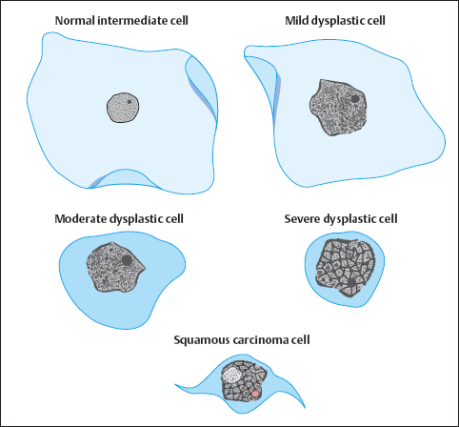

- Biopsy : A procedure used to remove a piece of tissue or a sample of cells from your body so that it can be analyzed in a laboratory. Biopsy procedures are commonly used to make a cancer diagnosis.

- Palliative Care: Specialized medical and nursing care for people with chronic conditions. It focuses on providing relief from the symptoms, pain, physical stress, and mental stress at any stage of illness. The goal is to improve quality of life for both the person and their family. It is often practiced when a patient's condition is terminal (life-ending).

- Leukemia (highest rate/person =Canada): A cancer of the body's blood-forming tissues, including the bone marrow and the lymphatic system. Many types of leukemia exist. Some forms of leukemia are more common in children. Other forms of leukemia occur mostly in adults. Leukemia usually involves the white blood cells, the number of white blood cells in the body are usually elevated and their ability to properly function is impaired.

- Radiotherapy Dosimetrist : A medical dosimetrist is a part of the radiation oncology team. The dosimetrist ensures that radiation treatment promotes the most lethal radiation dose with the fewest side effects to the patient's healthy organs. The dosimetrist will calculate how much radiation over how many treatments is the most efficient and safe schedule for treatment.

- Chemotherapy: The use of any drug to treat any disease. But the term most commonly refers to using drugs used to treat cancer. These drugs kill or slow the growth of cancer cells. Most chemotherapy drugs also affect many healthy cells that are in active cell division, this also causes several negative side effects including nausea, weakness/fatigue and hair loss etc.

- Oncogene: Is a gene in a cell that has the potential to cause cancer. In tumor cells, these genes are often mutated, or expressed at high levels.

- Apoptosis: Programmed cell death of a cell, it is a genetically controlled mechanism that is essential for the maintenance of cellular balance (homeostasis) within healthy tissues as cells get old or undergo a mutation. Cancer cells lose do not exhibit this property.

- List 7 fairly common warning signs associated with Cancer …. (Hint – W.S. B.U.T.I.N.)

W: A change to a wart of mole
S: Sores that do not normally heal
B: Bladder or Bowel habit changes
U: Unusual bleeding or discharge
T: Thickenings or lumps
I: Indigestion and loss of appetite, unexplained weight loss
N: Nagging cough or horseness

HISTOLOGY
- List the 4 main categories of tissue types:
Epithelial Connective Muscle Nervous

- Describe the difference between SIMPLE epithelials and STRATIFIED epithelials.
Simple epithelials only have one layer of cells, stratified epithelials have two or more layers of cells.

- Identify each EPITHELIAL and site a location where it could be found in the body:

- 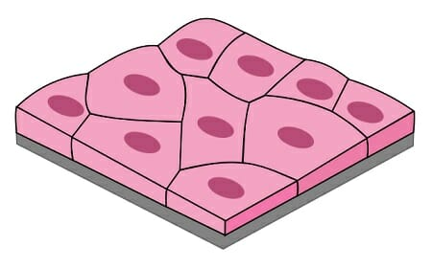 Name: SIMPLE SQUAMOUS
LOCATION in body : Walls of alveoli (lungs) walls of blood capillaries.
- 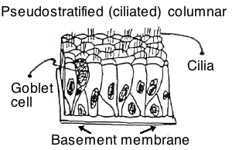
NAME : Ciliated Pseudostratified Epithelium
LOCATION : Lining nasal passages and trachea
- 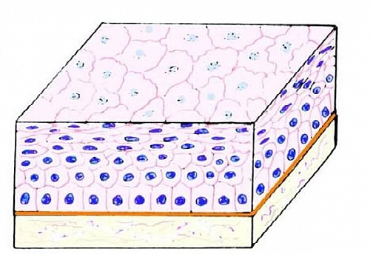
NAME : Stratified Squamous Epithelium
LOCATION : Skin, mouth wall

- 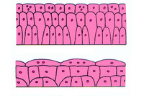
Tissue when stretched
Tissue when relaxed
NAME : Transitional Epithelium
LOCATION : Lining Urinary Bladder
- IDENTIFY each CONNECTIVE TISSUE:
- 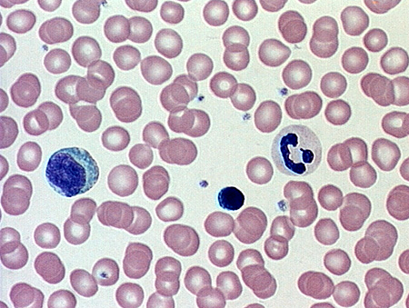 NAME : BLOOD

- 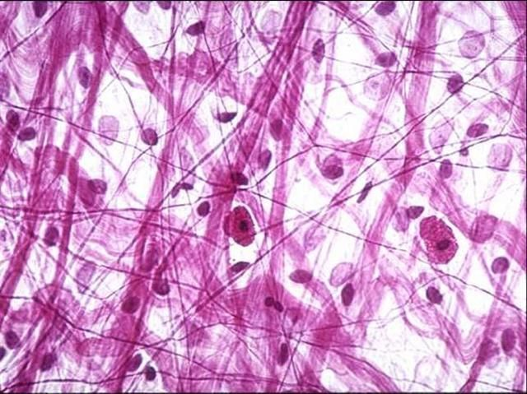 NAME : AREOLAR

- 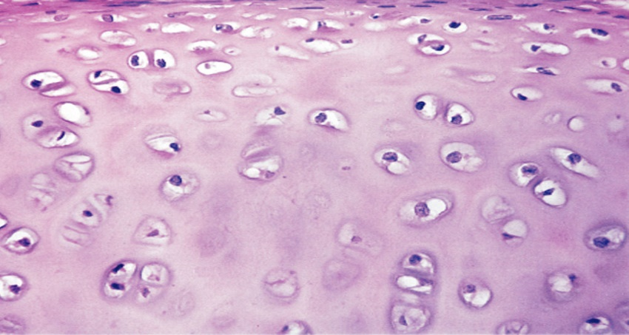 NAME: CARTILAGE

- 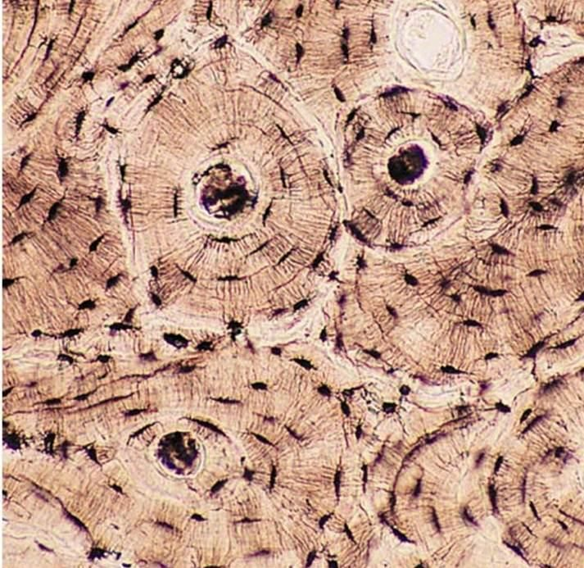 NAME : BONE
- IDENTIFY each MUSCLE Tissue:
- 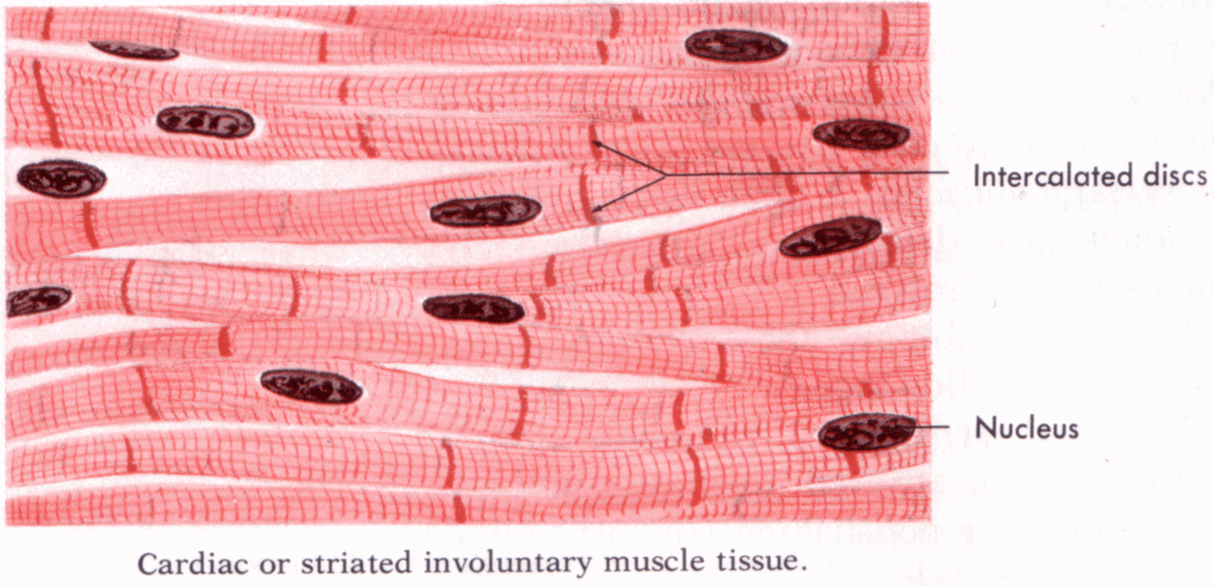NAME: CARDIAC MUSCLE
- 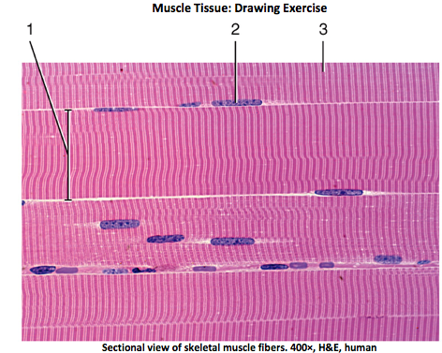NAME : SKELETAL/STRIATED/
VOLUNTARY
- 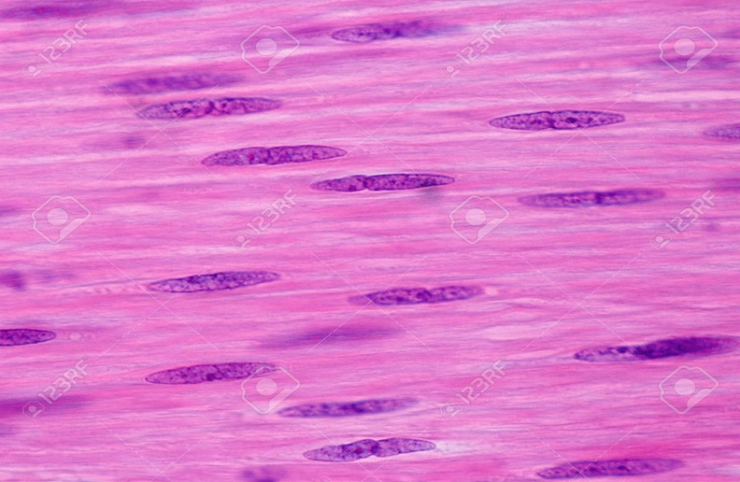 NAME : SMOOTH

MICROSCOPY – Review by reading over all parts of your "Viewing Tissues Lab"

