Name: ___________________________

Connective Tissues

- Connective tissue is the most abundant and widely distributed tissue in the body.

- Connective tissue differs from epithelial tissue in that it has much more variety in its cells and it has much more material (intercellular/extracellular matrix and fibers) between its cells.

- The type of matrix a connective tissue has will determine the characteristics of that tissue.
Example:

TISSUE | TYPE OF MATRIX
Cartilage | Gristlelike/Rubbery Gel
Bones | Hard Calcified/Cement-like

- 1. Areolar : Cells embedded in a loose matrix with a network of fibers to act as a “GLUE”. Functions to connect other tissues and organs.
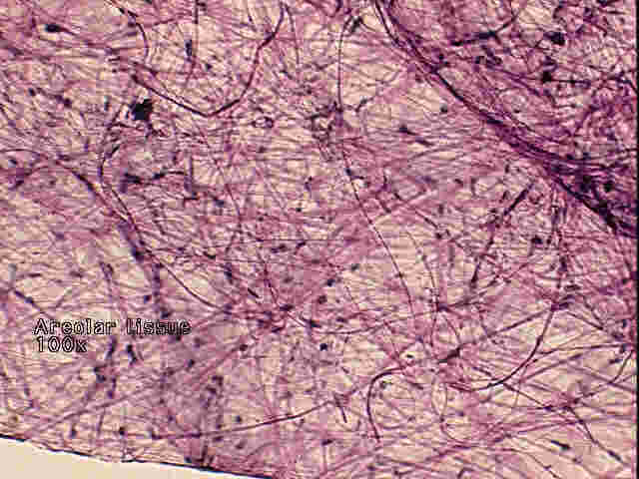

- 2. Adipose : Cells (adipocytes) with very large compartments to store fat. Functions to provide padding and insulations as well as for energy storage.
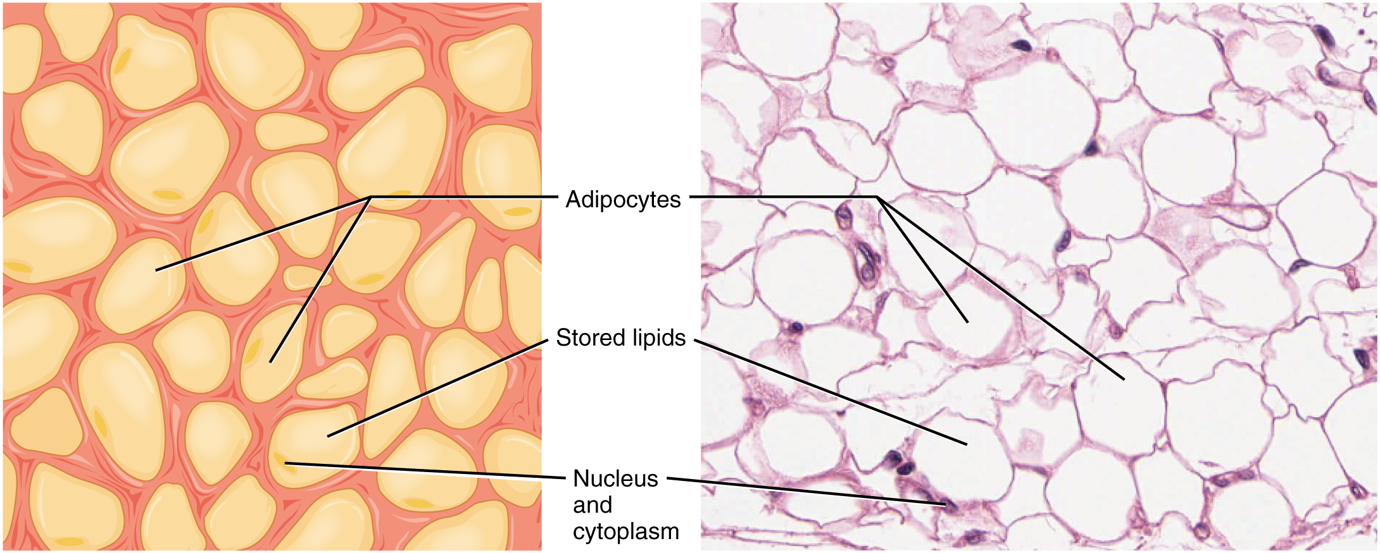
3. Dense Fibrous : Cells that produce parallel bundles of strong white collagen (type of protein) fibers. Functions to provide a strong flexible connective tissue that will not stretch.
Example : Tendons to attach muscle to bone.
- Tendon Photomicrograph


- 4. Bone : Cells (osteocytes) embedded in a calcified matrix, the matrix consist of circular building blocks called osteons. Functions to provide structural support and protection.
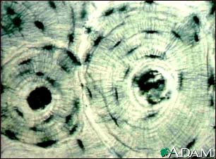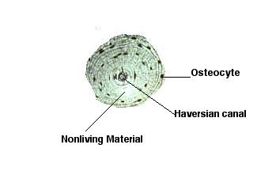

- 5. Cartilage : Cells (chondrocytes) forms hard but flexible matrix. Functions to provide strong but flexible structural support.
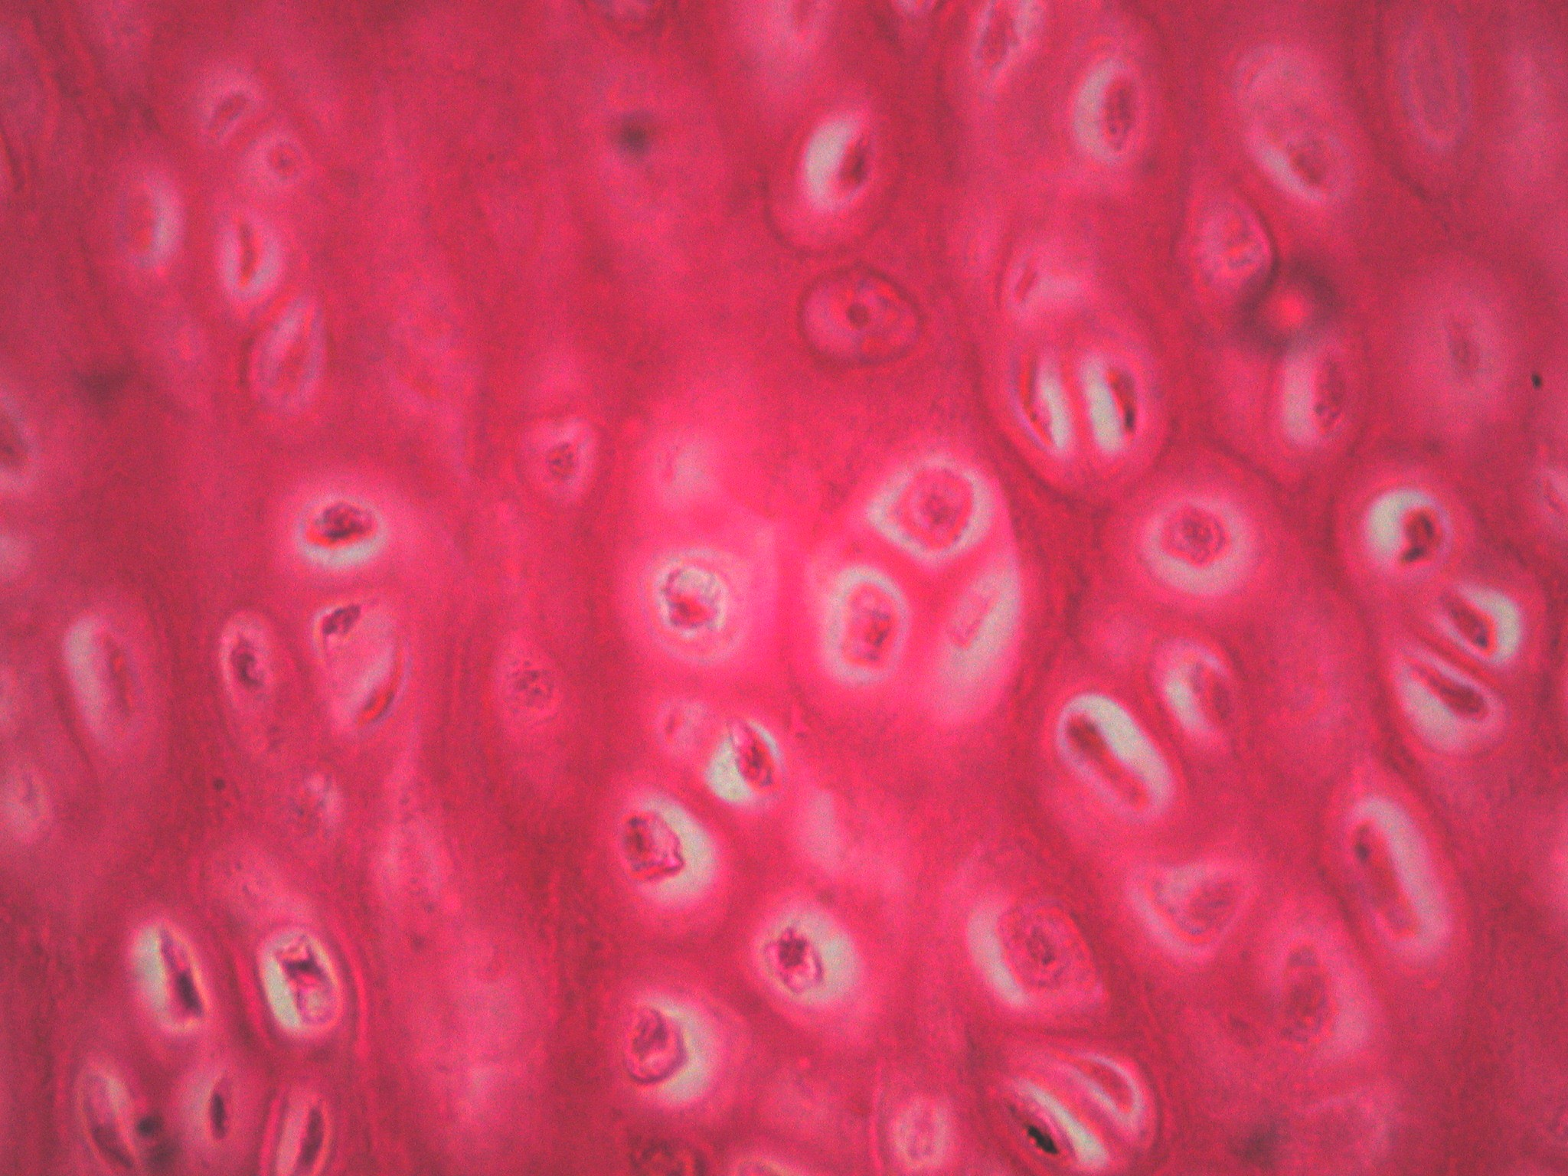

- 6. Blood : Red (erythrocytes) and white (leukocytes) surrounded by a liquid matrix (plasma). Functions in the transport of molecules to and away from other tissues.
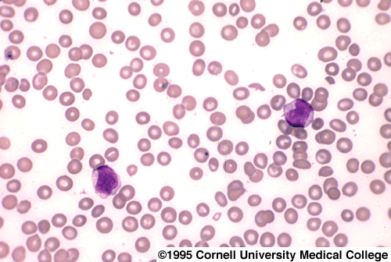

- 7. Hemopoietic : Blood-cell and lymphatic-cell producing cells densely arranged in a liquid matrix. Found in red marrow cavities, and organs such as spleen, tonsils and lymph nodes. Functions in the production of the cells.


