Other Tissues : Practice Test

- Which of the following is NOT a type of connective tissue?
- Adipose
- Blood
- Bone
- Cartilage
- Muscle

- The diagram below illustrates which connective tissue?
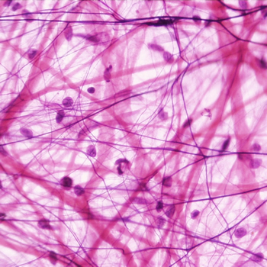
- Fat
- Striated Muscle
- Areolar
- Blood
- Cartilage

- The entire structure shown below is known as a…
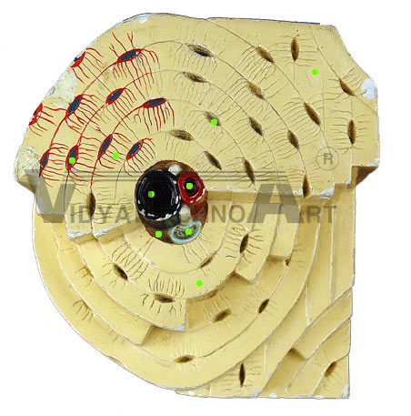
- Osteon
- Osteocyte
- Chondrocyte
- Lacuna
- Canaliculi

- Hemopoeitic tissue is found most abundantly …
- In blood vessels
- In cartilage
- In nervous tissue
- Inside bone cavities
- In most epithelial tissues.

- The material found between the cells of a connective tissue is known as…
- Matrix
- Marrow
- Medium
- Cytoplasm
- Cytosol

- The tissue below is best classified as…
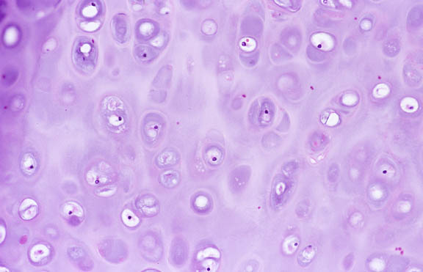
- A connective tissue called blood
- A connective tissue called cartilage
- A connective tissue called fat
- A connective tissue called muscle
- None of the above are correct

- The intercalated disks shown here are key characteristics associated with..
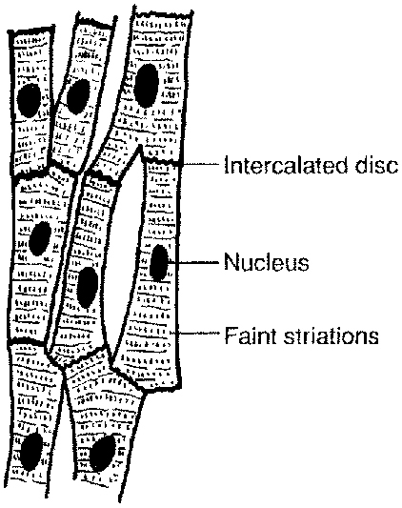
- Smooth muscle
- Nervous tissue
- Skeletal muscle
- Cartilage
- Cardiac muscle

- The diagram below shows what would be best described as:
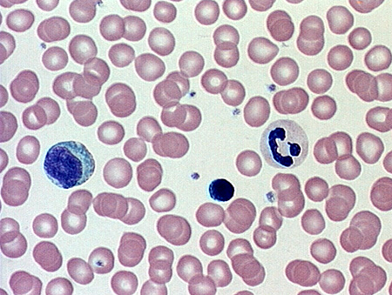
- A connective tissue called blood
- A connective tissue called cartilage
- A connective tissue called adipose
- A connective tissue called areolar
- None of the above are correct

- The cell below is best described as:
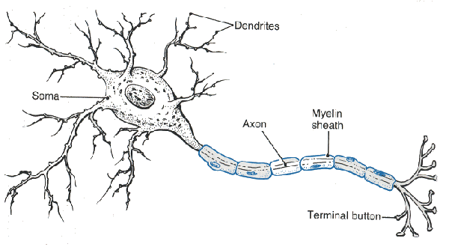
- A cardiac muscle cell
- A smooth muscle cell
- A striated muscle cell
- None of the above
Practice Quiz – KEY

- Which of the following is NOT a type of connective tissue?
- Adipose
- Blood
- Bone
- Cartilage
- Muscle

- The diagram below illustrates which connective tissue?
- Fat
- Striated Muscle
- Areolar
- Blood
- Cartilage

- The entire structure shown below is known as a…
- Osteon
- Osteocyte
- Chondrocyte
- Lacuna
- Canaliculi

- Hemopoeitic tissue is found most abundantly …
- In blood vessels
- In cartilage
- In nervous tissue
- In bone cavities
- In most epithelial tissues.

- The material found between the cells of a connective tissue is known as…
- Matrix
- Marrow
- Medium
- Cytoplasm
- Cytosol

- The tissue below is best classified as…
- A connective tissue called blood
- A connective tissue called cartilage
- A connective tissue called fat
- A connective tissue called muscle
- None of the above are correct

- The intercalated disks shown here are key characteristics associated with..
- Smooth muscle
- Nervous tissue
- Skeletal muscle
- Cartilage
- Cardiac muscle

- The diagram below shows what would be best described as:
- A connective tissue called blood
- A connective tissue called cartilage
- A connective tissue called adipose
- A connective tissue called areolar
- None of the above are correct

- The cell below is best described as:
- A cardiac muscle cell
- A smooth muscle cell
- A striated muscle cell
- None of the above are correct

