Digestive System Intro – Practice Quiz

- Which of the following arrows is pointing at a PRE-MOLAR tooth?
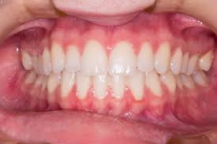
D
C
B
A

- What is the name of the salivary gland that the arrow is pointing to?
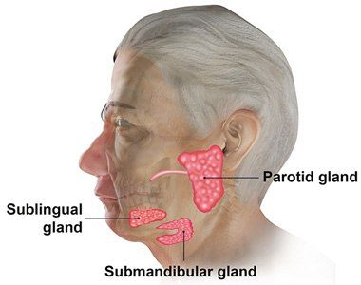
- Which of the following is an example of physical/mechanical digestion?
- Gastric juices in the stomach converting proteins into small peptide chains.
- Salivary amylase breaking starch molecules into maltose molecules
- Molars grinding up a carrot into carrot mush
- Peristaltic contractions in the small intestine that allow pancreatic enzymes to cause triglycerides to change into glycerol and fatty acids

- If you were a French Fry, what structures would you pass by on your way from the mouth to the large intestine?
- Pharynx Esophagus Cardiac Sphincter Stomach Pyloric Sphincter Duodenum of small intestine Large Intestine
- Pharynx Esophagus Pyloric Sphincter Stomach Cardiac Sphincter Duodenum of small intestine Large Intestine
- Esophagus Pharynx Pyloric Sphincter Stomach Cardiac Sphincter Duodenum of small intestine Large Intestine
- Pharynx Esophagus Cardiac Sphincter Duodenum of small intestine Pyloric Sphincter Stomach Large Intestine

- Where would you find the following structures : Plicae, Villi and Microvilli?
- Large Intestine
- Esophagus
- Stomach
- Small Intestine

- Which of the following is an ENDOCRINE Gland?
- Salivary Glands that secrete saliva
- Gastric Glands that secrete gastric juice into the stomach
- Pancreatic Glands that secrete pancreatic juice into the duodenum
- Pancreatic Glands that secrete Insulin into the bloodstream

- Which nutrient group undergoes CHEMICAL digestion in the mouth?
- FATS C) PROTEINS
- CARBOHYDRATES D) NUCLEIC ACIDS

- Identify each lettered structure:
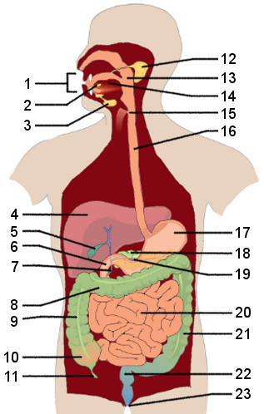
F
G
C
B
D
E
A

- Which nutrient group undergoes CHEMICAL digestion in the Stomach?
- FATS B) PROTEINS
- CARBOHYDRATES D) NUCLEIC ACIDS

- Which of the following is absorbed into a Lacteal?
- Amino Acids
- Hydrochloric Acid
- Glucose
- Glycerol

- Which of the following is NOT associated with the SMALL INTESTINE?
- CILIA
B) PLICAE
C) VILLI
D) DUODENUM
E) MICROVILLI

ANSWER KEY:

- A – Central Incisor
B – Lateral Incisor
C – Canine
D – Premolar

- The arrow is pointing to the SUBMANDIBULAR SALIVARY GLAND – it is always lower and further back (posterior) than the Sublingual Salivary Gland

- Which of the following is an example of physical/mechanical digestion?
- Gastric juices in the stomach converting proteins into small peptide chains. - Chemical
- Salivary amylase breaking starch molecules into maltose molecules - Chemical
- Molars grinding up a carrot into carrot mush - Physical
- Peristaltic contractions in the small intestine that allow pancreatic enzymes to cause triglycerides to change into glycerol and fatty acids – Chemical

- If you were a French Fry, what structures would you pass by on your way from the mouth to the large intestine?
- Pharynx Esophagus Cardiac Sphincter Stomach Pyloric Sphincter Duodenum of small intestine Large Intestine
- Pharynx Esophagus Pyloric Sphincter Stomach Cardiac Sphincter Duodenum of small intestine Large Intestine
- Esophagus Pharynx Pyloric Sphincter Stomach Cardiac Sphincter Duodenum of small intestine Large Intestine
- Pharynx Esophagus Cardiac Sphincter Duodenum of small intestine Pyloric Sphincter Stomach Large Intestine

- Where would you find the following structures : Plicae, Villi and Microvilli?
- Large Intestine
- Esophagus
- Stomach
- Small Intestine – all structure to increase surface area for absorption of nutrients

- Which of the following is an ENDOCRINE Gland?
- Salivary Gland that secretes saliva - Exocrine
- Gastric Glands that secrete gastric juice into the stomach - Exocrine
- Pancreatic Glands that secrete pancreatic juice into the duodenum - Exocrine
- Pancreatic Glands that secrete Insulin into the bloodstream - ENDOCRINE

- Which nutrient group undergoes CHEMICAL digestion in the mouth?
- FATS C) PROTEINS
- CARBOHYDRATES D) NUCLEIC ACIDS

- A- Submandibular Salivary Gland
B – Epiglottis
C – Esophagus
D – Pyloric Sphincter
E – Pancreas
F – Small Intestine
G – Rectum

- Which nutrient group undergoes CHEMICAL digestion in the Stomach?
- FATS C) PROTEINS
- CARBOHYDRATES D) NUCLEIC ACIDS

- Which of the following is Absorbed by a LACTEAL?
- Amino Acids
- Hydrochloric Acid
- Glucose
- Glycerol

- Which of the following is NOT associated with the SMALL INTESTINE?
- CILIA
B) PLICAE
C) VILLI
D) DUODENUM
E) MICROVILLI

