DNA PRACTICE QUIZ
- Which description most scientifically describes the SHAPE of DNA?
- An alpha helix
- A double helix
- A nuclear histone
- A helical monomer

- Which of the following is NOT a nitrogenous base found in DNA?
- Uracil
- Adenine
- Guanine
- Cytosine
- Thymine

- How many chromosomes of DNA are typically found in a SINGLE healthy body cell when it is getting ready for division?
- 23
- Billions
- 46
- 102
- Chromosomes are never found in cells
- What most accurately describes the way that DNA nitrogenous bases pair up (Complementary Base Pairing)?
- Adenine to Guanine with 3 H-Bonds, while Cytosine bonds to Thymine with 2 H-bonds.
- Adenine to Guanine with 2 H-Bonds, while Cytosine bonds to Thymine with 3 H-bonds.
- Adenine to Thymine with 3 H-Bonds, while Cytosine bonds to Guanine with 2 H-bonds.
- Adenine to Thymine with 2 H-Bonds, while Cytosine bonds to Guanine with 3 H-bonds.

- A section of a chromosome that codes for a particular protein is known as….
- A codon
- A chromatin
- A gene
- A nucleotide

- The molecule below is called…
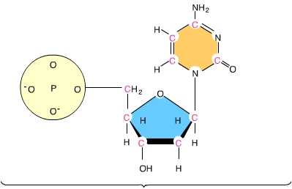
- A Gene
- A Histone
- A Nucleic Acid
- A Nitrogenous Base
- A Nucleotide

- Which of the following is a PURINE?
A) Cytosine C) Thymine
B) Adenine D) Uracil

- In the diagram below, indicate what nitrogenous base each letter represents. (scroll down to bottom of diagram
X = _____________
Y = _____________
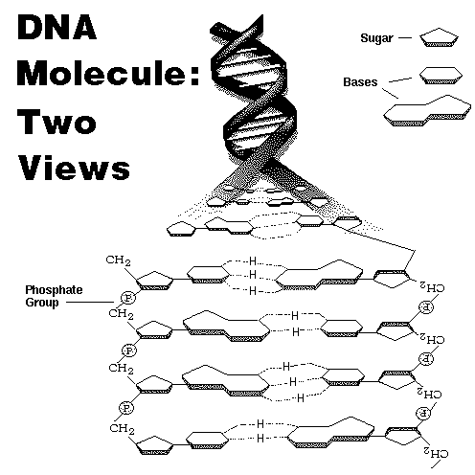
X
Y
- If one strand of a DNA molecule had the following sequence : A C G G G C A TG

- What would it's complementary strand sequence have for bases and how many total H-bonds would form between these two strands?
- Every three nitrogenous bases on a gene is a triplet of bases that codes for a particular amino acid. What are these triplets called?
A) Exons
B) Codons
C) Variables
D) Nucleotides

Keep scrolling for answer KEY

ANSWER KEY
- Which description most scientifically describes the SHAPE of DNA?
- An alpha helix
- A double helix
- A nuclear histone
- A helical monomer

- Which of the following is NOT a nitrogenous base found in DNA? (Any Geek Can Teach)
- Uracil
- Adenine
- Guanine
- Cytosine
- Thymine

- How many chromosomes of DNA are typically found in a SINGLE healthy body cell when it is ready for division?
- 23
- Billions
- 46
- 102
- Chromosomes are never found in cells

- What most accurately describes the way that DNA nitrogenous bases pair up (Complementary Base Pairing)?
- Adenine to Guanine with 3 H-Bonds, while Cytosine bonds to Thymine with 2 H-bonds.
- Adenine to Guanine with 2 H-Bonds, while Cytosine bonds to Thymine with 3 H-bonds.
- Adenine to Thymine with 3 H-Bonds, while Cytosine bonds to Guanine with 2 H-bonds.
- Adenine to Thymine with 2 H-Bonds, while Cytosine bonds to Guanine with 3 H-bonds.

- A section of a chromosome that codes for a particular protein is known as….
- A codon
- A chromatin
- A gene
- A nucleotide

- The molecule below is called…
- A Gene
- A Histone
- A Nucleic Acid
- A Nitrogenous Base
- A Nucleotide ……(Phosphate, Sugar Base)

- Which of the following is a PURINE? ("Any Geek…. My first two words have two rings… Adenine and Guanine are my Purines. Cytosine, Thymine are Pyrimidines – Big name with a Y in it is the group/category name for the little single-ringed bases.)
A) Cytosine C) Thymine
B) Adenine D) Uracil (RNA pyrimidine)

- In the diagram below, indicate what nitrogenous base each letter represents. (scroll down to bottom of diagram
X = _____________
Y = _____________
Y
X
X = "C to G with Three, and it is a double-ringed purine, which can only be A or G. So it must be GUANINE with 3 H-Bonds

Y = "TATOO" – T to A with Two H-Bonds. It is also a double-ringed purine, either A or G, so it must be ADENINE, as it has two H- Bonds

- If one strand of a DNA molecule had the following sequence : A C G G G C A T G
- What would it's complementary strand sequence have for bases and how many total H-bonds would form between these two strands?
Strand A Strand B
A = T
C = G
G = C
G = C
G = C
C = G
A = T
T = A
G = C
- And the total number of H-Bonds between all of the bases is 24

- Every three nitrogenous bases on a gene is a triplet of bases that codes for a particular amino acid. What are these triplets called?
A) Exons
B) Codons
C) Variables
D) Nucleotides

