ENZYME MATCHING CHALLENGE
NAME: ________________________________Block: ______

ENZYME | SOURCE and Optimal pH | SUBSTRATE | PRODUCT | REACTION
LIPASES
PEPSIN
SALIVARY
AMYLASE
(Ptyalin)
TRYPSIN
ENZYME | SOURCE and Optimal pH | SUBSTRATE | PRODUCT | REACTION
MALTASE
NUCLEASES

PEPTIDASES
NUCLEOSIDASES
PANCREATIC
AMYLASE

Source and Optimal pH

1. | PANCREAS  pH =  7.5 8.5
2 | STOMACH  (Gastric Glands)  pH =  2 3
3 | PANCREAS  pH =  7.5 8.5
4 | DUODENUM  pH =  7.5 8.5
5 | Sublingual/  Parotid/  Submandibular  pH = 7
6 | PANCREAS  pH =  7.5 8.5
7 | DUODENUM  pH =  7.5 8.5
8 | PANCREAS  pH =  7.5 8.5
9 | DUODENUM  pH =  7.5 8.5

SUBSTRATE

1. | SMALL  PEPTIDE  CHAINS
2 | NUCLEOTIDES
3 | DNA/RNA  (Nucleic Acids)
4 | PROTEINS
5 | MALTOSE
6 | STARCH
7 | TRIGLYCERIDES  (FATS)
8 | STARCH
9 | PROTEINS

PRODUCT

1. | AMINO  ACIDS
2 | NUCLEOTIDES
3 | PHOSPHATE,  PENTOSE SUGAR &  NITROGENOUS  BASE
4 | SMALL  PEPTIDE  CHAINS
5 | GLUCOSE  Molecules
6 | SMALL  PEPTIDE  CHAINS
7 | MALTOSE
8 | MALTOSE
9 | GLYCEROL  &  FATTY  ACIDS

REACTION IMAGES

1 | 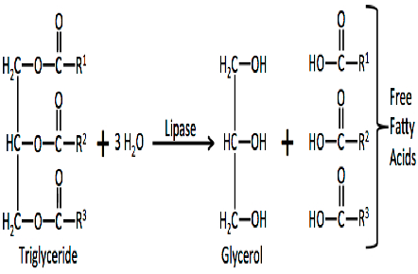
2 | 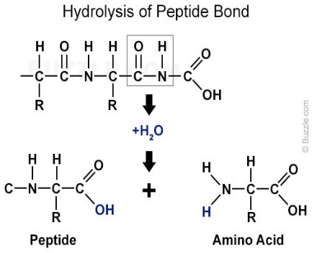
3 | 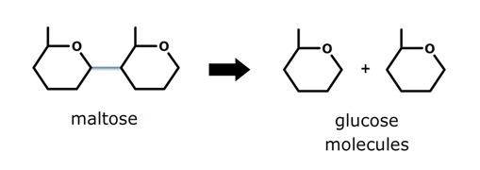
4 | 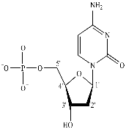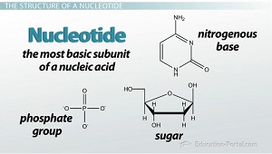
5 | 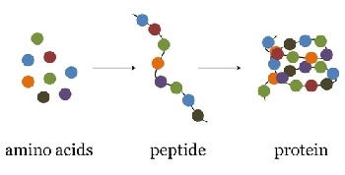
6 | 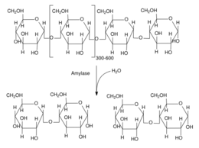
7
8 | 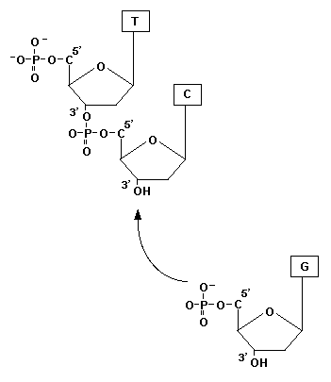
9

