Evolution : Evidence Of Change - KEY

Read pp. 268-274 and 280 - 285
- Define “Evolution” : The process by which modern organisms have descended from ancient organisms.
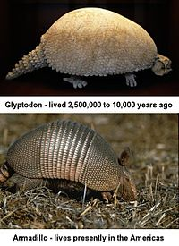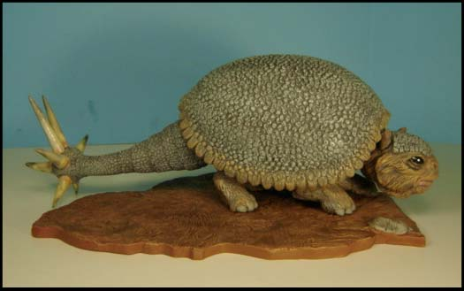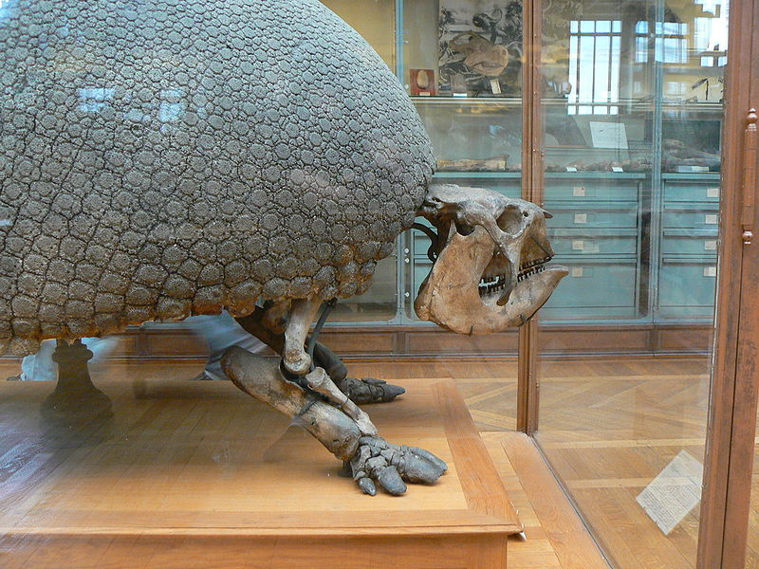
- Complete the following:
- Famous Naturalist: Charles Darwin
- Year he set sail: 1831
- Name of ship: HMS Beagle
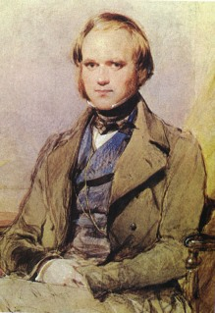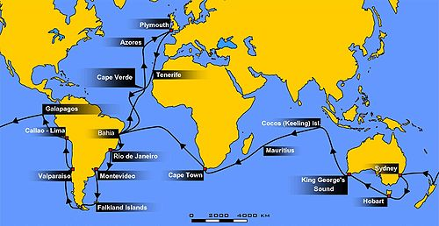
- What is another term for the “great variety of life forms”?
"Diversity of Life"

- Approximately how many different species inhabit earth? 3- 20 million

5. Of all the species that have ever lived
on earth, what percent are now extinct? 99.9%
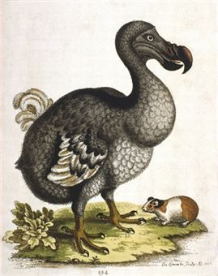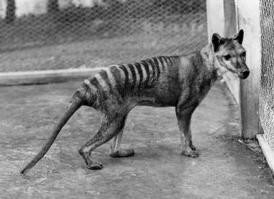
DODO BIRD TASMANIAN WOLF
- What are “physical and behavioural traits of fitness” (also known as structural, behavioural, and physiological adaptations). Describe the behavioural adaptation that a cuckoo bird (Spider in Newer Edition) uses? Certain structures, behaviours that a species uses to help it survive. Example, the spider places its egg sack on leaves to increase their chance of survival.
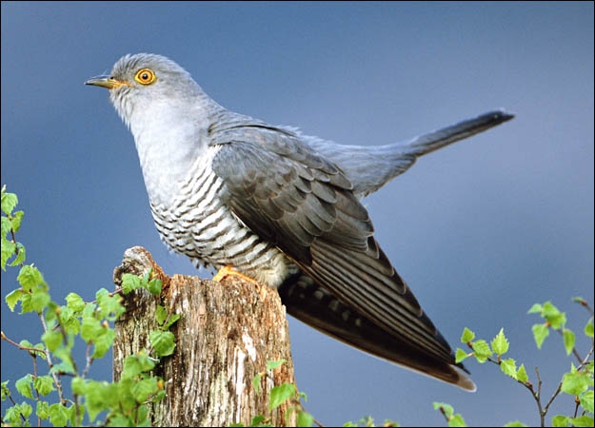
1. CUCKOO BIRD - Another interesting example of Behavioural Adaptation
This is truly the mother of all cheaters — the female cuckoo bird will not only raid the nest of her warbler neighbor to steal eggs, she then leaves her own eggs behind to replace what she just ransacked. In a true testament of nature vs. nurture, despite being abandoned, the baby cuckoo bird is just as much of a con artist as its birth mother. Thanks to incubating an egg similar in appearance to the other warbler eggs, the baby cuckoo bird blends among the other chicks and is therefore treated and fed like one of the family.
- Describe Darwin’s “Principle of Common Descent”
The idea that all species have shared or common ancestors and have descended from these common ancestors. See some examples below.
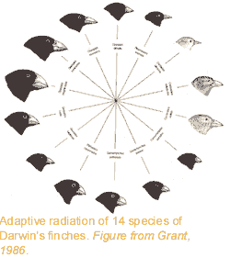
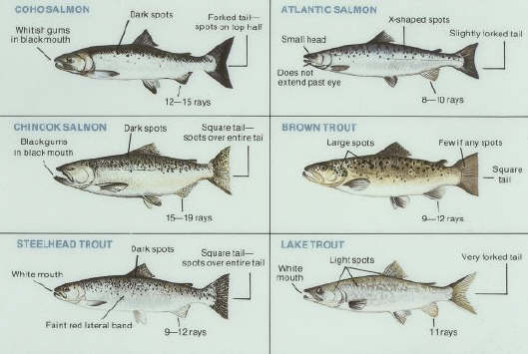

8. What is the definition of an “Adaptation”
Changes to structures, behavior or physiological processes that increase survival of an organism/species.

- Give the structural adaptation for each:

- Giraffe: Long neck and long legs – help them with obtaining food and competing for a female.
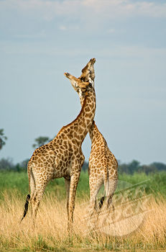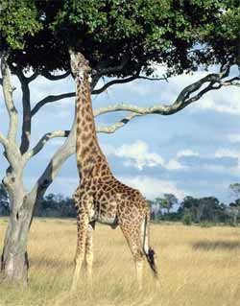

b) Sphinx Moth: Long feeding tube.
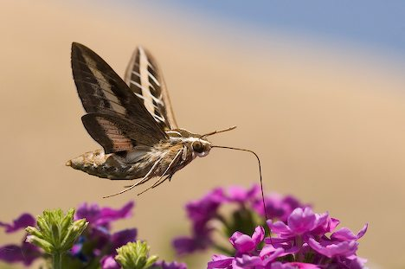
c) Vampire Bat: Razor sharp teeth to obtain blood.
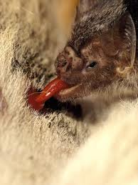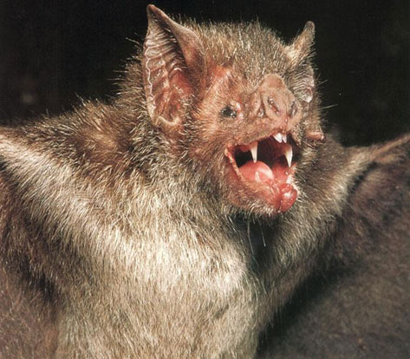
- Geological evidence has allowed scientist to estimate how old the earth is, which is estimated to be: More than 4 billion years old.
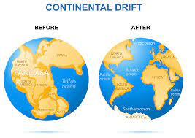
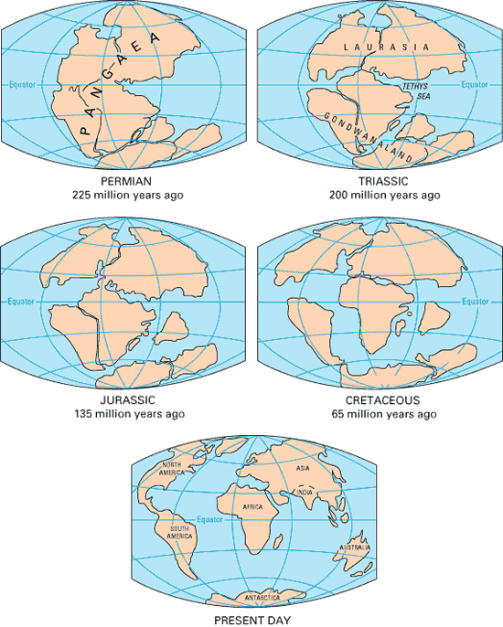
- Describe the process of “Relative Dating”
The technique used to determine fossil age relative to other fossils found in older layers of rock deposits.
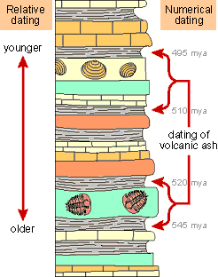

280-285
12. Over what length of period does the fossil
record for the evolutionary line for horses run?
Over 50 million years
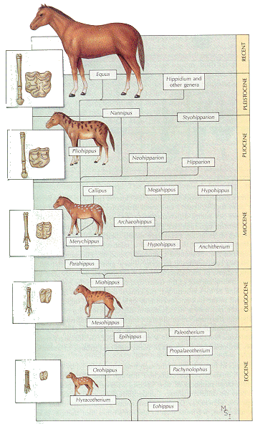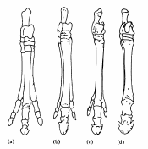
13. What two main adaptations have developed in the horse?
a) Increased size
b) Foot to hoof development

14. When the earth underwent considerable geological change, what happened to the organisms on earth according to the fossil record?
Many of the species of plants and animals die out.

15. The genes that are active in our embryonic development are also active in what other animals?
Pig, Chicken, Fish etc, things with backbones.
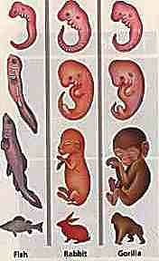
16. What term is used to describe the event that
results in a change to a species genetic blue print?
MUTATION
Use the text and the Google to define and give examples for each term listed below:

17. Homologous Structures: Parts of different species that are quite often dissimilar, but that have developed from the same ancestral body parts. Ex: Dolphin Flipper, Bats wing and Dog Leg
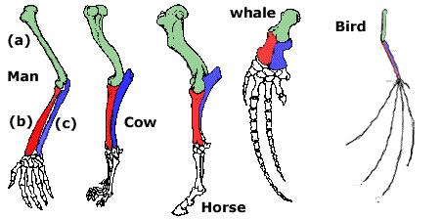
18. Vestigial Organs: Structures that serve no useful purpose or function in the present time, but likely served a purpose in their ancestral form.
Ex. Snake hips and claws
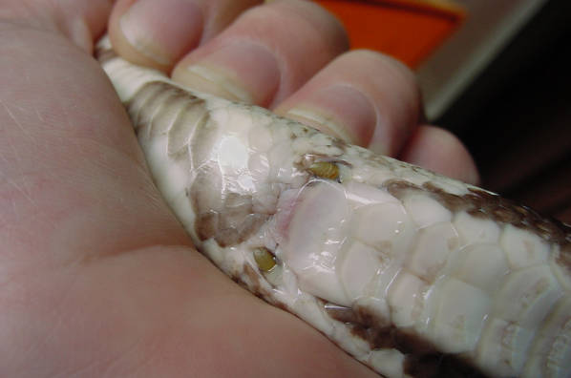
Eyes in a blind cave fish
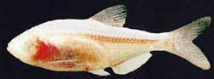

Human appendix- No longer serves much purpose – may help repopulate gut bacteria after very bad gut issues take place
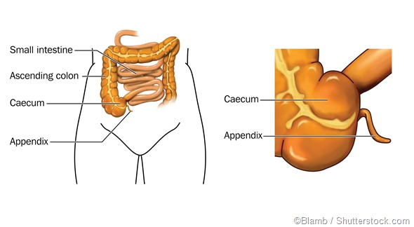
19. List some biochemical homologies seen in the cells of eukaryotic organisms:
Almost all organisms use the following biochemical: DNA, RNA, Proteins, ATP, Similar Enzymes.

