Factors Affecting Enzyme Productivity

- SUBSTRATE CONCENTRATION:

Increase

Substrate Conc.

= Substrate = Enzyme

* Enzyme productivity will increase as more substrates are added, but at a certain point. Productivity (Turnover rate) will plateau. This occurs as active sites become saturated with substrate, so that as fast as they kick out a product, they pick up another substrate.

Enzyme
Productivity

(Low) Substrate Concentration (High)

- The only way to increase enzyme productivity at this plateau point, is to add more enzymes.

- TEMPERATURE

- As temperature is increased (0ºC 40ºC) the substrates gain more Kinetic Energy. As their kinetic energy goes up, they have a far greater chance of making contact with the active site.
- However, as the temperature continues to increase the increase in kinetic energy of the actual enzyme (protein) gets so high that some of the key structural bonds (especially H-bonds) that give the enzyme its proper shape begin to break apart. As the enzyme undergoes denaturation the active site is destroyed and it is unable to properly accommodate the given substrate. (40 ºC 100 ºC)

-"Optimal Temperature" = 37ºC

Enzyme
Productivity

5ºC 20 ºC 40ºC 60ºC 80ºC
(Low) Increasing Temperature (High)

- pH

-A change in pH can also affect enzyme productivity.
- If the concentration of H+ ions gets too high (acidic environment, drop in pH) or as the concentration of OH⁻ ions gets too high (basic environment, raise to pH), the ionization around the amino acid R-Group bonds and around the weak H-Bonds interferes with these bonds to make them break apart. This causes Denaturation of the protein.
- Example: Sour Milk as bacteria put out acid the pH goes down and as more H+ ions are present, the Casein and Whey proteins change shape and can no longer stay soluble in the water milk. The proteins clump/coagulate together and form "curds" in what is now the curdled milk.
- As a result the tertiary structure of the protein will not hold up and it begins to unfold.
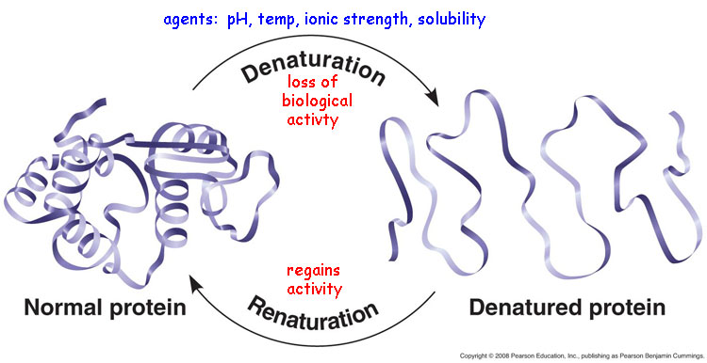

- So again, enzymes will have what is called an "Optimal pH", this is the specific pH at which they are most productive (highest turnover rate).
- Example : Pepsin enzyme in the stomach works best at a pH of 2, but most bodily enzymes like a pH around 7.4 – Slightly Alkali (basic).
"Optimal pH" = 7.4

Enzyme
Productivity

0 1 2 3 4 5 6 7 8 9 10 11 12 13 14
(Low) pH (High)
ACIDIC NEUTRAL BASIC (alkali)

- INHIBITORS

- Competitive Inhibitors – A molecule other than the substrate, but similar in shape and size to the specific substrate, competes for the Active Site.
- As this other molecule joins onto the active site, it blocks the actual substrate from entering the active site.
- Sometime this competitive inhibitor is reversible and will leave the active site, other times it will be irreversible and completely shut down the enzyme.
Competitive Inhibitor
Added into system
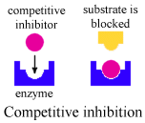 TIME

Enzyme
Productivity

Example: Carbon Monoxide (CO) is a competitive inhibitor for one of the key enzymes that runs cellular respiration. The normal substrate is Oxygen (O₂) not Carbon Monoxide. Every hear of Carbon Monoxide Poisoning, yeah, it can KILL YOU!

Sometimes this can be overcome by adding in more substrate, the extra substrate will have a higher concentration than the competitive inhibitor. As a result the intended substrate will have a better chance than the competitive inhibitor of getting into any unoccupied active sites.
Example : Treatment of carbon monoxide poisoning largely consists of administering 100% oxygen and even providing hyperbaric (Gas Pressure Chamber) therapy.
b) Non-Competitive Inhibitors:
- In this case a molecule binds onto an enzyme at a site other than the Active Site. This other binding area is often referred to as an "Allosteric Site". When this non-competitive inhibitor binds onto the protein at that allosteric site, the protein changes shape. As the enzyme (protein) changes shape, the active site's shape undergoes a change of shape. As a result, the active site is no longer able to accommodate the specific substrate. So enzyme productivity goes down.
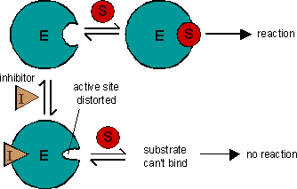

- In the diagram above, the inhibitor is classified as being a non-competitive inhibitor as it does NOT compete with the substrate for the actual active site.

Heavy metal poisoning
You are probably aware that compounds containing heavy metals such as lead, mercury, copper or silver are poisonous. This is because ions of these metals are non-competitive inhibitors for several enzymes.

