Fats And Proteins Review – KEY

- 9.3 Kcal/g = 9.3 Cal/gram

- Vitamins A, D, E and K. (ADEK, DEAK)

- Type of Fat Source Good/Bad

Monounsaturated Vegetables very GOOD
Plant oils

Saturated Fats Animals BAD
A few plants

Essential Fish Oils GOOD
Fatty Acids Some seed
(ex Omega 3) oils (flax)

Polyunsaturated Vegetables Very GOOD
Plants, Corn
Soy, Fish

- 10% or less

- Some of the double bonds are broken apart and the fatty acid straightens out to become more saturated.
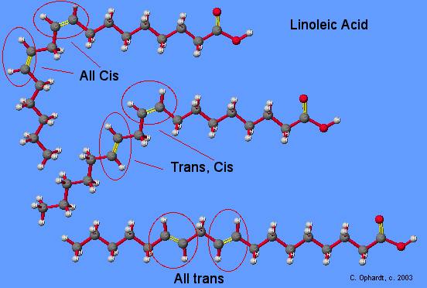
- Melting point goes up.

- 30%

- Cis vs Trans:
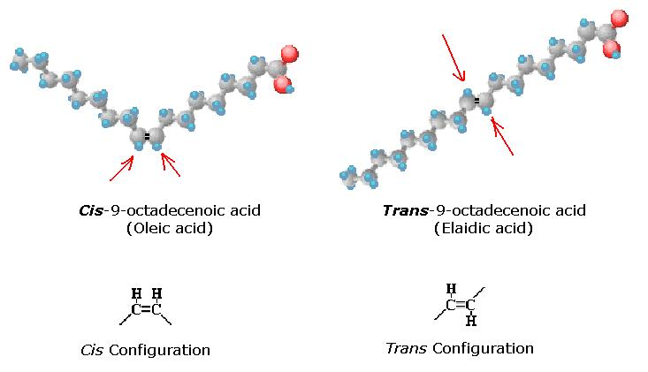
- Melting point also goes up, to give a more solid texture.

- HDL = High density lipoprotein – Good Cholesterol. Mops up loose blood cholesterol and takes it back to liver to excrete it.

LDL = Low density lipoprotein – Bad. Leaks cholesterol into the blood stream and forms cholesterol deposits called plaques.
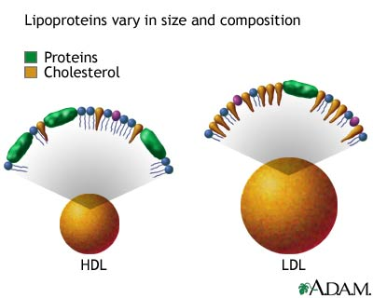

PROTEINS:

- 4.1 Kcal/gram = 4.1 Cal/gram

- Amino Acids.

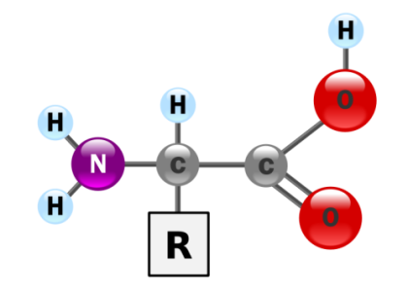
- There are 22 – most textbooks will state the standard - 20.

- A) Essential Amino Acids

B) Non-essential Amino Acids

15. 10-15%

16. Cellular Metabolism switches to burn proteins.

17.
A) Dehydration
- B) Ketosis – Overproduction of Ketones (Headache, Dizziness, Weakness, Fatigue, Constipation, Halitosis, Foul Smelling Urine)
C) Calcium loss Osteoporosis.
D) Inadequate fuel for muscle work and repair.
E) Gout – Build up of uric acid crystals.

18. Yes, by combining incomplete protein foods.

19. Complete Protein.

