Final Exam Review #3 KEY
QUESTIONS – Part A

- C – Gastrin is a hormone released from gastric endocrine glands that goes through the bloodstream to turn on exocrine gastric glands that will release gastric juice into the stomach. All the others are digestive enzymes. Ptyalin = Salivary Amylase.

- B – A massive amount of active transport is required to absorb 100% of the nutrients travelling across the intestinal cells.

- A – The liver produces bile, but bile is stored in the gallbladder.

- B – Normal strains of E-coli take up residence in the large intestine.

- C – Trypsin is just like Pepsin. They both break proteins into shorter peptide chains.

- D

- A – In the mouth "Salivary Amylase" AKA Ptyalin will break starch into maltose molecules.

- D – It contatins Lipase for fats, Trypsin for Proteins, and Pancreatic Amylase for Starch.

- B – Lacteals are special lymph vessels found inside intestinal villi that absorb the products of fat digestion.

- C – The small intestine consists of the duodenum, jejenum then the ileum.

SHORT ANSWERS – PART A
11.
A- Stomach – To store larger quantities of food and start the chemical digestion of protein.
B) Pancreas – To release pancreatic juice which helps neutralize acidic chime as well as provide numerous enzymes for further chemical digestion.
C) Gall Bladder – To store and release bile which emulsifies fat globules into fat droplets.
D) Esophagus – To use peristalsis to move food from mouth to the stomach.
E) Duodenum – To receive acidic chime from stomach, bile from gall bladder/liver, pancreatic juice from pancreas. It also produces and releases peptidases and nucleosidases.

12.Physical/Mechanical digestion involves breaking food down into smaller particles without changing any molecules. Examples include Churning food in stomach, chewing food in mouth.
Chemical digestion involves using enzymes to hydrolyse large molecules into smaller more absorbable monomers.

13. Bile is not an enzyme because it does not chemically change fat. It only spreads the fats out into smaller droplets to create more surface area for lipase enzymes.

14. See Table Below:
SUBSTRATE | ENZYME | pH | PRODUCT
Starch | Salivary and Pancreatic Amylase | 7.0 | Maltose Molecules
Maltose | Maltase | 7.5 | Glucose Molecules
Lipids (Triglycerides) | Lipase | 7.5 | Fatty Acids and Glycerol
Proteins | Pepsin and  Trypsin | 2.5 for Pepsin  7.5 for Trypsin | Shorter Peptide Chains
Peptide Chains | Peptidase | 7.5 | Amino Acids
Nucleic Acids | Nuclease | 7.5 | Nucleotides
Nucleotides | Nucleosidases | 7.5 | Phospate, Sugar and Base

15. See Table Above

16. See villus structure below – Lacteal absorbs products of fat digestion. Capillary bed absorbs most other nutrient molecules. Microvilli increase surface are for absorption.
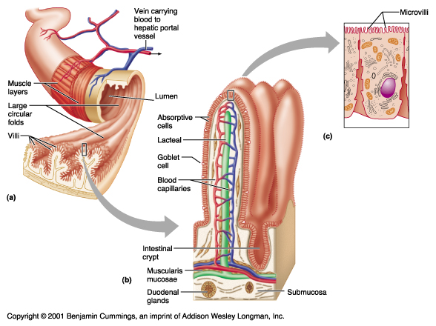

17. A) Production of Urea from ammonia to detoxify the blood
B) Produce Bile to help digestive system
C) Produce many plasma proteins to help with bloods ability to transport and clot
D) Produce cholesterol to help provide sterol lipids to cells for membranes or to act as a precursor for many sterol hormones.
E) Stores fat soluble vitamins such as ADEK
F) Works with the pancreatic hormones Insulin and Glucagon to help the body maintain proper blood sugar levels.
G) Contains many detoxifying enzymes to help break down poisons such as alcohol.

18. Insulin is produced and released from the endocrine glands of the pancreas. It directs muscle and liver cells to take up excess glucose and store it as glycogen. Thyroxin is thyroid hormone, it is produced and released from the thyroid gland. When it hits cells, it directs cells to speed up their metabolic reactions such as cellular respiration. The faster cells perform cellular respiration, the more glucose will be consumed by cells.

19. The small intestine is quite long it is very vascular to absorb nutrients and it possess plicae, villi and microvilli to increase surface area for absorption.

20. E-coli along with other normal bacteria found in the large intestine play a role with helping free up minerals and help with the manufacturing of some vitamins as well.

21. Endocrine Glands – Produce and secrete hormones into the blood stream. Example, the thyroid and pituitary glands.
Exocrine Glands – Produce chemicals which are released through ducts into open cavities of the body. Example, the salivary or gastric glands.

QUESTIONS – Part B

- B

- B – Calcium is required to help convert Prothrombin into Thrombin.

- C – Renal vein Inferior Vena Cava Right Atrium Right Ventricle Pulmonary Artery Lungs

- OMIT – Based off of learning outcomes dealing with Blood Typing. Not covered anymore.

- D – Closure of the "Arterial Duct" found between the pulmonary trunk and the aorta will now cause deoxygenated blood to go to lungs and prevent it from mixing with oxygenated blood in aorta.

- D – Hepatic portal vein picks up blood from the small intestine and carries it to the liver. This blood will be rich in nutrients but low in oxygen as the intestinal cells have used much of the oxygen for active transport.

- B – Thrombocytes (platelets) and the proteins Prothrombin and Fibrinogen must b present.

- D – Osmotic pressure at the venule end of capillaries has a stronger pulling power than blood pressure has pushing out.

- D – Biconcave and lacking a nucleus. This shape makes it more flexible and provides it with more surface area for housing more hemoglobin.

- B – Systole is when walls of chambers come together.

- See picture below.
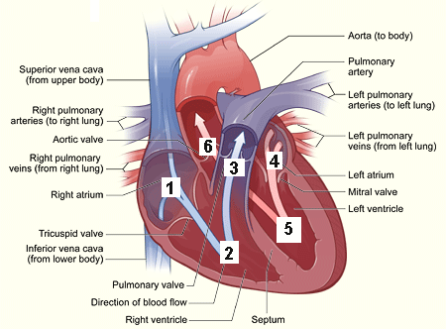

- See picture below:
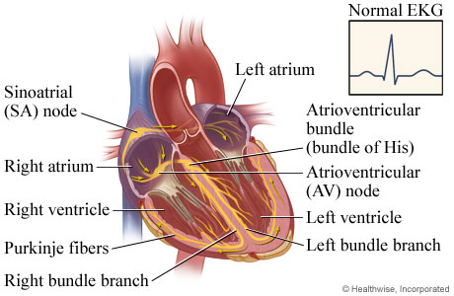

- See picture below:
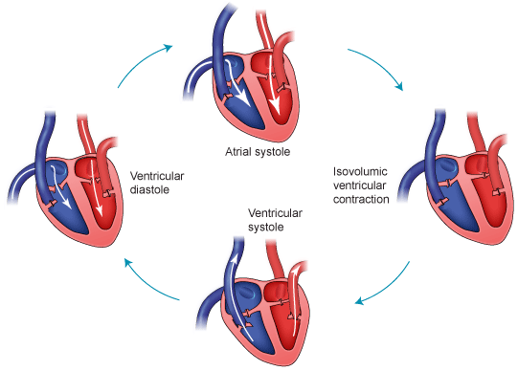
14.
A) Valves are flaps of tissues that shut in order to prevent the backflow of blood.
B) Valves can be found in veins, while semi-lunar valves can be found at the base of the aorta and also at the base of the pulmonary trunk. AV valves can be found in between the right atrium and the right ventricle (Tricuspid AV valve) also between the left atrium and the left ventricle (Bicuspid/Mitral valve).
C) Chordae Tendinae are tendons that reinforce the AV valves to prevent them from collapsing.
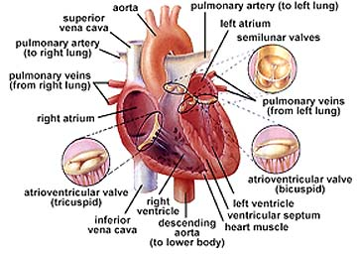
15. A) The brain sends messages from the Medulla Oblongata through the Vagus Nerve to the SA node to help regulate the heart rate. The autonomic nerves will use either the parasympathetic system to maintain a normal heart rate or the sympathetic system to speed it up.

B) The brain can use the autonomic nervous system to control the smooth muscles of arteries to increase or decrease blood pressure.

16. A) If the Foramen Ovale (Oval Opening) between the right and left atria did not close, oxygenated and deoxygenated blood will continue to mix and oxygen levels will be inadequate.
B) Blood would continue to bypass the lungs. This would cause blood oxygen levels to quickly drop.

17. Arterioles have sphincter muscles to open and close capillary beds in the body to help shunt blood to where it is required.
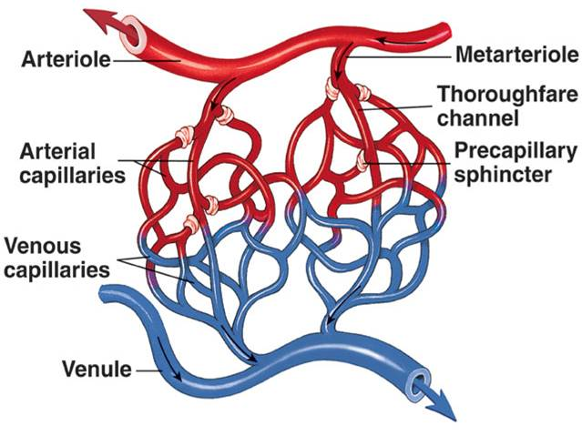
18. The cell would travel via the blood stream along the following pathway:
BRAIN Jugular Vein Right Atrium Right Ventricle Pulmonary Trunk Pulmonary Artery Lungs Pulmonary Veins Left Atrium Left Ventricle Aorta Mesenteric Artery Hepatic Portal Vein LIVER

19. OMIT as Agglutination has to do with Blood Typing – No Longer a required learning outcome.

20. See picture below: On the arterial end of the capillary bed, Blood pressure is much stronger than Osmotic pressure. In the middle of the capillary bed, both pressures are about equal. On the venule side of the capillary bed, osmotic pressure back into the capillary is greater than the blood pressure driving out into the tissue.
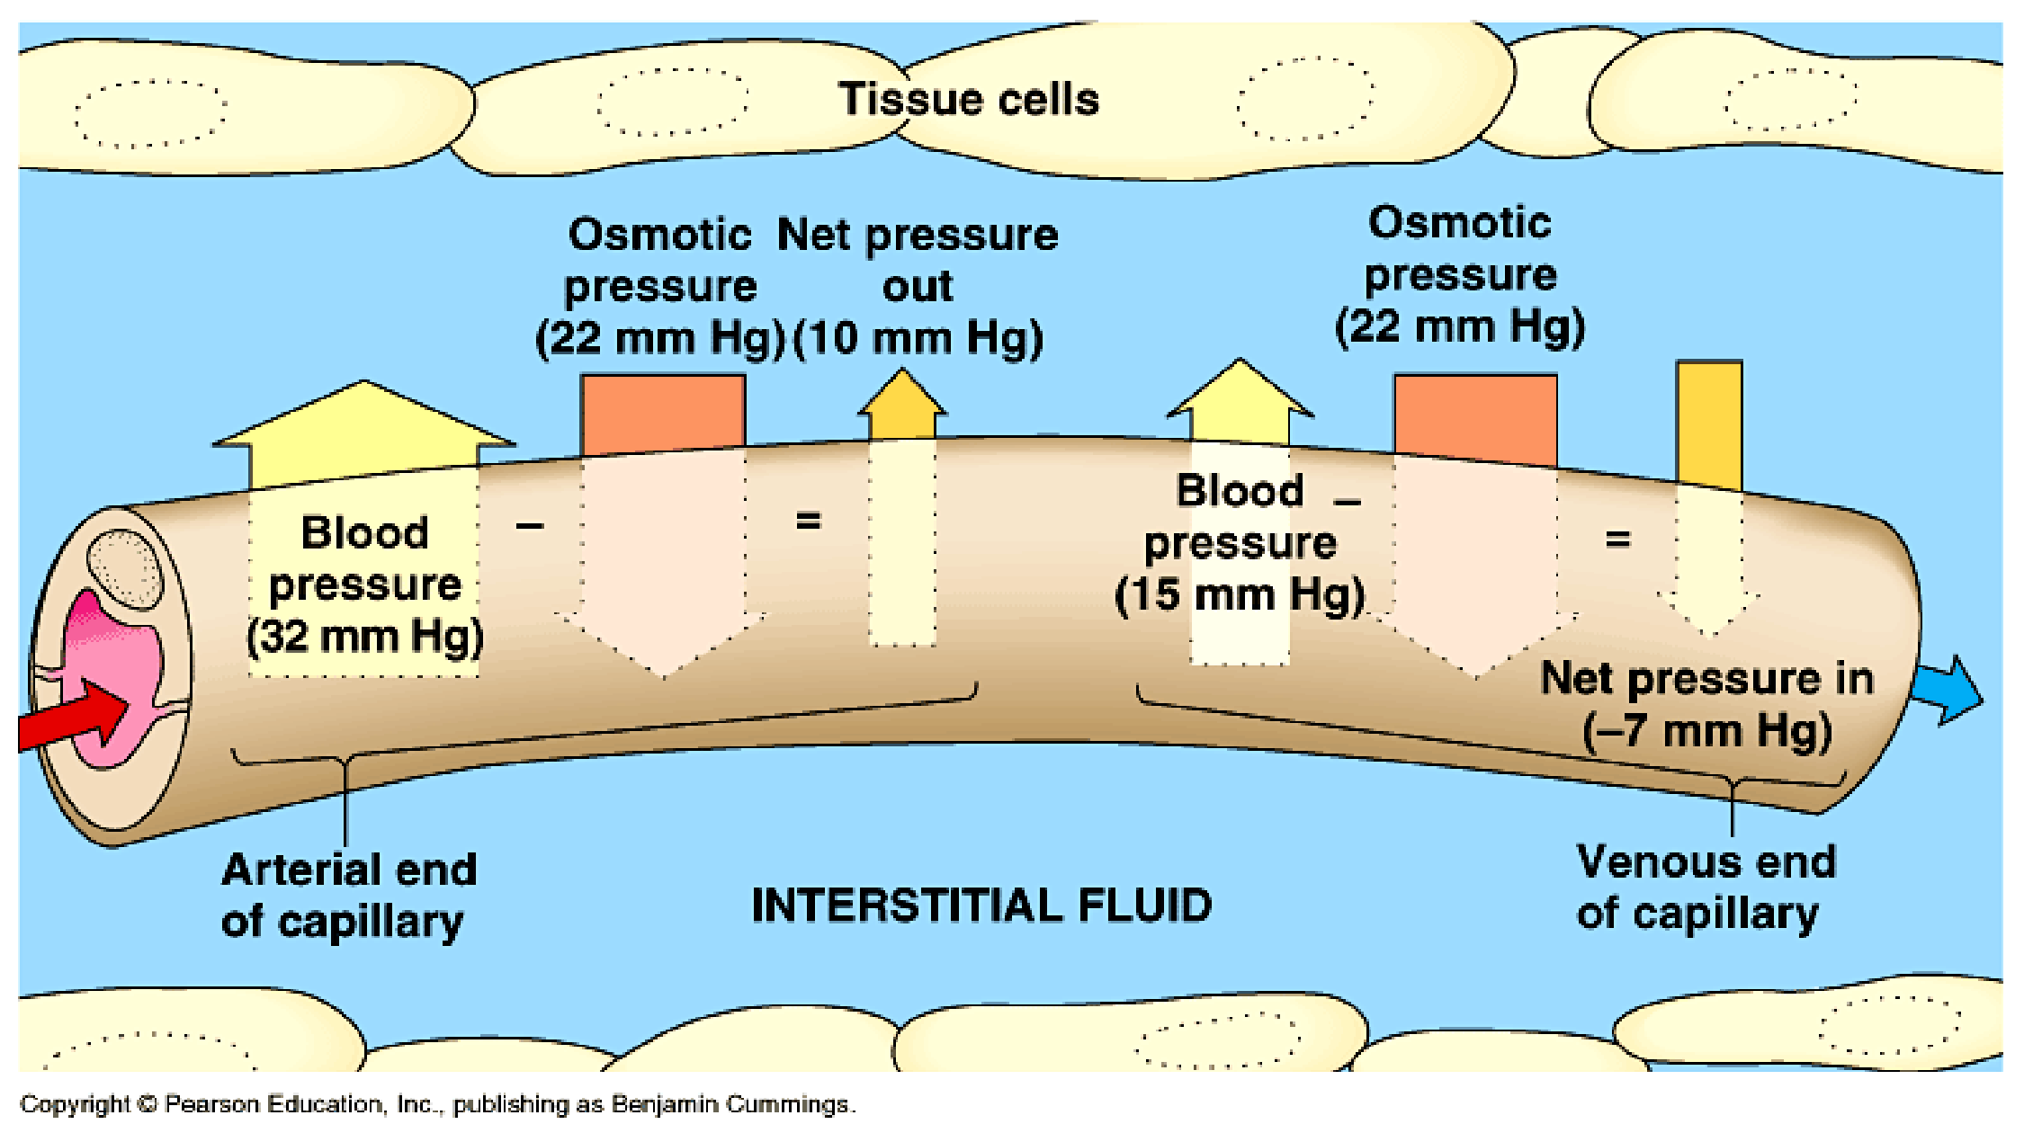
The osmotic pressure is the water drawing affect created from the concentration of blood cells and plasma proteins that stay behind in the capillary. They draw water back in from the tissue fluid.

