Final Exam Review #1 Worksheet KEY

Multiple Choice

Questions – Part A
- C – Water is inorganic

- D – Between the Hydrogen of one molecule and the Oxygen of another water molecule.

- D

- B – High pH is something that might be a pH of 10-14; it will be very basic.

- B – Sounds like stringing glucoses together to make Glycogen.

- B – Glycerol is a backbone to add fatty acids on to build triglycerides

- D – Phospholipid bilayers are the main components of a cell membrane

- A – Neutral fats like diglycerides or triglycerides consist of Glycerol with either Two (di) or Three (tri) fatty acid chains joined on.

- B – A peptide bond forms between the two AA's.

- D – Hydrogen bonds form between the bases of complimentary strands, while Covalent bonds form between Nucleotide units running down each strand.

Short Answer: Part A

- When water molecules form, the Oxygen bonds covalently to Hydrogen. The Oxygen Hogs the electron pairs so that they spend most of their time around Oxygen making that end of the molecule more negatively charged than the Hydrogen side of the same water molecule.
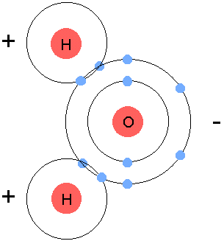
- A) Water is cohesive so the molecules like to stick to each other. When the blood is pumped it is mostly water so the blood plasma flows as a unit to efficiently transport stuff around the body.

B) Water is polar so it is a Universal Solvent. This helps blood and tissue fluid better dissolve materials. These fluids can move stuff more efficiently and chemical reactions can occur more easily in a liquid than in solid form.

C) Water has a very high specific heat capacity. So it can absorb or release vast quantities of energy without seeing a significant change in temperature. This helps us maintain thermoregulation better.

D) Water molecules are cohesive so they have a very high boiling point, so water is a liquid at room temperature. So we can drink it, and we are mostly composed of water so we do not vapourize or over heat.

- Acids release H+ ions and have a pH between 0 6.9
Bases release OH- ions and have a pH between 7.1 14
- When H+ concentration goes up, that means that the pH number is dropping. Example pH from 5 2. Each number drop is a Ten-Fold increase in H+ ions. So from 5 4 3 2 = 1000 times more H+ ions.

- Buffers are chemical that work to resist pH changes. They can either take up extra OH – ions or take up extra H+ ions.
Example : HCO₃⁻ (bicarbonate) can take up extra H ⁺ ions.

HCO₃⁻ + H⁺ H₂CO₃ H₂O + CO₂

- Categories of Organic Molecules:
MONOMERS
- Carbohydrates - Monosaccharides like Glucose
- Proteins - Amino Acids
- Fats – Glycerol and Fatty Acids
- Nucleic Acids – Nucleotides

Functions:
- Carbohydrates - Mostly for energy
- Proteins - Mostly for structure
- Fats – Mostly for storing energy
- Nucleic Acids – For containing genetic blue prints to build proteins

- Hydrolysis is the addition of water to a polymer to break apart the polymer into its monomers.
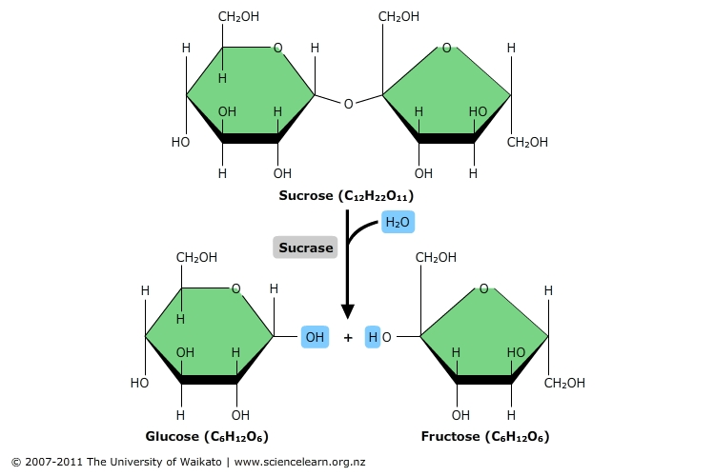

Dehydration Synthesis is the type of reaction that occurs when a "H" atom is taken off of one monomer while an "OH" is taken off of another monomer. So water is formed and a covalent bond forms between the two monomers.
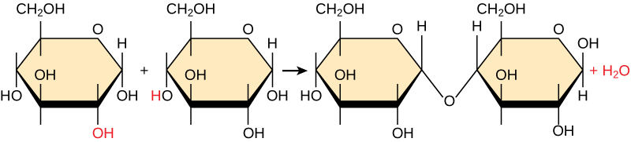

- Monosaccharide – Is a one-unit carbohydrate molecule. Ex GLUCOSE
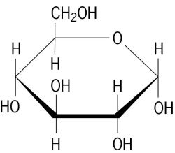
Disaccharide – Is a double-unit carbohydrate molecule. Ex. MALTOSE
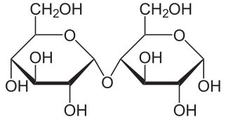
Polysaccharide – Is a many-unit carbohydrate molecule. Ex. GLYCOGEN, STARCH or CELLULOSE.
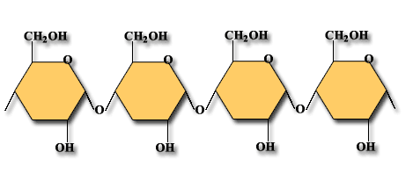

- See Below:
TYPE OF  CARBOHYDRATE | STRUCTURE | FUNCTION
STARCH | Many glucoses joined together with little to no side chains. | Produced by plants as a way to store glucose (energy)
GLYCOGEN | Many glucoses joined together, with many side chains. | Produced by animals in liver and muscle cells as a way to store glucose (energy)
CELLULOSE | Many glucoses joined together. But bonding pattern is unique with one glucose right-side-up and the next upside down. | Produced by plants as a way of building a strong structural molecule. Cellulose is the main components in a plant's cell wall
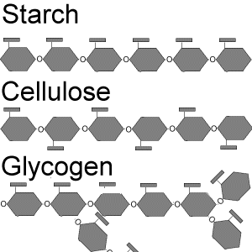

- Fatty Acid Structure: Note that there are less Hydrogens in an unsaturated fatty acid (as double bonds form) than in a Saturated Fatty Acid (no double bonds)
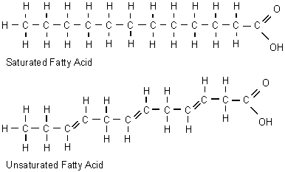
- AMINO ACID Structure:
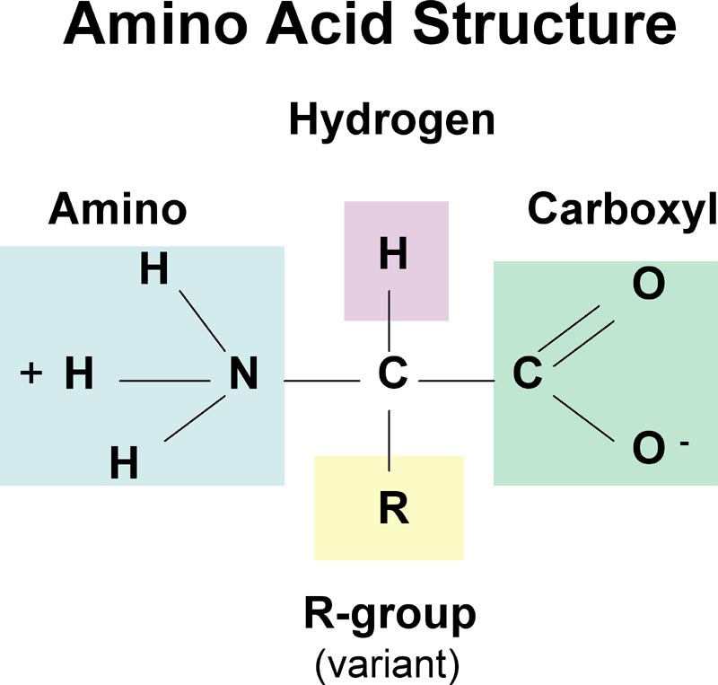
- Levels of Protein Structure Illustrated Below:
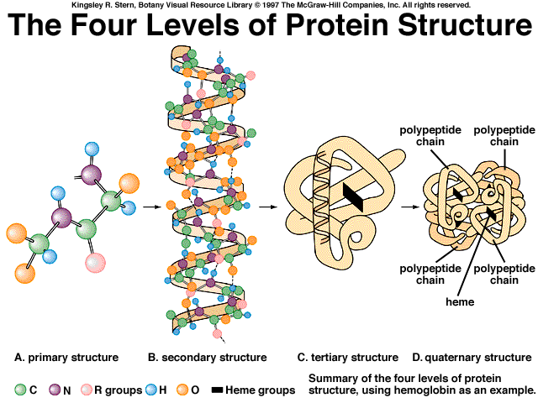
- For Primary Structure – Covalent Peptide bonds hold specific amino acids in their proper place.
- For Secondary Structure – Weak Hydrogen Bonds form Between about every third adjacent amino acid to cause the polypeptide to spiral up taking on an "Alpha Helix Shape"
- For Tertiary Structure – Covalent, Hydrogen and even some Ionic bonds may form between particular R-Groups to cause the polypeptide to fold over on itself to take on a 3-D shape.
- For Quaternary – Two or more separate polypeptides that are already in their own Tertiary Structure will come together.

- DNA vs RNA
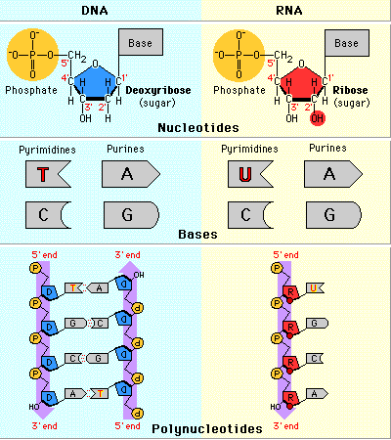
DNA is also Helical (spiral) while RNA is Linear (straight). Also DNA is stuck in Nucleus, while RNA can move out, and it forms three different Types - mRNA, rRNA and tRNA.

- ATP
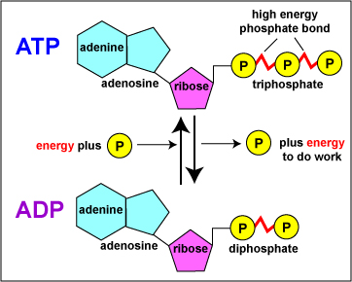

Questions – Part B
- B - Chloroplasts perform photosynthesis, which is the opposite of cellular respiration.

- Smooth Endoplasmic Reticulum – D – Smooth ER produces Sterol Lipids and Stores Detoxifying enzymes. It also blebs off vesicle for transportation.

- A – The nucleolus uses DNA to produce rRNA subunits.

- A – Ribosomes consist of rRNA subunits joined to proteins

- C – They will be more concentrated as they will have already gone to the Golgi Apparatus to be sorted, modified and re-packaged to form vesicles that carry the same type of contents.

- B – Before heading out to membrane, vesicles from smooth and rough ER head to the Golgi.

- B – Lysosomes contain enzymes which are proteins. Proteins are always built during translation of mRNA at a Ribosome.

- C – Polysomes are long chains of Ribosomes, each Ribosome consists of Proteins that mingle with rRNA to form subunits.

- D – Plant cells possess a large central vacuole and a cell wall, both of these structures are absent in Animal Cells.

10. D – Receiving, Modifying and Shipping.

Short Answers: Part B

11. Smooth ER and Rough ER
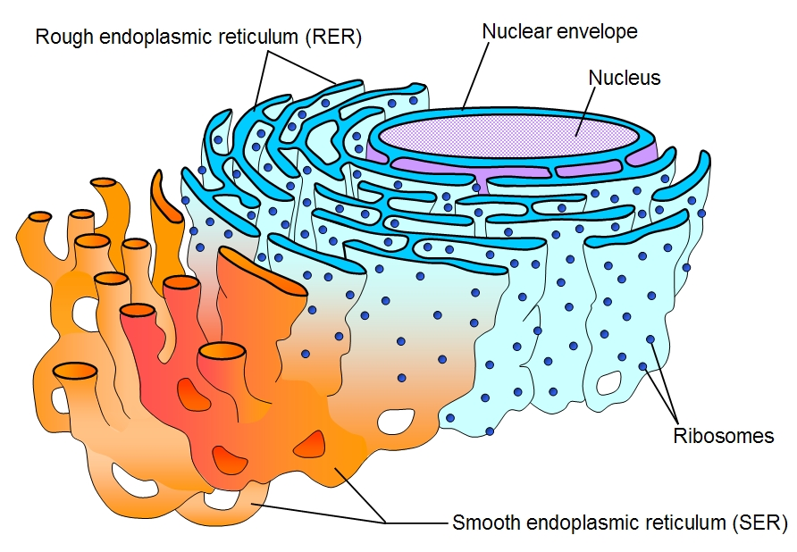
Functionally – Rough ER is all about building Proteins and then transporting them.
Smooth ER is all about synthesizing Sterol Lipids and transportation of synthesized molecules.

12. See above

13. Ribosomes are found out in the cytoplasm fluid along with being attached to the Rough ER.

14. Golgi manufactures Lysosomes (to help digest macromolecules or old worn out cell structures) as well as Secretory Vesicles (to release key substances to the outside of a cell, ex, release of insulin).

15. Cellular Respiration vs. Photosynthesis.
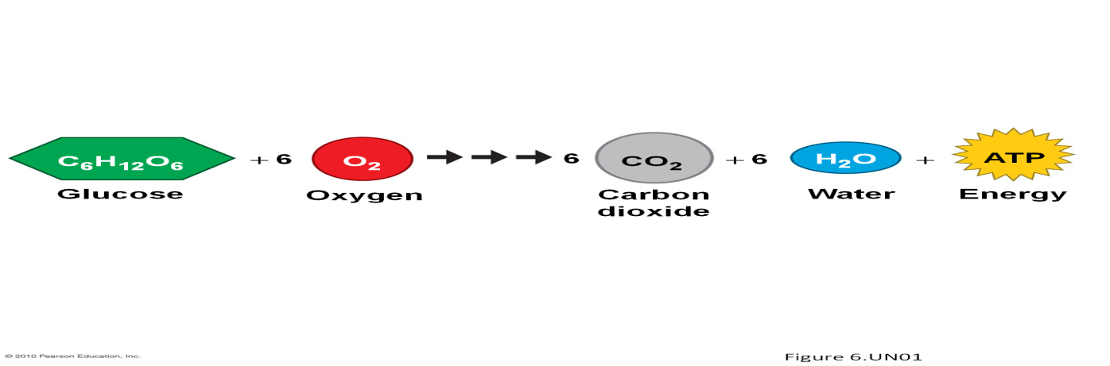
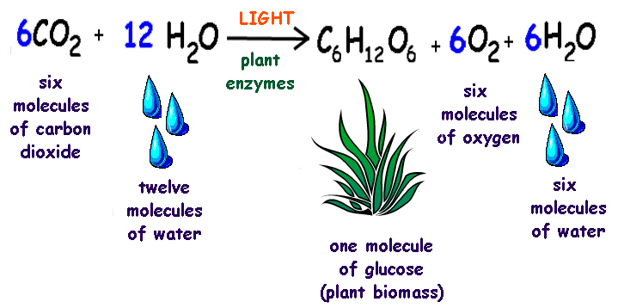

QUESTIONS Part C

Multiple Choice:

- B – using DNA to make more DNA
- C – DNA is used to make mRNA during Transcription

- A – Example : Codon ACU will match up with the anticodon UGA

- B – DNA to mRNA = Transcription, then during Translation, mRNA codons bind to tRNA anticodons and the tRNA molecule is carrying the AA.

- C – When DNA opens up and RNA polymerase enzyme works to make a piece of mRNA. The Nucleolus is the site of making rRNA.

- B – the DNA "ACG" will code for mRNA "UGC" which will bind with the anticodon "ACG" on the tRNA.

- D – "Degeneracy" is a property of the genetic code that helps reduce the chances of mutation.

- OMIT – DO NOT NEED TO KNOW CANCER

- OMIT – DO NOT NEED TO KNOW CANCER

- A – Insulin is mass produced in bioreactors, with transgenic bacteria that contains cDNA (complimentary DNA – lacking introns) for the human gene for insulin.
SHORT ANSWER – PART B
- DNA is a double helix held together by weak hydrogen bonds between the two complimentary strands.
RNA is only single stranded and rather than containing Thymine, it contains Uracil.
DNA
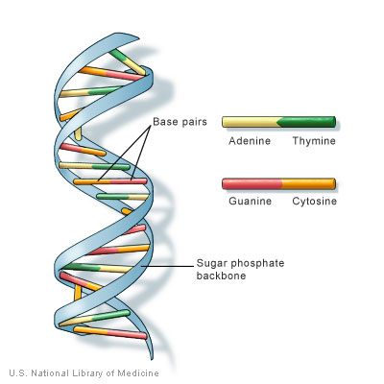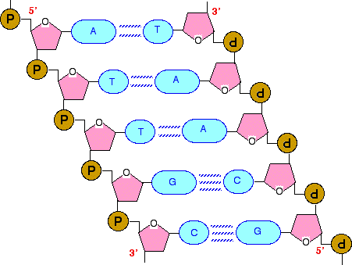

RNA : 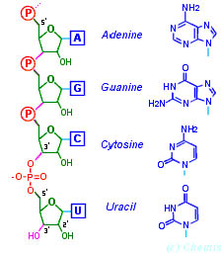

- DNA does the following:
- Replicate itself
- Stores blue-prints that can be used to synthesize proteins
- Undergo Mutations

- DNA Replication illustrated below. DNA will unwind and unzip, (helicase) then each strand will act as a template to build a new complimentary strand. DNA polymerase enzymes will bring the proper DNA nucleotide into place and bond them together. By the time replication is done, two identical molecules of DNA are produced, each molecule will contain one strand of the original DNA molecule.

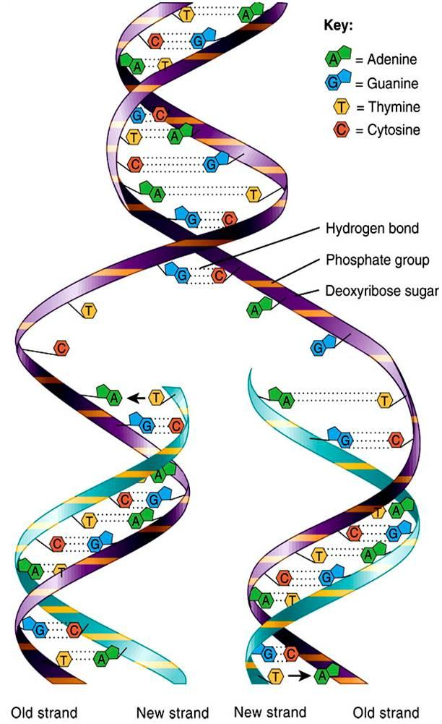

- See table below:
Type of Triplet of Bases | Location | Structure | Function
CODE | Triplet found on DNA in Nucleus | Three nucleotides bearing three bases. Example AGC | To hold information of a gene that can be expressed or passed on from cell to cell
CODON | Triplet found on mRNA, this mRNA can move from nucleus to cytoplasm | Three mRNA Nucleotides that bear a specific set of three bases. It will be complimentary to the DNA it was built from. Example UCG | This codon will deliver information from the nucleus out to the ribosome to determine what Amino Acid it codes for.
ANTICODON | Triple of tRNA bases found on one end of a tRNA molecule. Each tRNA molecule will transport a specific type of Amino Acid on it. | Sequence of three bases found along a tRNA molecule. It will perfectly compliment a specific mRNA codon.  Example AGC | To match up with a specific mRNA codon to deliver a specific Amino Acid to that location.

- The three types of RNA are as follows:

- mRNA – "Messenger RNA" Built off of DNA gene to carry blue print for building specific protein from the Nucleus out to the ribosomes in the Cytoplasm.
- rRNA – "Ribosomal RNA" Built off of specific DNA found in the Nucleolus of the nucleus. These strands of rRNA will associate with proteins to form Ribosomal subunits.
- tRNA- "Transfer RNA" – Specific strands of RNA that attach to specific Amino Acids and the delivers that amino acid to the ribosome. Will drop off that amino acid at the ribosome if the tRNA anticodon matches the mRNA Codon.
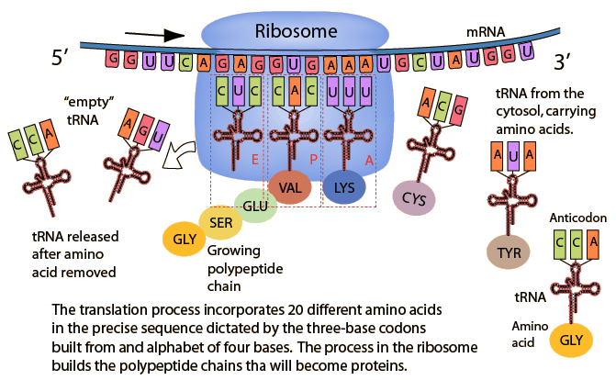
- The role of start Codon is to code for delivery of the first amino acid – Methionine. The role of a stop codon is to bring in a release factor to direct the ribosome to break apart to stop translation of the mRNA.

- Transcription – Takes place in the Nucleus when DNA is used as a template to form mRNA. This mRNA can then carry the code out of the nucleus.
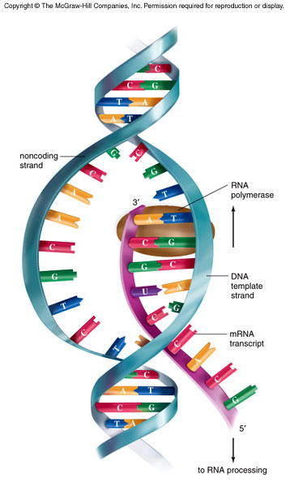
Translation – Takes place out in the cytoplasm at a Ribosome, when the mRNA is decoded with the help of tRNA to build a polypeptide made out of Amino Acids.
- DNA Sequence : AAC CCA TCG CCA
mRNA Produced : UUG GGU AGC GGU

tRNA Anticodons: AAC CCA UCG CCA

Amino Acid Delivered: Leucine – Glycine-Serine-Glycine
Determined by looking
Up codon of mRNA.

- A) If a deletion occurred in the DNA, this would result in a Frameshift mutation whereby all the codes(DNA Triplets) and codons(mRNA triplets) would be off from that point on. This would ruin the formation of the polypeptide.
B) If an extra base was added in, this would again result in a Frameshift mutation to the gene. All of the codons from that point on would be altered.
C) With a substitution of one base for another, the results will be mixed. This type of mutation is called a POINT mutation. Sometimes they are harmless as the new base may still create a codon that still codes for the same amino acid. This results in a Silent Point Mutation. Other times, the new base may code for a wrong amino acid, but all the other codons are still correct, so the polypeptide has one wrong amino acid in it. This is called a Mis-sense Point Mutation. The worst case scenario is that the new codon ends up being a Stop Codon and the polypeptide is terminated much too early. This is called a Non-Sense Point Mutation.

- These are Cancer Terminology – OMIT

- OMIT – Cancer

- Omit – Cancer

- Omit – Cancer

- Omit – Cancer

- You just need to know what Recombinant DNA is. It is made when DNA from one species is spliced to the DNA of another species. This tends to alter the DNA makeup of a species to create transgenic organisms.

