Germ Killing –ANTIBIOTICS WS - KEY

1. Alexander Fleming discovered penicillin in 1928.

2. Penicillium notatum is a species of mould and it belongs to Kingdom Fungi.

3. Some deadly bacterial infections that were quickly eliminated with the advent of penicillin are: Syphilis, Gangrene, and Tuberculosis.

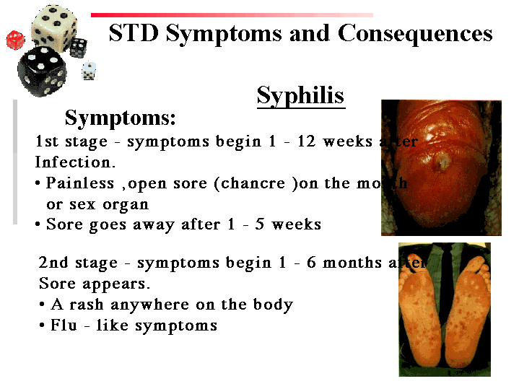

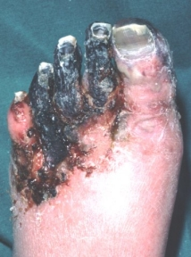

WHAT ARE ANTIBIOTICS?
4. Most antibiotics fight bacteria because bacteria are cellular organisms that can live freely and use their own enzymes. Viruses are not as easy to target because they are non-cellular and they live parasitically in a host’s cells and hijack the enzymes and raw materials of the host cell.

5. Prokaryotic cells are smaller simpler cells than eukaryotic cells. Prokaryotic cells have no membrane bound organelles and they lack a true nucleus.
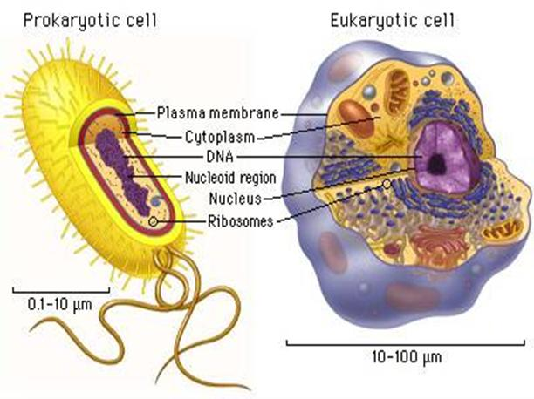
6. Bacteria damage a body by putting out toxins or by directly invading and damaging bodily tissues.

KINDS OF ANTIBIOTICS
7. The four main families of antibiotics are as follows:
a) Penicillins/Cephalosporins
b) Sulfas
c) Macrolides (Erythromycin)
d) Trimethoprim-Sulfamethoxazoles (TMP’s)
8. The most widely used family of antibiotics is the penicillin/cephalosporin family.

9. Penicillins/cephalosporins act by inhibiting some of the key enzymes involved in cell wall synthesis.

10. Common side effects of penicillin/cepha use include, diarrhea, rashes and hives. Some individuals may experience an anaphylactic reaction (inflammation causing the blocking of the airway).

11. Desensitizing is a process of gradually introducing a drug or a chemical to an individual who has allergic sensitivity to the drug. The method injects small amounts of the drug over a long period of time, the dose is gradually increased.

12. The most commonly used macrolide is “Erythromycin”.

13. Macrolides work by targeting prokaryotic ribosomes, by doing so, protein synthesis is shut down. Prokaryotic ribosomes are a different shape and size than eukaryotic ribosomes.
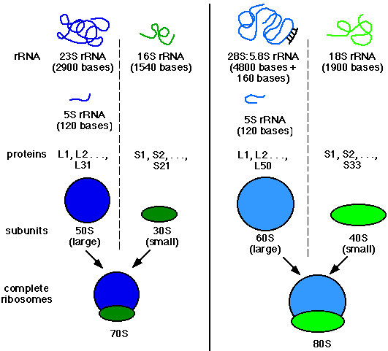
14. Erythromycins (and other macrolides) have been commonly used to fight bacterial bronchitis, chlamydia, and Pertussis (Whooping Cough).
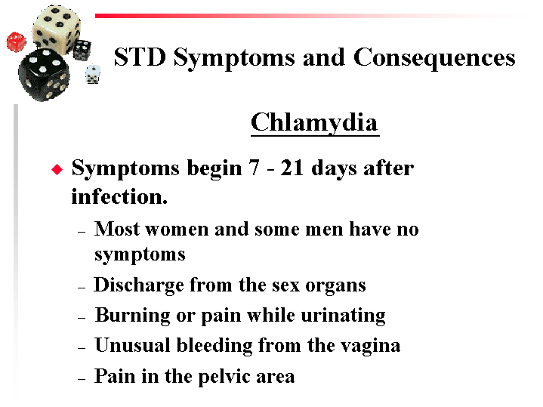
WHOOPING COUGH - Pertussis

15. The most common side effect of macrolide use is upset GI (gastrointestinal)

16. Sulfa-based antibiotics fight bacteria by shutting down the prokaryotic enzymes involved in DNA replication.

17. Sulfa-based antibiotics are not as commonly used as they once were because many of the bacteria they have been used on are now resistant and a fair amount of the population experience allergic reactions to these meds.

METHODS OF TAKING ANTIBIOTICS:

18. Antibiotics are taken orally, intravenously, and sometimes taken topically for skin or eye infections.

ANTIBIOTIC RESISTANCE
19. When you start taking an antibiotic you wipe out many of the bacteria in the first few days, but some bacteria are a bit more resistant so they need to be exposed to the med for a longer period of time before they will die. If you stop taking the antibiotic prematurely you leave behind the somewhat resistant bugs to flourish and reproduce to give rise to a strain that is more resistant than the original population.
http://www.youtube.com/watch?v=VQhIz2LqrYA

20. A virus can get into a bacteria and inject its DNA, causing the bacterial DNA to get mutated.

