The GOOD, the BAD and the UGLY – The FAT STORY
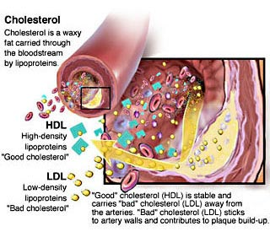
The BAD :
Cholesterol – Although your body does need cholesterol, you do not need any dietary cholesterol, your liver will make all the cholesterol you ever need. Cholesterol is packaged up and transported around the body. The liver packages up some cholesterol in tightly packaged spheres that ship nicely through the blood while mopping up any loose cholesterol. This form of cholesterol is called, HDL (high density lipoproteins). "GOOD CHOLESTEROL"
The liver will also package up cholesterol in loose sloppy spheres which leak cholesterol throughout the bloodstream, this form is called LDL (low density lipoprotein). "BAD CHOLESTEROL", these cholesterol deposits (plaques) clog up arteries.
The only source of dietary cholesterol is from animal based foods. When taking in too much cholesterol your body tends to increase its serum LDL (bad cholesterol).
DIETARY FATS:
Some More BAD fat:
Saturated Fats: Tend to be found primarily in animals. These saturated fats act to drive up the LDL (bad cholesterol) levels. Studies also have shown that diets high in saturated fats cause cells to become LESS responsive to Insulin.
The GOOD:
Monounsaturated and Polyunsaturated Fatty Acids, primarily found in plant seed/nut oils, a couple found in animal oils. Very good for cardiovascular system, by helping lower LDL cholesterol (bad cholesterol) levels. Studies also have shown that diets high in unsaturated fats cause cells to become MORE responsive to Insulin.

The UGLY :
Trans Fats – Trans fats lower HDL (Good Cholesterol and raise LDL (Bad Cholesterol)
