INORGANICS PRACTICE QUIZ

- Which of the following best describes the property of water by which water molecules like to link to other water molecules via Hydrogen Bonding?
- Covalent Bonding
- Ionic Bonding
- Adhesion
- Cohesion

- Which of the following is INORGANIC ?
- CH₃
- C₆H₁₂O₆
- CO₂
- NH₂C₂O₃

- Water is a universal solvent, which statement below would best describe this property?
- Polar molecules will easily mix with water
- Non-polar molecules will easily mix with water
- Ionic molecules will easily mix with water
- Polar and Ionic molecules will easily mix with water
- Polar and Non-Polar molecules will easily mix with water
- Urine has a pH of 6, while a batch of Vinegar has a pH of 3, what best compares urine to vinegar?
- Urine has 3 X as many H⁺ ions
- Vinegar has 1000 X as many H⁺ ions
- Vinegar has 1000 X as many OH – ions
- Urine has 3 X as many OH – ions
- In the diagram below, the arrow is pointing at what?
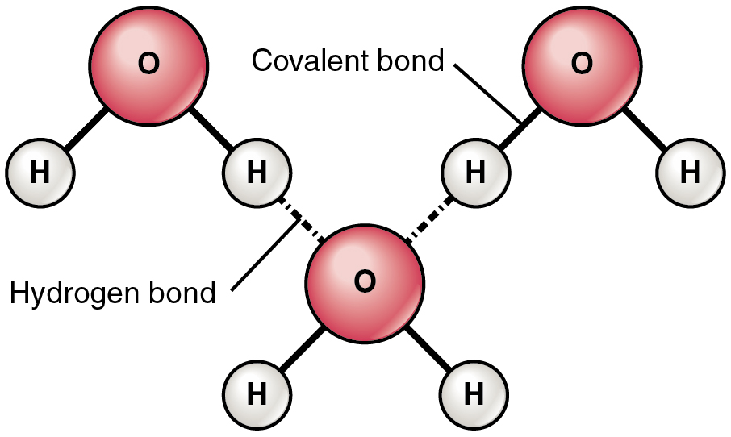

- A polar covalent bond
- A hydrogen bond
- A S.H.C. bond
- An ionic bond

- If your blood pH is supposed to be at a pH of 7.4, but it has dropped to 7.1, what best describes the situation and what will happen within your body to fix this imbalance?
- You are experiencing "Alkalosis" and your breathing rate and heart rate will slow down to fix this situation while your kidneys reabsorb more HCO₃⁻ ions from your urine.
- You are experiencing "Acidosis" and your breathing rate and heart rate will speed up to fix this situation while your kidneys reabsorb more HCO₃ – ions from your urine.
- You are experiencing "Acidosis" and your breathing rate and heart rate will slow down to fix this situation while your kidneys reabsorb more HCO₃ – ions from your urine.
- You are experiencing "Alkalosis" and your breathing rate and heart rate will speed up to fix this situation while your kidneys excrete more HCO₃ – ions into your urine.

- What best describes a molecule of water?
- A charged molecule that is polar
- A polar molecule that has no charge (neutral)
- A charged molecule that is non-polar
- A molecule that has no charge (neutral) and is non-polar.

- Chlorine is in Group 7 on the periodic table, what does this mean?
- It has 7 electrons
- It has 7 protons
- It has an atomic mass of 7 units
- It has 7 valence electrons

- Draw the electron configuration of a WATER molecule:

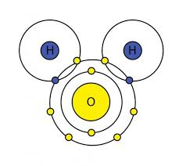
Notice the molecule has 10 protons and 10 electrons, so it is electrically neutral (no overall charge) but one side has a negative field while the other has an equally positive field.
IT IS A POLAR MOLECULE

INORGANICS PRACTICE QUIZ - KEY

- Which of the following best describes the property of water by which water molecules like to link to other water molecules via Hydrogen Bonding?
- Covalent Bonding
- Ionic Bonding
- Adhesion
- Cohesion

- Which of the following is INORGANIC ?
- CH₃
- C₆H₁₂O₆
- CO₂
- NH₂C₂O₃

- Water is a universal solvent, which statement below would best describe this property?
- Polar molecules will easily mix with water
- Non-polar molecules will easily mix with water
- Ionic molecules will easily mix with water
- Polar and Ionic molecules will easily mix with water
- Polar and Non-Polar molecules will easily mix with water

- Urine has a pH of 6, while a batch of Vinegar has a pH of 3, what best compares urine to vinegar?
- Urine has 3 X as many H⁺ ions
- Vinegar has 1000 X as many H⁺ ions
- Vinegar has 1000 X as many OH – ions
- Urine has 3 X as many OH – ions

- In the diagram below, the arrow is pointing at what?

- A polar covalent bond
- A hydrogen bond
- A S.H.C. bond
- An ionic bond
- If your blood pH is supposed to be at a pH of 7.4, but it has dropped to 7.1, what best describes the situation and what will happen within your body to fix this imbalance?
- You are experiencing "Alkalosis" and your breathing rate and heart rate will slow down to fix this situation while your kidneys reabsorb more HCO₃⁻ ions from your urine.
- You are experiencing "Acidosis" and your breathing rate and heart rate will speed up to fix this situation while your kidneys reabsorb more HCO₃ – ions from your urine.
- You are experiencing "Acidosis" and your breathing rate and heart rate will slow down to fix this situation while your kidneys reabsorb more HCO₃ – ions from your urine.
- You are experiencing "Alkalosis" and your breathing rate and heart rate will speed up to fix this situation while your kidneys excrete more HCO₃ – ions into your urine.

- What best describes a molecule of water?
- A charged molecule that is polar
- A polar molecule that has no charge (neutral)
- A charged molecule that is non-polar
- A molecule that has no charge (neutral) and is non-polar.

- Chlorine is in Group 7 on the periodic table, what does this mean?
- It has 7 electrons
- It has 7 protons
- It has an atomic mass of 7 units
- It has 7 valence electrons

