KNEE ANATOMY - PRACTICE QUIZ
Omit #9 – Transverse ligaments – connect menisci to each other and to tibial plateau
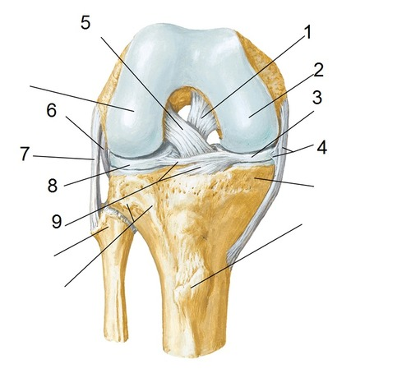
6
Expanded portion of distal epiphysis
11. Is this a right or left knee? Explain how you know.
10
ANSWER KEY:
- POSTERIOR CRUCIATE LIGAMENT
- MEDIAL CONDYLE OF FEMUR
- MEDIAL MENISCUS
- MEDIAL COLLATERAL LIGAMENT
- ANTERIOR CRUCIATE LIGAMENT
- TIBIAL TUBEROSITY
- LATERAL COLLATERAL LIGAMENT
- LATERAL MENISCUS
- TRANSVERSE LIGAMENT (you do not need to know this structure)
- FIBULA
- As this is an anterior view of the knee and the Fibula is always lateral to the Tibia, this must be a RIGHT KNEE

