KNEE ANATOMY

For each diagram use the word bank to label each structure

Lateral Epicondyle Head of Femur Medial Epicondyle
Greater Trochanter Lesser Trochanter
Neck of Femur Diaphysis

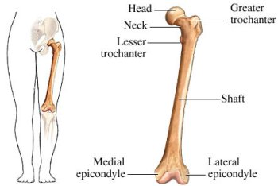

Tibial Crest Lateral Condyle Tibial Tuberosity
Fibula Diaphysis Lateral Malleolus Head of Fibula
Medial Condyle Medial Malleolus

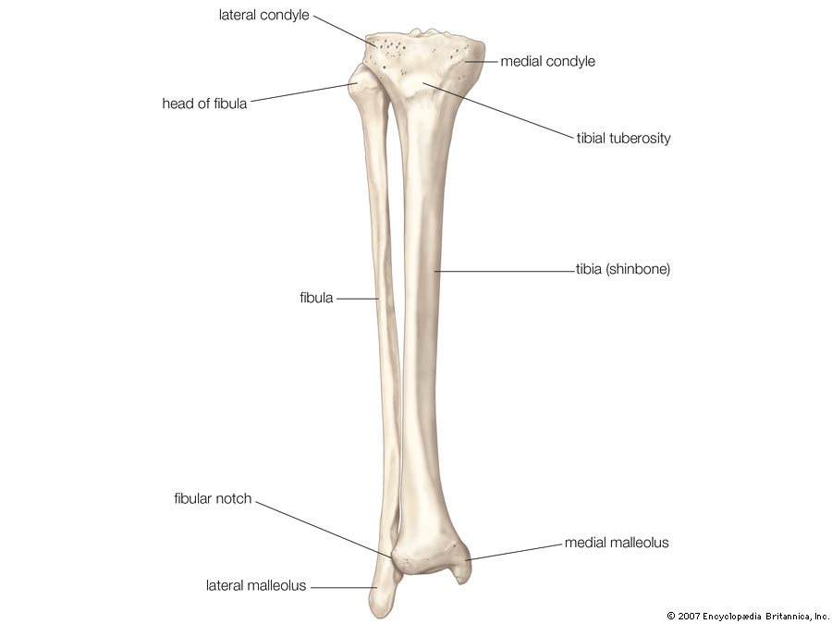

Medial Meniscus Lateral Meniscus
Anterior Cruciate Ligament Posterior Cruciate Ligament
Medial Collateral Ligament Lateral Collateral Ligament

ANTERIOR VIEW OF RIGHT KNEE

