Lipids Practice Quiz

- Which of the following is NOT a typical function of a LIPID?
- Form energy rich storage molecules
- Store genetic information for heredity
- Insulate the body and pad organs
- Form cell membranes
- Act as hormones in the body

- The lipid shown below is best described as:
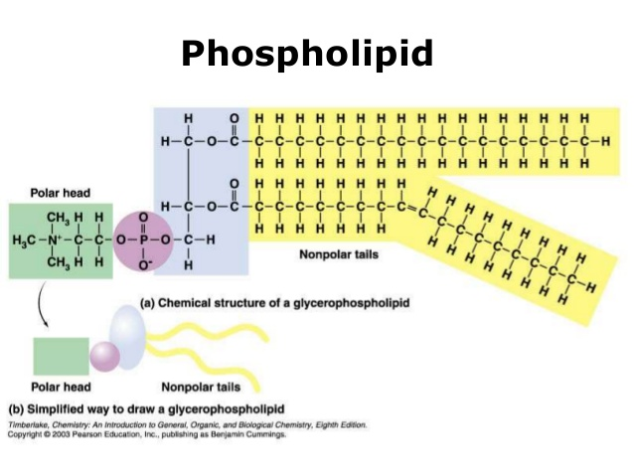
- Neutral fat with saturated fatty acids
- Neutral fat with unsaturated fatty acids
- Sterol lipid used to firm up cell membranes
- Phospholipid used to build cell membranes

- The molecule shown below is best described as..
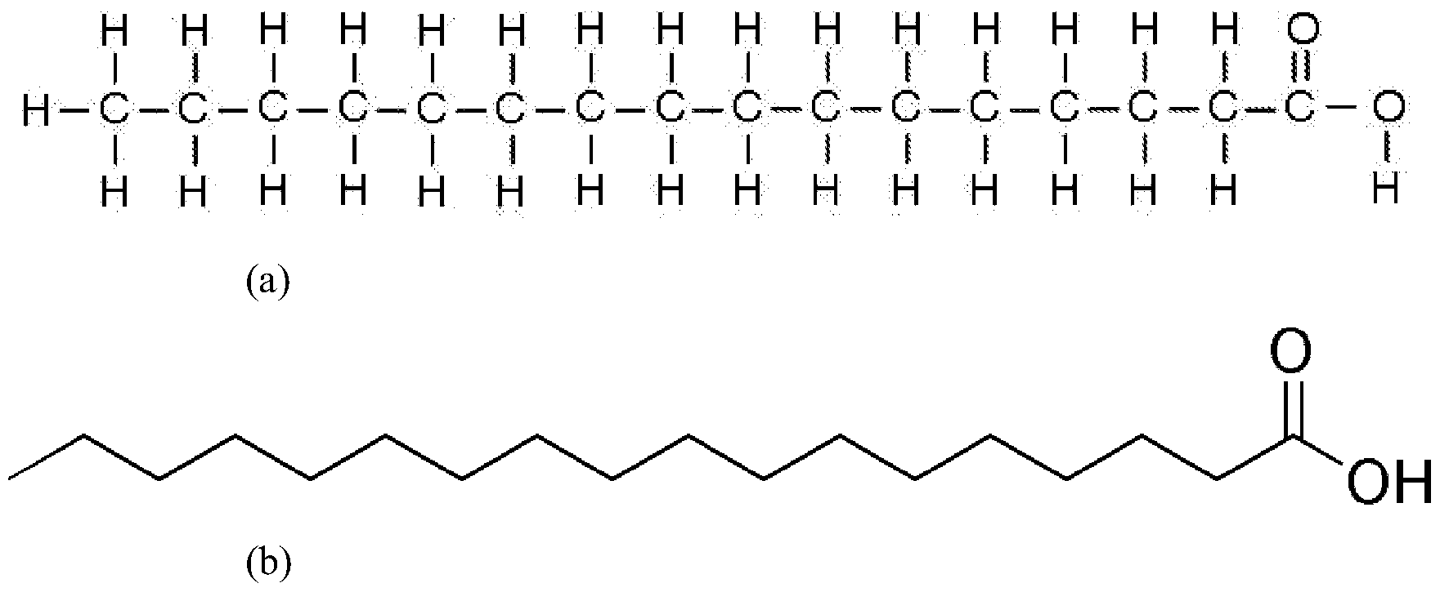
- A glycerol molecule
- A sterol lipid
- A saturated fatty acid
- An unsaturated fatty acid

- During the formation (synthesis) of the molecule below, what statement is accurate?
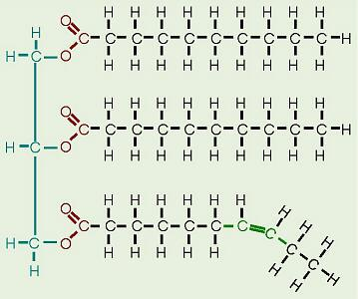
- Three waters were produced
- Three waters were consumed
- Four waters were produced
- Four waters were consumed
- The molecule below is classified as…
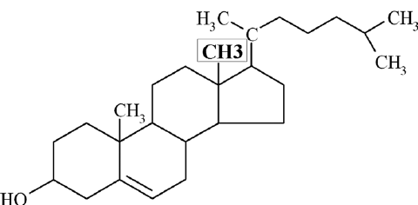
- Neutral Fat
- Phospholipid
- Monoglyceride
- Sterol Lipid

- What function may it serve in living things?
- Helps store energy
- Helps store genetic information
- Helps firm up (proper texture) cell membranes
- Is burned as a fuel to release energy

- Which of the following would likely be a Fatty Acid?
- H₂O
- C₁₈H₃₄O₂
- C₁₂H₂₂0₁₁
- C₅H₁₀O₅
- A cell's membrane would mostly consist of which of the following?
- 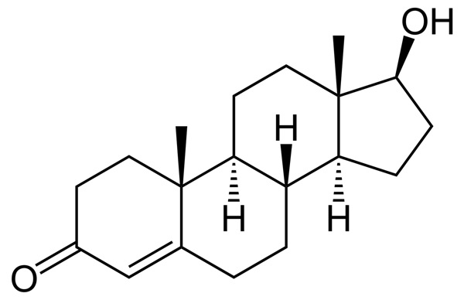

- 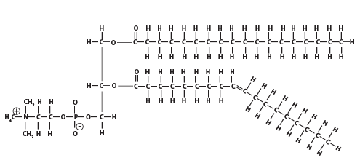

- 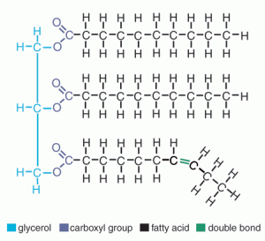

- 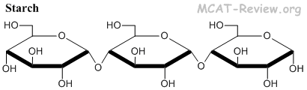
- Name the molecule that the arrow is pointing to
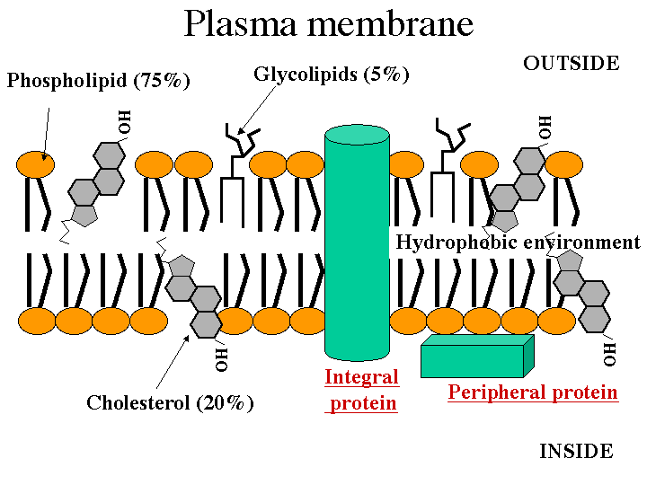
- PHOSPHOLIPID C) GLYCOGEN
- GLYCEROL D) ESTROGEN
- CHOLESTEROL
10. Which of the following was NOT mentioned when talking about this Organic Group known as FATS/Lipids?
A) Amino Acids
B) Carboxylic Acid Group
C) Glycerol
D) Monoglyceride
E) Phosphate Group

ANSWER KEY:
- Which of the following is NOT a typical function of a LIPID?
- Form energy rich storage molecules (neutral fats)
- Store genetic information for heredity (sounds like DNA to me)
- Insulate the body and pad organs (fat/adipose tissue)
- Form cell membranes (phospholipids)
- Act as hormones in the body (sterol lipids)

- The lipid shown below is best described as:
- Neutral fat with saturated fatty acids
- Neutral fat with unsaturated fatty acids
- Sterol lipid used to firm up cell membranes (cholesterol)
- Phospholipid used to build cell membranes (the glycerol has two hydrophobic FA's and the final spot on the glycerol is occupied by a hydrophilic phosphate head)

- The molecule shown below is best described as..
- A Glycerol molecule (only has 3 carbons)
- A sterol lipid (would look like honeycomb)
- A saturated fatty acid (every carbon is holding as much H as possible and there is an acid group at one end)
- An unsaturated fatty acid (would have a double bond in the carbon chain)

- During the formation (synthesis) of the molecule below, what statement is accurate?
- Three waters were produced (as each FA is added to the 3 spots on the glycerol a water is produced)
- Three waters were consumed (that would be hydrolysis to break apart)
- Four waters were produced (only 3 spots of synthesis)
- Four waters were consumed (Hydrolysis)
- The molecule below is classified as…
- Neutral Fat (would have glycerol with 3 FAs)
- Phospholipid (would have glycerol with 2 FAs and a phosphate head)
- Monoglyceride (need a glycerol with 1 FA)
- Sterol Lipid (has that honeycomb pattern)

- What function may it serve in living things?
- Helps store energy (neutral fats do)
- Helps store genetic information (DNA does that)
- Helps firm up cell membranes (sounds like cholesterol)
- Is burned as a fuel to release energy (fatty acid or carb, but not sterol lipid)

- Which of the following would likely be a Fatty Acid?
- H₂O (inorganic water)
- C₁₈H₃₄O₂ (organic hydrocarbon with acid group at end)
- C₁₂H₂₂0₁₁ (organic but has a Carbohydrate ratio – disaccharide)
- C₅H₁₀O₅ (organic but has a Carbohydrate ratio – monosaccharide – 5 carbon pentose)

- A cell's membrane would mostly consist of which of the following?
Sterol lipid with honeycomb shape

Glycerol with two FA's and a phosphate head = Phospholipid

Glycerol with 3 FA's = Neutral Fat – specifically a Triglyceride

Each unit is a Glucose, which is a carbohydrate, many glucoses linked together = a polysaccharide. If this had more and did not have many branches it would be STARCH

- Name the molecule that the arrow is pointing to
- PHOSPHOLIPID C) GLYCOGEN
- GLYCEROL D) ESTROGEN
- CHOLESTEROL

10. Which of the following was NOT mentioned when talking about this Organic Group known as FATS/Lipids?
A) Amino Acids – these are the monomers of a PROTEIN
B) Carboxylic Acid Group – Found at the end of a fatty acid
C) Glycerol – One of the basic monomers in Neutral fats
D) Monoglyceride – A glycerol with one Fatty Acid attached
E) Phosphate Group – The polar group found on a Phospholipid

