Name: ______________________
Date:______________
Nutrient Groups - Macronutrients – Part II

A) Fat (Lipids) Metabolism:
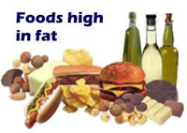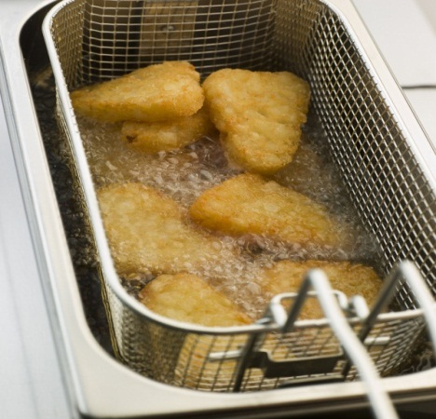

- Fats are also primarily used ___________________________________________________; however, most cells tend to use fats only when glucose levels are inadequate (glycogen reserve has also been drained).
- Ingested fats are converted to a form that can be used to release a substantial amount of
energy ________________

- Fats that are not needed are stored; they are anabolized into triglycerides, which are
stored in _______________________________ tissue.
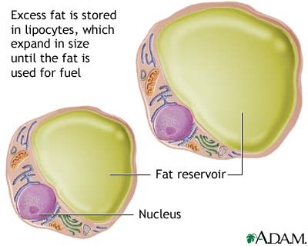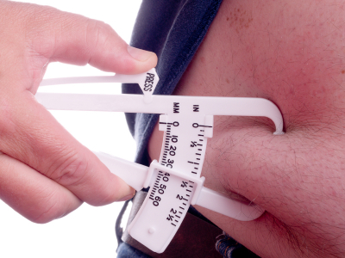
- Fats have a BAD reputation because of their close association with a number of chronic diseases (heart disease, hypertension, diabetes etc.)

- The truth is that we need some lipids in our diet as they provide us with:

i) _____________________ - Over twice as much per gram.
ii) ____________________________ – To manufacture essential lipid-based molecules.
Ex. Cell membrane, cholesterol, and many hormones
iii) ________________: Longer-lasting _________________________________
iv) ______________________________________: Fatty tissue in hypodermis.
v) _______________________________: Adipose padding vital organs
vi) Nerve Impulse Transmission: ___________________________________
vii) _____________________________________________

Good Fats vs. Bad Fats:
1. _______________________: _________________ (hard) fats and ____________________, most commonly found in animal sources. (Exterior meat fat, butter, cream, tropical oils –Palm and Coconut). ____________________ = The Worst of all.

2. GOOD FATS: _____________________ (softfree-flowing) fats, usually from plant sources (olive oil and canola). Some fats contain essential fatty acids (EFA), for example fish oils are rich in “Omega-3”. “Omega-3” has been linked to healthy cardiovascular function.
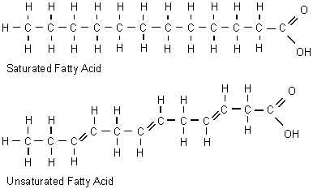
- When we eat fatty foods we are often taking in both saturated and unsaturated fats in the same food.

- Although we knew that Unsaturated fats were healthy for us, the food industry did not like the oily texture in their foods. So the food industry learned how to harden these
healthy fats. Example; ___________________--> _________________; this is done by
injecting hydrogen gas into them. This process is called ___________________________

- In nature, most fatty acid chains that have unsaturated spots tend to take a __________ form at that bond. This means chain before the double bond extends to the same plane/side as the chain after the double bond.

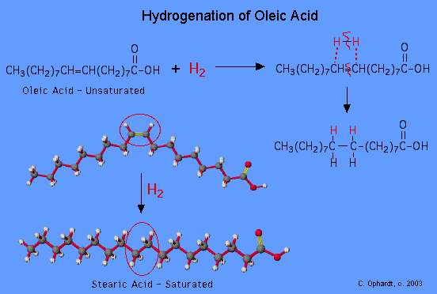

- ____________________________________________________________________________
_______________________________________ form. This means that the chain leading to the double bond is extending to a different side than the one extending from the double bond.

** Trans fats are the worse as they lower your good blood cholesterol (HDL) and raise your bad blood cholesterol (LDL) !
That’s a recipe for HEART DISEASE.
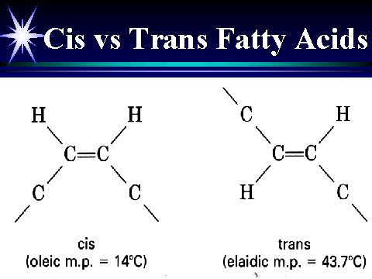
- The desired result is to raise the melting point for a given oil by changing its shape.

Is BUTTER better than MARGARINE?
VS. 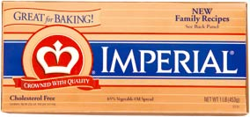

from Martha Grogan, M.D. – MAYO CLINIC
Margarine is made from vegetable oils, so it contains no cholesterol. Margarine is also higher in "good" fats — polyunsaturated and monounsaturated — than butter is. These types of fat help reduce low-density lipoprotein (LDL), or "bad," cholesterol, when substituted for saturated fat. Butter, on the other hand, is made from animal fat, so it contains cholesterol and high levels of saturated fat.
But not all margarines are created equal — and some may even be worse than butter. In general, the more solid the margarine, the more trans-fat it contains — so stick margarines usually have more trans-fat than do tub margarines. Like saturated fat, trans-fat increases blood cholesterol and the risk of heart disease. In addition, trans-fat can lower high-density lipoprotein (HDL), or "good," cholesterol levels. Most of the newer soft spreads margarines are fortified with plant stanols and sterols, which can help reduce LDL cholesterol levels.

Different Types of Fat in Butter and Margarines (grams/serving)
product | total fat | saturated fat | trans fat | trans+saturated
butter | 10.8 | 7.2 | 0.3 | 7.5
stick margarine  (82% fat) | 11.4 | 2.3 | 2.4 | 4.7
tub margarine  (80% fat) | 11.2 | 1.9 | 1.1 | 3.0
sources: United States Food and Drug Administration
Table of Trans Values,1995;
USFDA Composition DATA, 1995
Note: a serving is defined as 13-14 g,
approximately 1 tablespoon

Answer: A good choice would be to use a non-hydrogenated vegetable oil spread. ** Just double-check the listed ingredients.
- A recent study showed that on average people obtain 34% of their calories from fat. Current dietary guidelines recommend all people above the age of 2, obtain no more than 30% of their calories from fat and no less than 10% of their calories from fat.

B) Protein Metabolism:
- ____________________________________________________________________________
______________________________________________________________________________
_____________________________________________

- Proteins are digested down to amino acids, these amino acids are then used by cells to build complex protein compounds.
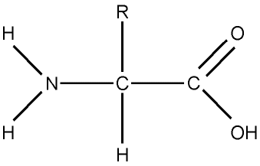
General
Amino
Acid Structure

- There are __________________________________ required for protein synthesis. Of
these 22, __________________________________________________________; these are
called ____________________________________

- Recent studies showed that diets high in protein, cause satiety (satisfy hunger), making you feel full for longer periods of time.

- ____________________________________ are foods that contain all essential AA’s in a sufficient quantity. Most of these are from animal sources. (dairy products, poultry, fish etc)

- A vegetarian will still meet the requirements for essential AA’s if they eat a variety of proteins complementing one another.

- Amino acids are incorporated by the body into:
i) Tissue Proteins
ii) Plasma Proteins

- In North America (western societies), most people eat 2-3 times the amount of protein
they really need. __________________________________________ can lead to kidney problems due to excessive excretion of nitrogenous wastes (urea/creatinine), and obesity and vascular problems due to the close association of protein rich foods (animal source) with high levels of saturated fats and cholesterol.

- In many third world countries, protein deficiency malnutrition is a major health concern. In the unfed state, bodily proteins are broken down for energy release. Ingestion of carbohydrates and fats will help spare the catabolism of protein tissues.
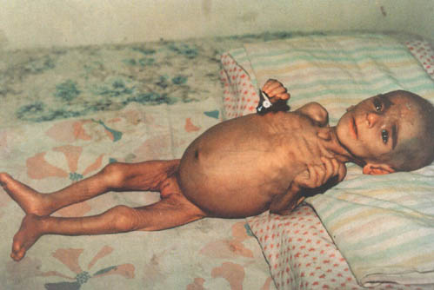
- The lack of amino acids results in the loss of body tissues and plasma proteins.

- Some of the results include ____________________________ (break down of muscle and other tissues), anemia due to lack of red blood cells, edema (swelling) due to a lack of plasma proteins.

EATING HEALTHY

- Eat the way we were intended to eat!

