WORKING WITH A MICROSCOPE
NAME: ____________________________
- SPECIMEN NAME : __________________________________ (view on medium power)

Power of Magnification: ___________ X

Field of View on that power
in micrometers : ____________

Estimated length (or width if you
choose) of cell : ________________

DRAWING Magnification: __________ X

- SPECIMEN NAME : __________________________________ (View on High Power)

Power of Magnification: ___________ X

Field of View on that power
in micrometers : ____________

Estimated length (or width if you
choose) of cell : ________________

DRAWING Magnification: __________ X

- SPECIMEN NAME : __POND WATER_ (View on Suitable Power and state it below)

Power of Magnification: ___________ X

Field of View on that power
in micrometers : ____________

Estimated length (or width if you
choose) of organism : ________________

MORE PRACTICE on Microscopy:
- Place the letter of the scope part by the correct name in the word bank.
_______ = Stage
_______ = Disc Diaphragm
_______ = Objective Lens
_______ = Ocular Lens
_______ = Coarse & Fine Focus
_______ = Revolving Nose Piece
_______ = Light/Mirror
_______ = Base
_______ = Arm
_______ = Clamps or Mechanical Stage Apparatus
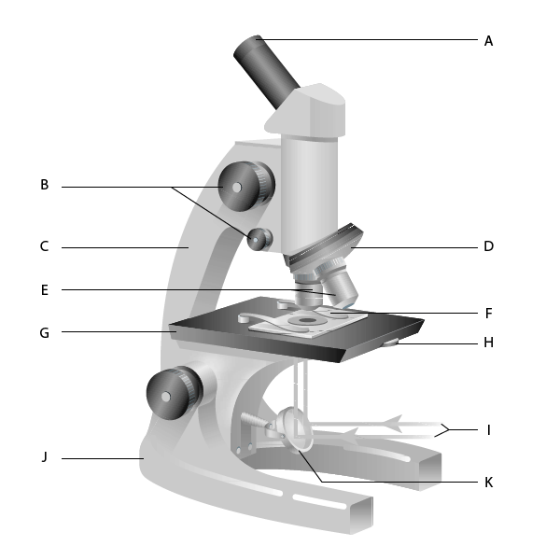
- Fill in the table below:
Power | Ocular Lens | Objective Lens | Total Power
LOW | 10 X | 4 X | X
MEDIUM |  | 10 X | 100 X
HIGH | 10 X |  | 400 X

- If you wrote the word "dod" like this on a very tiny piece of paper and put it under your microscope on low power. What would it read when you look at it through the scope?
___________
- As you increase your power of magnification what happens to the size of your field of view?
_____________________________________________________
- Convert the following measurements into the specified units:
A) 5 cm _______ mm
B) 1 mm _______ um
C) 3.5 mm ______ um
D) 0.7 mm _______ um
E) 250 um _______ mm
F) 5750 um ________ mm
G) 2.2 cm ________ mm _________ um
H) 0.9 cm _______ mm _______ um
- Calculating Drawing Magnification
SHOW YOUR CALCULATION
- - Actual size of specimen = 50 um
- Diagram size = 2.0 cm
Drawing Mag = ______________ X

- Actual Size of Specimen = 200 um
- Diagram size = 3.5 cm

Drawing Mag = ______________ X

- Complete all the calculations using the image below
Specimen (Euglena gracilis) was viewed on high power (400 X) and field of view was 440 um

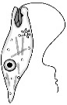

A) Estimated length of real specimen: __________________________ um
Show your calculation:

B)Drawing Magnification of sketched specimen : ____________________X
Show your calculation:

