MICROSCOPY CALCULATIONS
- Use the sketch and other relevant information stated below to complete the following calculations.
*Specimen was viewed and sketched on medium power – 100 X – (FOV = 1800 um)

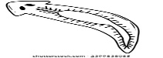

Show calculations for each step
- Approximately how many of these specimens would fit across the middle of the field of view?

- Calculate the approximate length of this specimen. Show your work

- What is the Drawing Magnification of this specimen on this sheet of paper?
Show your work.

