MICROSCOPY - KEY

- What is the name given to the most commonly used microscope?
LIGHT MICROSCOPE (Compound Microscope)

Label the diagram below, use figure 2-12 on p.34 and the word bank below.
Mirror or light (#10)  Revolving nosepiece (#3)  Stage (#8)  Coarse adjustment (#11)  Arm (#5)  Body tube (#2) | Diaphragm (#9)  Low power objective lens (#4)  Eyepiece/ocular lens (#1)  Base (#12)  High power objective lens (#6)  Stage clips (#7)

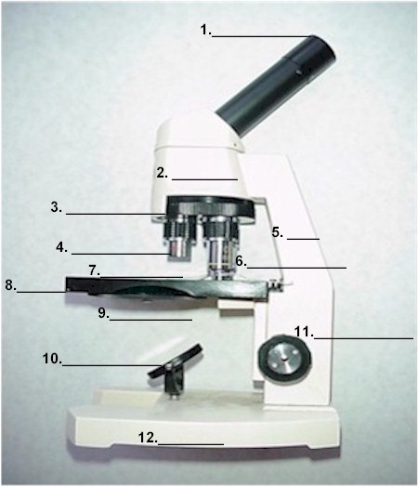
OVER

Power Of Magnification:
1. If an ocular lens is 10X and a high power objective
lens is 40X, what is the total power of magnification?
400X

- Define what “Limit Of Resolution” means.
It is the most powerful power of magnification that can be obtained at which two separate points can still be distinguished.
3. What is the limit of resolution for a standard light microscope?
0.2 um

4. What power of magnification is the maximum
for the best light microscopes that we can make?
Approximately 1000 X

5. What do scientist do to most prepared cell specimens before viewing them?
Stain them to get contrast

Other Types of Microscopes:
- How does a Transmission electron microscope work?
It shines a beam of electrons at a sample and the beam goes through the object and creates a magnified image on a fluorescent screen.

2. How does a Scanning electron microscope work?

A S.E.M. directs a beam of electrons onto a sample, this beam bounces back to create an image on a computer monitor.

For homework:
- Go to the following website and view some of the amazing images that can be seen with the variety of different microscopes. The site is a bit interactive so you can select the power of magnification that you want to use.

Go to: http://micro.magnet.fsu.edu/primer/virtual/virtual.html

