DIGESTIVE SYSTEM – MID-UNIT PRACTICE QUIZ
- Which is NOT a key component of Gastric Juice?
A) Hydrochloric Acid
B) Mucous
C) Pepsinogen
D) Gastrin

- Which of the following is NOT an Enzyme?
A) Pepsin
B) Gastrin
C) Trypsin
D) Lipase

- Which hormone will see a spike in the bloodstream when your blood sugar is starting to get LOW?
A) Insulin
B) Gastric Inhibitory Peptide
C) Gastrin
D) Glycogen
E) Glucagon

- Which of the following ENZYMES will help break Starch into Maltose?
A) Pancreatic Amylase
B) Gastrin
C) Pepsin
D) Lipase
E) Bile

- Which of the following is a Hormone?
A) Pepsin
B) Nuclease
C) Trypsin
D) Gastrin
E) Bile

- Which organ is responsible for the production of BILE?
A) Pancreas
B) Liver
C) Duodenum
D) Stomach
E) Gall Bladder
- Which of the following is produced by the Small Intestine (primarily the Duodenum)?
A) Gastrin
B) Peptidase
C) Trypsin
D) Lipase

- Which of the following is responsible for turning on the exocrine glands which will produce more HCl acid?
- CCK
- GASTRIN
- SECRETIN
- GASTRIC INHIBITORY PEPTIDE

9. Which structure below produces BILE?
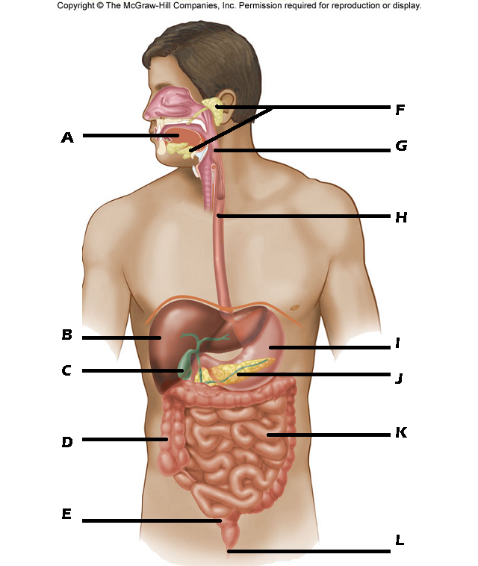

10. Secretions from which structure above will cause the acidic chyme leaving the stomach to go from a pH of 2.5 pH of 8.0?

- In the diagram below what is the name of the central vessel that the "Arrow X" is pointing to?
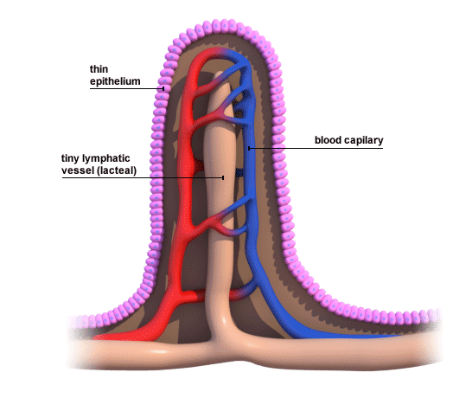
X
- The structure the "Arrow X" is pointing to would be responsible for the absorption of….
- Fats
- Carbohydrates
- Vitamins
- Amino Acids
- Minerals

13. Which hormone is primarily responsible for stimulating the release of BILE?
- INSULIN
- CCK
- SECRETIN
- GASTRIN
- GLUCAGON

14. Which of the following is NOT a role of the LIVER?
A) Production of plasma proteins
B) Production of bile
C) Production of cholesterol
D) Production of Trypsin
E) Storing extra Glucose as Glycogen

- Which organ is responsible for the production and release of LIPASE?
A) Stomach
B) Duodenum
C) Pancreas
D) Liver

- Which of the following is an example of PHYSICAL digestion?
- Breaking starch into maltose
- Breaking proteins into short peptide chains
- Breaking triglycerides into glycerol and fatty acids
- Breaking fat clumps into fat droplets
- None of the above are examples of Physical Digestion

ANSWER KEY
- Which is NOT a key component of Gastric Juice?
A) Hydrochloric Acid
B) Mucous
C) Pepsinogen
D) Gastrin

- Which of the following is NOT an Enzyme?
A) Pepsin
B) Gastrin
C) Trypsin
D) Lipase

- Which hormone will see a spike in the bloodstream when your blood sugar is starting to get LOW?
A) Insulin
B) Gastric Inhibitory Peptide
C) Gastrin
D) Glycogen
E) Glucagon

- Which of the following ENZYMES will help break Starch into Maltose?
A) Pancreatic Amylase
B) Gastrin
C) Pepsin
D) Lipase
E) Bile

- Which of the following is a Hormone?
A) Pepsin
B) Nuclease
C) Trypsin
D) Gastrin
E) Bile

- Which organ is responsible for the production of BILE?
A) Pancreas
B) Liver
C) Duodenum
D) Stomach
E) Gall Bladder
- Which of the following is produced by the Small Intestine (primarily the Duodenum)?
A) Gastrin
B) Peptidase
C) Trypsin
D) Lipase

- Which of the following is responsible for turning on the exocrine glands which will produce more HCl acid?
- CCK
B) GASTRIN
- SECRETIN
- GASTRIC INHIBITORY PEPTIDE
9. Which structure below produces BILE?

STRUCTURE B
10.Secretions from which structure above will cause the acidic chyme leaving the stomach to go from a pH of 2.5 pH of 8.0?
STRUCTURE J

11. In the diagram below what is the name of the central vessel that the "Arrow X" is pointing to?
LACTEAL
X
- The structure the "Arrow X" is pointing to would be responsible for the absorption of….
- Fats
- Carbohydrates
- Vitamins
- Amino Acids
- Minerals

13. Which hormone is primarily responsible for stimulating the release of BILE?
- INSULIN
- CCK
- SECRETIN
- GASTRIN
- GLUCAGON

14. Which of the following is NOT a role of the LIVER?
A) Production of plasma proteins
B) Production of bile
C) Production of cholesterol
D) Production of Trypsin
E) Storing extra Glucose as Glycogen

15.Which organ is responsible for the production and release of LIPASE?
A) Stomach
B) Duodenum
C) Pancreas
D) Liver

16.Which of the following is an example of PHYSICAL digestion?
- Breaking starch into maltose
- Breaking proteins into short peptide chains
- Breaking triglycerides into glycerol and fatty acids
- Breaking fat clumps into fat droplets
- None of the above are examples of Physical Digestion

