MOLECULE IDENTIFICATION

- - CARBOHYDRATES :
Looking for a formula with C₁H₂O₁ ratio.
Example of some monosaccharides C₅H₁₀O₅ (PENTOSE) or C₆H₁₂O₆ (HEXOSE)
Structures look like:
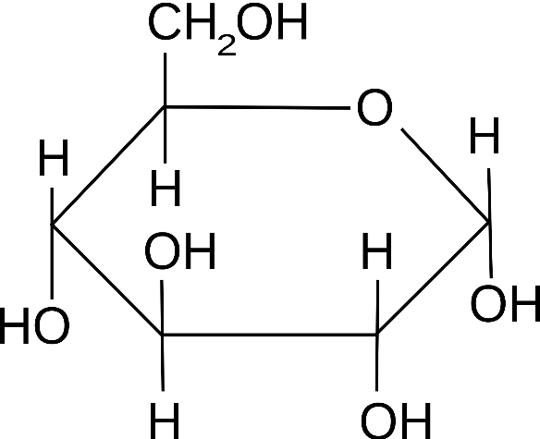 Glucose – Monosaccharide (hexose 6 carbons)

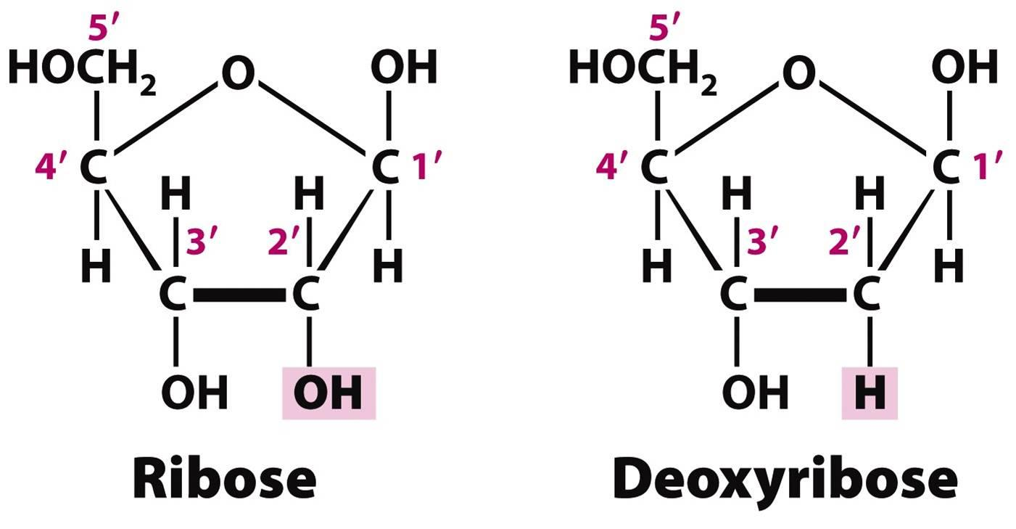
RIBOSE
DEOXYRIBOSE
- Both of the above are Pentose monosaccharide sugars (5 carbons)

Or like this – Two monosaccharides join to form a DISACCHARIDE
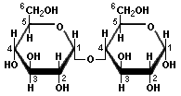 Maltose – Disaccharide
A disaccharide of two GLUCOSES called MALTOSE
Or when 100s of glucoses join together to form Polysaccharides:
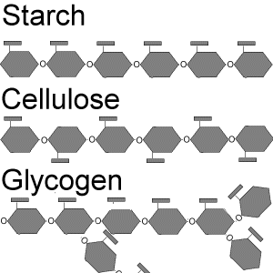
CELLULOSE – every 2nd glucose upside down
GLYCOGEN – lots of branching
STARCH

- - FATS/LIPIDS
Neutral Fats – Like a Triglyceride – To store energy
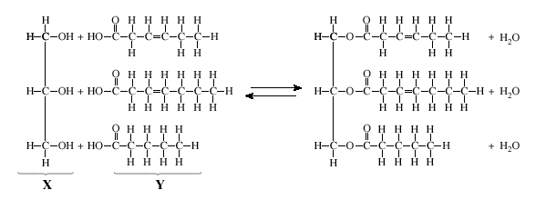
Recognize both monomers : Glycerol and a Fatty acid:
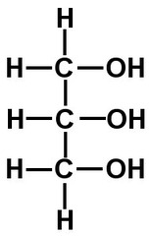
GLYCEROL
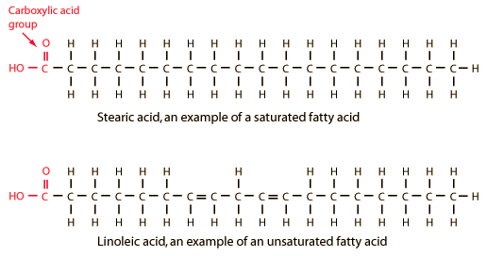
Phospholipids: To form cell membranes
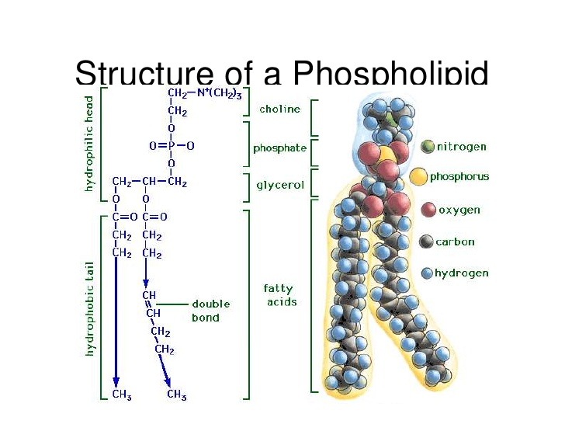

Phospholipid Bilayer forming cell membrane:
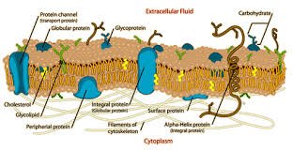

Sterol Lipids – Look a bit like honeycomb
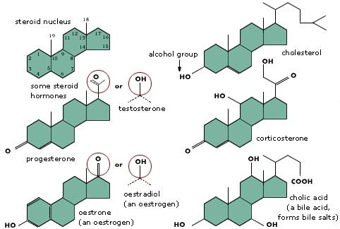

Cholesterol is used to firm up a cell's cell membrane and other cells will take cholesterol and modify its structure to make a variety of sterol lipid hormones
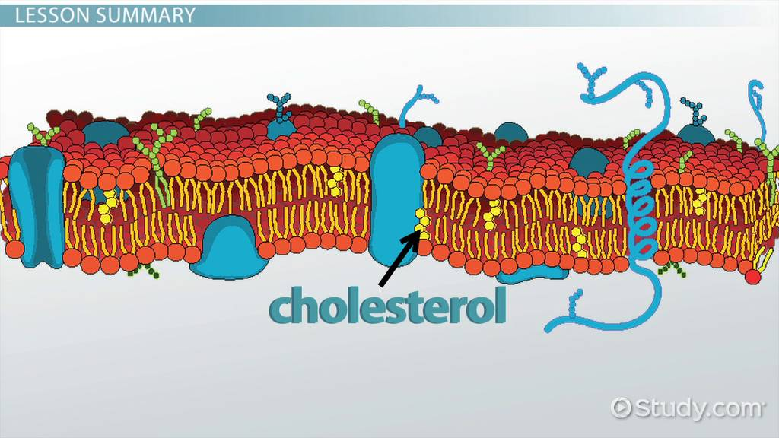
- -PROTEINS:
Look for the monomers of a protein : Amino Acids
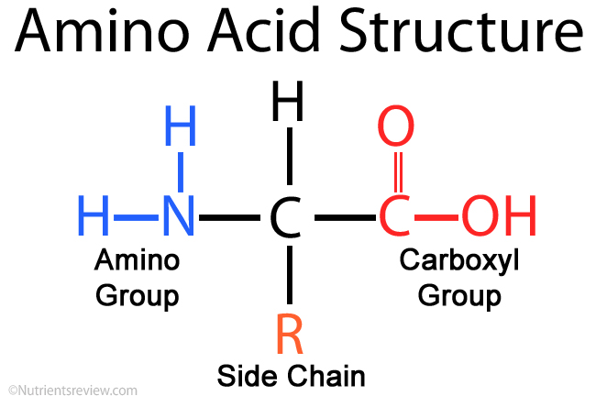
Amino acids connect together to form dipeptides (2 aa's) or polypeptides (many aa's linked together).
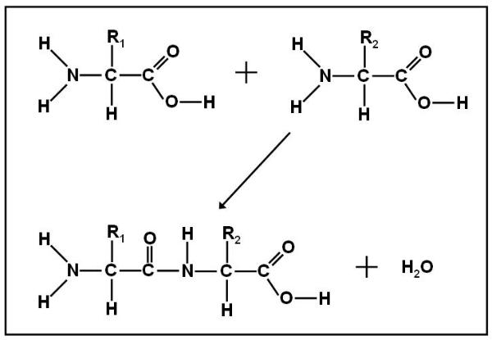
Small Polypeptides shown Below:
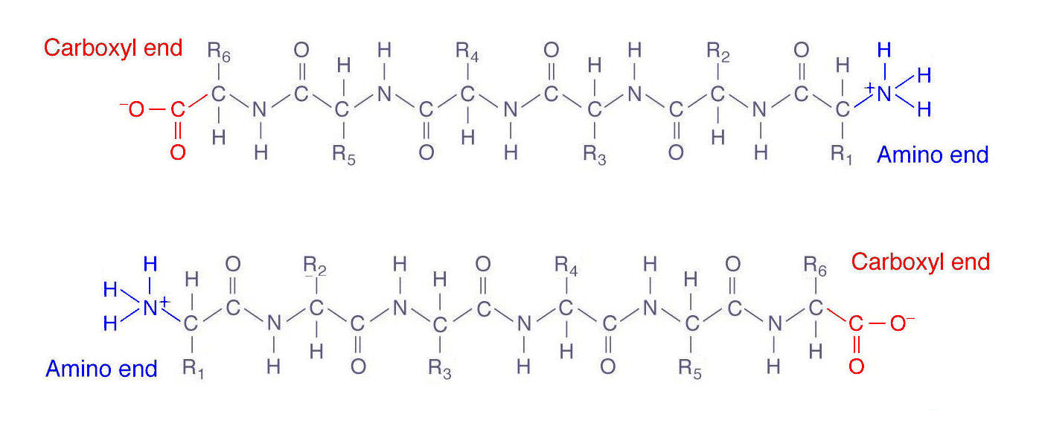
FOUR LEVELS OF STRUCTURE to a protein
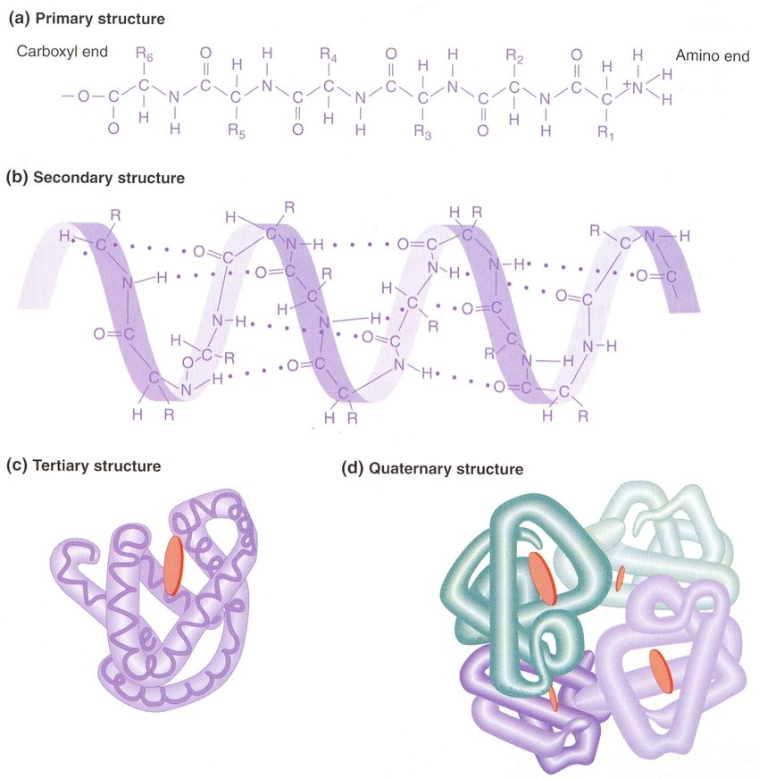

- -NUCLEIC ACIDS :
Look for the monomers : NUCLEOTIDES - Include a Phosphate Group, a 5-Carbon (pentose) Sugar and a Nitrogen-containing Base.
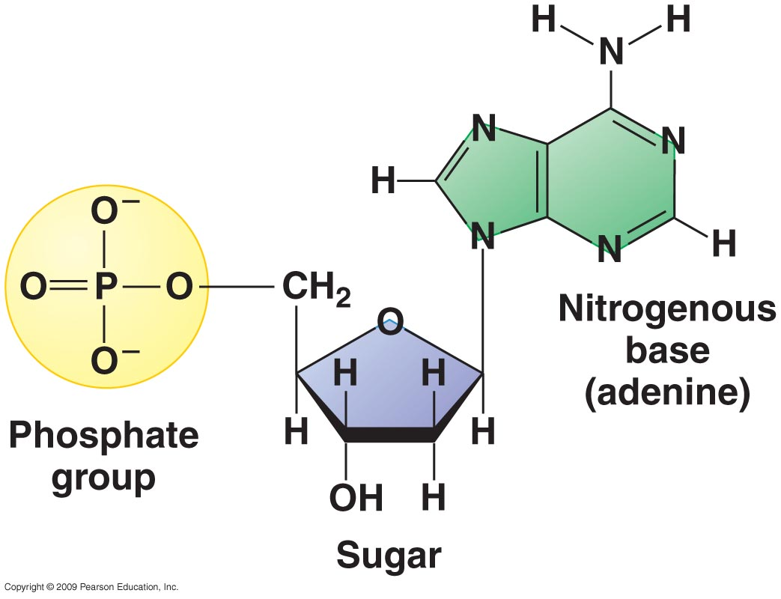
When these monomers (nucleotides) are joined together they can form DNA (Deoxyribonucleic Acid) or RNA (Ribonucleic Acid). DNA uses nucleotides that possess a "DEOXYRIBOSE Sugar – C₅H₁₀O₄". RNA on the other hand uses nucleotides that possess a "RIBOSE sugar – C₅H₁₀O₅"
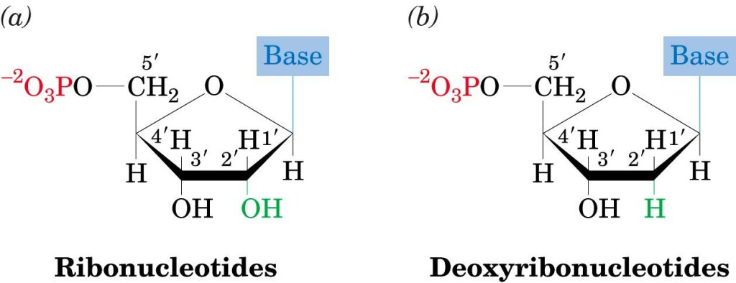

DNA Structure: Double stranded and Helical – Double Helix
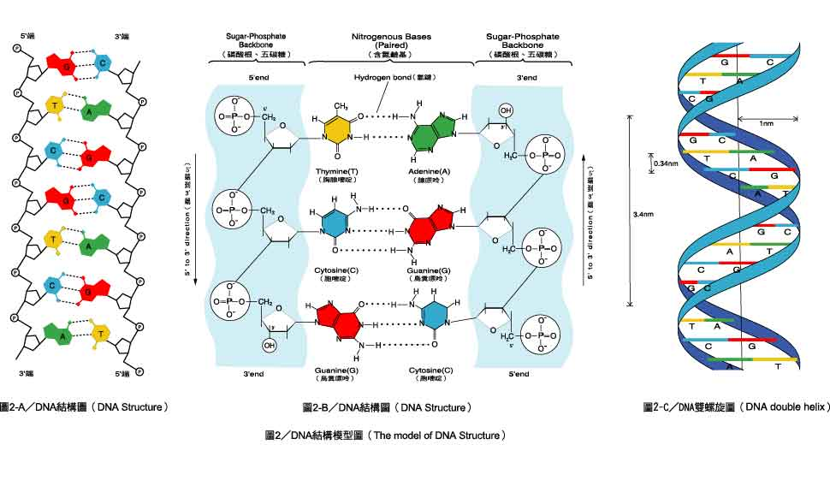
RNA Structure : Single-stranded and linear (straight)
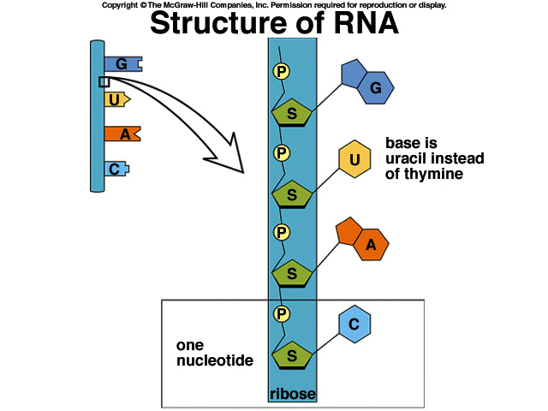

- ATP and the ATP CYCLE:
All life forms use a special molecule called Adenosine Triphosphate for all cellular processes that require energy. This ATP molecule is fairly similar to an RNA Nucleotide, but instead of possessing one Phosphate group, it possess 3 Phosphate groups.
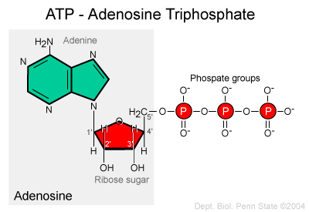
As fast as this molecule is formed in cells, it is hydrolyzed with water to release energy that can be used by the cell. Then the low energy molecules produced through this reaction (Adenosine Diphosphate and a free Phosphate group) can then be joined back together by restoring their bond by adding energy in. This is called the ATP Cycle:
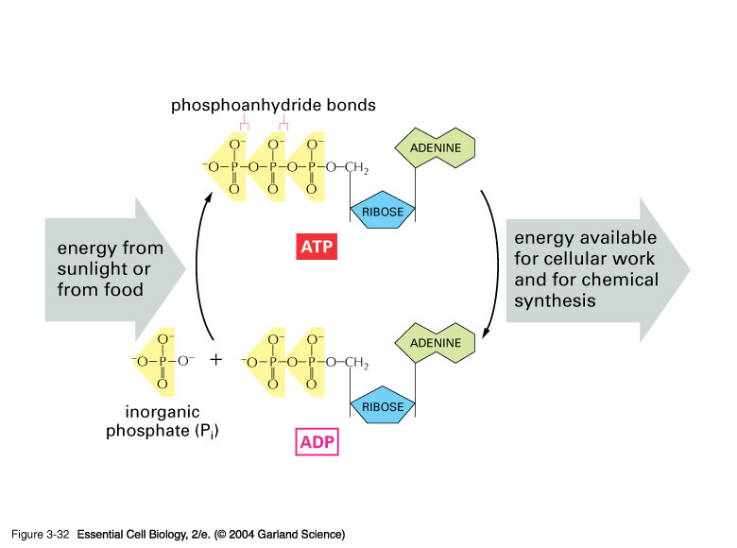
ADENOSINE:
