MUSCLE ANATOMY REVIEW WORKSHEET
1. For each diagram identify the type of muscle tissue shown:
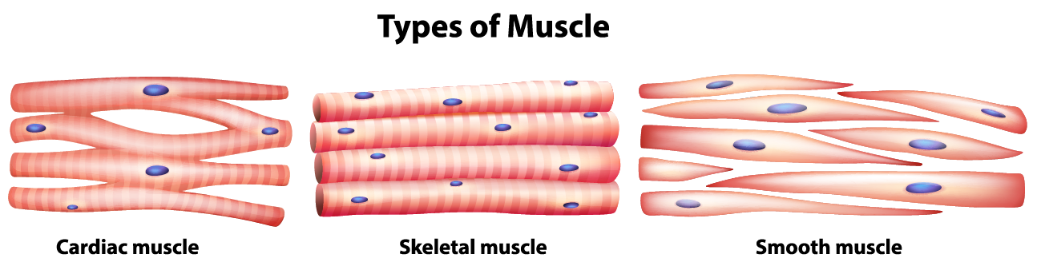
A)____________________ B)_______________________ C) _______________________

2. For the diagram below label each anatomical structure
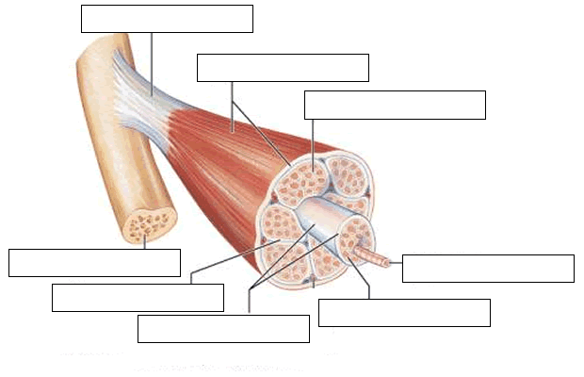
(Fascia
Layer)
(Fascia Layer)
(Scientific
Name for
Muscle Bundle)
(Fascia Layer)
(On to more stationary Bone)

3. For the Muscle Fiber Diagram below, label each structure:
(Word Bank : Mitochondria (Sarcosome), Transverse Tubules, Sarcolemma, Nucleus, Sarcoplasmic Reticulum, Actin, Myofibril and Myosin)
B) _______________________________
- ________________________
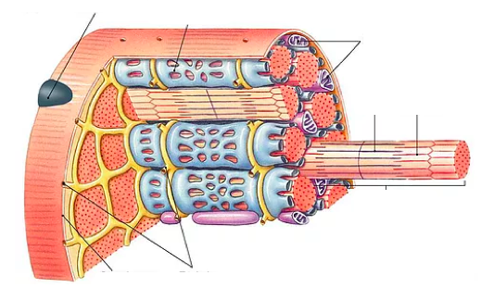
H) ________________________
G) ____________________________
F) _______________________
E) _________________
D) ________________
C) ________________________

4. For the structure shown below, label all parts:
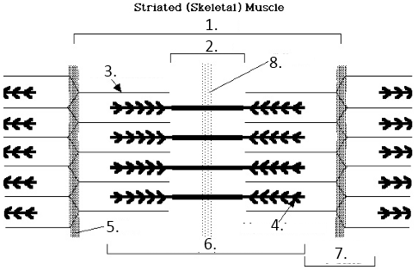
- ___________________________________ 5. ___________________________________
- ___________________________________ 6. ___________________________________
- ___________________________________ 7. ___________________________________
- ___________________________________

