NUTRITION – Practice Quiz #2

- The following food item contains, 4 grams of Fat, 6 grams of Carbs, 2 grams of protein and 1 gram of Vitamin C. If each nutrient group is completely metabolized for energy, how many Calories (kcals) will this food item provide?
- 49.2 Calories (kcals)
- 78.2 Calories (kcals)
- 34.2 Calories (kcals)
- 70.0 Calories (kcals)

- The diagram below represents what?
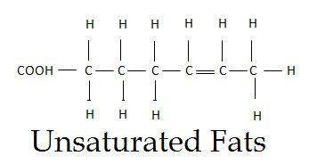
- A saturated fatty acid
- An unsaturated fatty acid
- An amino acid
- A glucose molecule
- Which of the following blood cholesterol levels would be the healthiest blood work?
- 60 mg of HDL with 120 mg of LDL
- 25 mg of HDL with 160 mg of LDL
- 65 mg of HDL with 200 mg of LDL
- 55 mg of HDL with 230 mg of LDL

- Which hormone will help raise blood sugar levels when you are feeling a little hypoglycemic?
A) Glycogen C) Glucagon
B) Insulin D) Cortisol

- Which of the following is a Fat-Soluble Vitamin?
- Thiamine (Vitamin B1)
- Vitamin C
- Riboflavin (Vitamin B2)
- Retinol (Vitamin A)

- Which of the following would be most harmful to your Blood Cholesterol ratio of HDL to LDL?
A) Trans Fat
B) Saturated Fat
C) Monounsaturated Fat
D) Polyunsaturated Fat
7. A food that has all of the essential amino acids in one food is termed ….
A) An Essential Protein Food
B) A Trans Protein Food
C) A Complete Protein Food
D) A Super Protein Food

8.Which of the following will yield the most Calories?
A) 4 Grams of Carbs
B) 4 Grams of Vitamin A
C) 4 Grams of Fats
D) 4 Grams of Protein

9. Which of the following groups is used more so for building materials rather than for energy?
A) Minerals
B) Carbs
C) Fats (Lipids)
D) Proteins

10. Which of the following plays an important role in blood clotting?
A) Vitamin A
B) Vitamin C
C) Vitamin K
D) Vitamin D
E) Vitamin E

11. Which of the following is INORGANIC?
A) Carbohydrates
B) Vitamin B1 – Thiamine
C) Calcium
D) Omega 3 Fatty Acid

12. 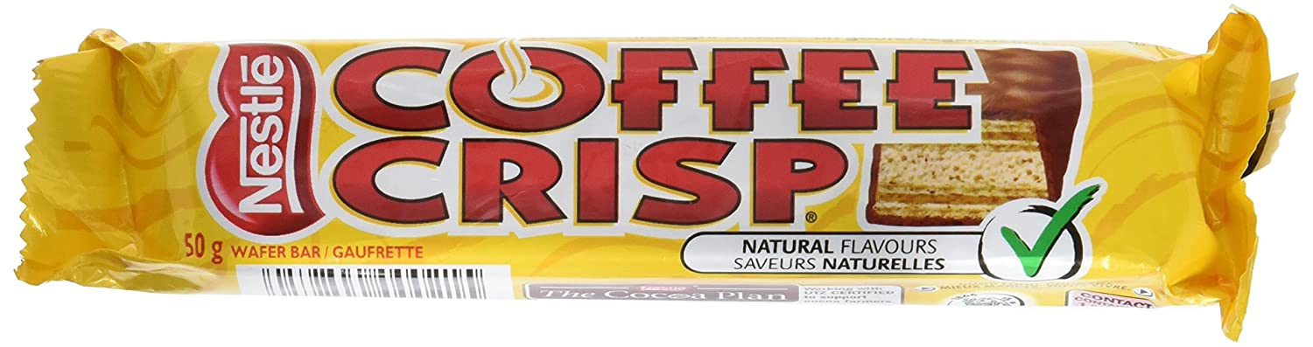
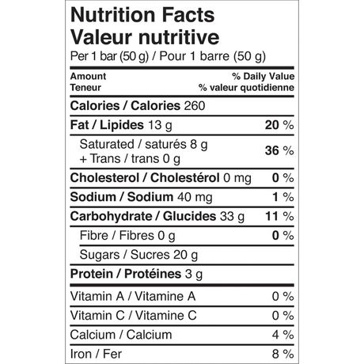
You have a sweet tooth and you love Coffee Crisps. One evening you sit down and eat two Coffee Crisps. Approximately, how many teaspoons of sugar did you consume?
- 5 C) 14
- 8 D) 10

13. That Coffee Crisp had 260 Calories, how many kcalories is that?
A) 2.6 kcal C) 260 kcal
B) 26 kcal D) 260,000 kcal

14. Which of the following Micronutrients can be made by your body when you get exposure to the sun?
A) Vitamin A C) Calcium
B) Vitamin D D) Vitamin K

NUTRITION – Practice Quiz #2 - KEY

1.The following food item contains, 4 grams of Fat, 6 grams of Carbs, 2 grams of protein and 1 gram of Vitamin C. If each nutrient group is completely metabolized for energy, how many Calories (kcals) will this food item provide?
- 49.2 Calories (kcals)
- 78.2 Calories (kcals)
- 34.2 Calories (kcals)
- 70.0 Calories (kcals)

- The diagram below represents what?
- A saturated fatty acid
- An unsaturated fatty acid
- An amino acid
- A glucose molecule
- Which of the following blood cholesterol levels would be the healthiest blood work?
- 60 mg of HDL with 120 mg of LDL
- 25 mg of HDL with 160 mg of LDL
- 65 mg of HDL with 200 mg of LDL
- 55 mg of HDL with 230 mg of LDL

- Which hormone will help raise blood sugar levels when you are feeling a little hypoglycemic?
A) Glycogen C) Glucagon
B) Insulin D) Cortisol

- Which of the following is a Fat-Soluble Vitamin?
- Thiamine (Vitamin B1)
- Vitamin C
- Riboflavin (Vitamin B2)
- Retinol (Vitamin A)

- Which of the following would be most harmful to your Blood Cholesterol ratio of HDL to LDL?
A) Trans Fat
B) Saturated Fat
C) Monounsaturated Fat
D) Polyunsaturated Fat
7. A food that has all of the essential amino acids in one food is termed ….
A) An Essential Protein Food
B) A Trans Protein Food
C) A Complete Protein Food
D) A Super Protein Food

8.Which of the following will yield the most Calories?
A) 4 Grams of Carbs
B) 4 Grams of Vitamin A
C) 4 Grams of Fats
D) 4 Grams of Protein

9. Which of the following groups is used more so for building materials rather than for energy?
A) Minerals
B) Carbs
C) Fats (Lipids)
D) Proteins

10. Which of the following plays an important role in blood clotting?
A) Vitamin A
B) Vitamin C
C) Vitamin K
D) Vitamin D
E) Vitamin E

11. Which of the following is INORGANIC?
A) Carbohydrates
B) Vitamin B1 – Thiamine
C) Calcium
D) Omega 3 Fatty Acid

12.
You have a sweet tooth and you love Coffee Crisps. One evening you sit down and eat two Coffee Crisps. Approximately, how many teaspoons of sugar did you consume?
- 5 C) 14
- 8 D) 10

13. That Coffee Crisp had 260 Calories, how many kcalories is that?
A) 2.6 kcal C) 260 kcal
B) 26 kcal D) 260,000 kcal

14. Which of the following Micronutrients can be made by your body when you get exposure to the sun?
A) Vitamin A C) Calcium
B) Vitamin D D) Vitamin K

