POPULATION GENETICS CALCULATIONS
- TONGUE ROLLING – The ability to curl up your tongue into a U-Shape.
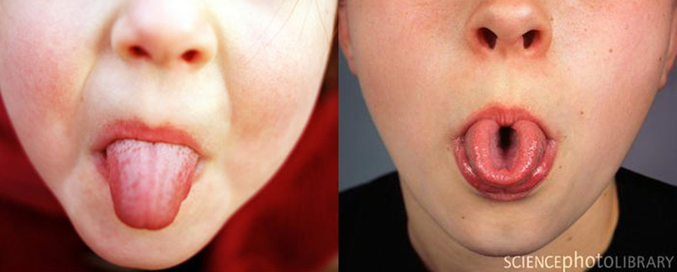
- A population of 20 humans were sampled. The population was asked to roll their tongue, also, each individual was asked to give a DNA sample for analysis.

- For tongue shape muscle control – there is one gene with two different alleles.

- Allele U (dominant) – has the DNA base sequencing : ATA GGC CCT ATT GCC
Allele u (recessive) – has the DNA base sequencing: ATA GTT CCT ATG GGC
Here are the Genotypes for the 20 individuals that were sampled:
UU | Uu | UU | Uu | UU
uu | UU | Uu | Uu | uu
Uu | Uu | Uu | UU | UU
Uu | UU | Uu | uu | Uu

For the above population answer the following questions:

- A) List the two possible PHENOTYPES in the population:
B) List the three possible GENOTYPES in the population:

C) List the two possible ALLELES in the population:

- Calculate the "PHENOTYPIC RATIO". – In other words, what percentage of the population can roll their tongues vs what percentage of the population cannot roll their tongues?
- Tongue Rolling Percentage :
- Non-Rolling Percentage:
- Calculate the "GENOTYPIC RATIO" – In other words, what percentage of the population are "UU", vs what percentage of the population are "Uu", versus what percentage of the population are "uu"?
- Percentage of population that are "UU":
- Percentage of population that are "Uu":
- Percentage of population that are "uu":

- Calculate the "ALLELIC FREQUENCY" – In other words, what percentage of the alleles in the population are "U" vs what percentage of the alleles in the population are "u"?
- Frequency of "U" allele in population:
- Frequency of "u" allele in population:

