Practice Quiz

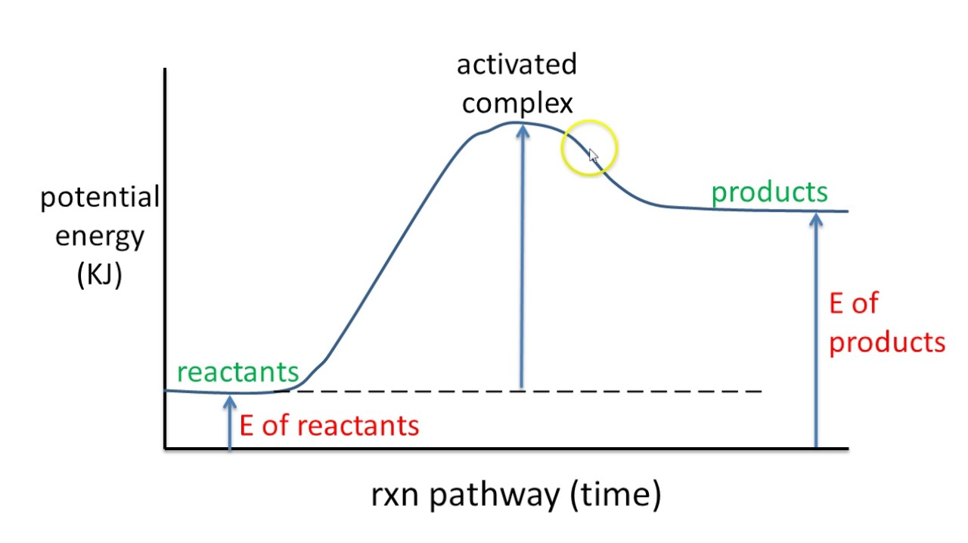
400 KJ
1300 KJ
CALCULATE the G for the graph above and categorize this metabolic reaction as either Catabolic or Anabolic.
- In the following diagram label each part
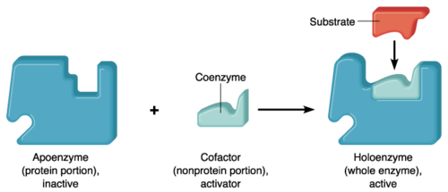
F
B - Vitamin
E
D
C
A

- What best describes an Enzyme?
- It is an organic catalyst that adds energy to a reaction
- It is an inorganic catalyst that reduces the amount of activation energy required for a reaction
- It is an organic catalyst that reduces the amount of activation energy required for a reaction.
- It is an inorganic catalyst that adds energy to a reaction

- Which of the following would be an ENDERGONIC/ENDOTHERMIC/ANABOLIC reaction?
- Photosynthesis
- Cellular Respiration
- Combustion of trees during a forest fire
- Hydrolysis of a protein into its amino acids

- Which of the following is an ENZYME?
- Glucose
- Glycogen
- Insulin
- Catalase
- Cholesterol

- Which of the following is most likely a COENZYME?
- Iron
- Ca⁺⁺
- Vitamin B3
- Hemoglobin

- When an enzyme gets overheated or put in the wrong pH, what will most likely happen to it?
A) Completely Hydrolyze
B) It will undergo Condensation Synthesis
C) It will undergo Phagocytosis
D) It will use ATP to maintain itself
E) It will Denature

- Which of the Following is NOT a key S.T.E.P.P.
- pH
- Product
- Enzyme Name
- Optimal Temperature
- Substitute Concentration

- Many enzymes are synthesized in an inactive form, what term is used to describe this inactive form?
A) Immature form
B) Concentric form
C) Lethargic form
D) Precursor form

- The model shown here is termed …..
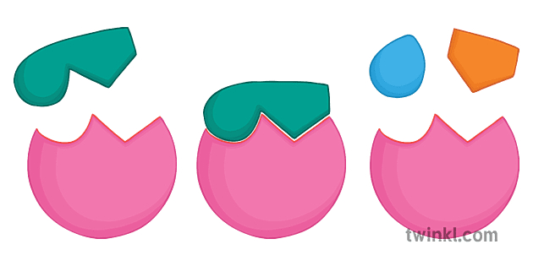
- Active Fit Model
- Induced Fit Model
- Lock and Key Model
- Brace and Hold Model
- Keychain and Lanyard Model

ANSWER KEY:
- G = Ep – Er
G = 1300 KJ – 400 KJ = +900 KJ

- As you have to add +900 KJ of energy into the system to complete this reaction, this is therefore an Endothermic RXN.
- Also known as ANABOLIC RXN

- A – APOENZYME
B – COENZYME as it is a vitamin (organic compound) rather than a mineral (cofactor)
C -SUBSTRATE
D – HOLOENZYME (Haloenzyme)
E – ACTIVE SITE
F – ALLOSTERIC SITE

- C - It is an organic catalyst that reduces the amount of activation energy required for a reaction.

- A – PHOTOSYNTHESIS

- D – CATALASE – look for ASE ending

- C – VITAMIN B3 – Coenzymes are organic vitamins

- E – DENATURE

- E- Substitute Concentration

- D – Precursor Form

- C – Lock and Key Model

