PROTEIN PRACTICE QUIZ

- Which of the following is the basic building block of a PROTEIN?
- GLUCOSE
- GLYCEROL
- AMINO ACID
- FATTY ACID
- NUCLEIC ACID

- Which formula below, would most likely be part of a PROTEIN?
- C₅H₁₀O₅
- C₃H₇NO₂
- C₁₇H₃₄O₂
- HNO₃

- Which of the following molecules would be part of an ENZYME (all enzymes are proteins)?
- 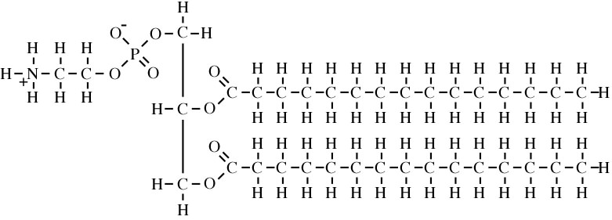

- 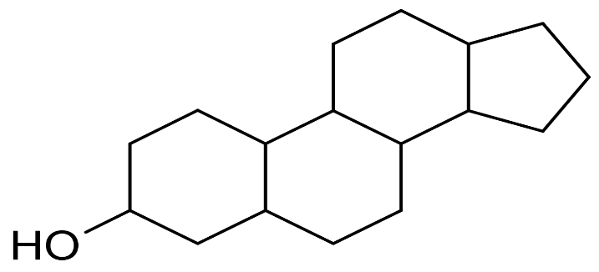

- 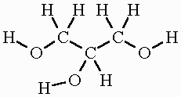

- 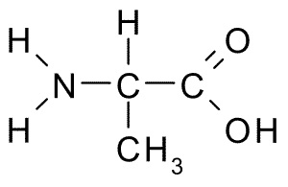

- The following polypeptide would have how many peptide bonds?
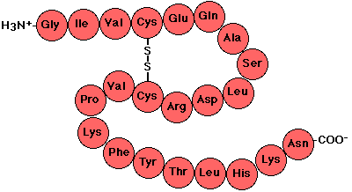
- 22 C) 0
- 24 D) 21

- When a polypeptide starts to spiral forming an "Alpha Helix" due to weak H-Bonding down the chain, what level of structure has it reached?
- Primary C) Tertiary
- Secondary D) Quaternary

- The arrow in the picture below is pointing to what part of an amino acid?
- R-Group
- Amino Group
- Carboxylic Acid Group
- Alpha Carbon
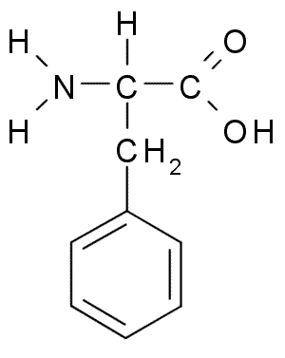
- The picture below, shows ONE polypeptide at what level of structure?
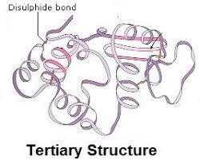
- Primary Structure
- Secondary Structure
- Tertiary Structure
- Quaternary Structure

- During the synthesis of the molecule (polypeptide) below, how many water molecules were produced?
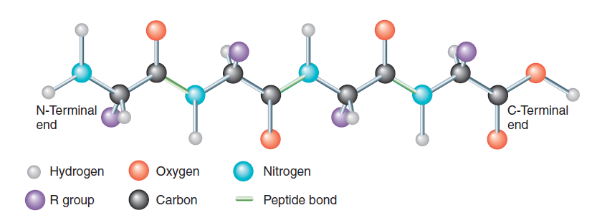
- 13 C) 6
- 3 D) 4

- When excess H⁺ ions, due to a low pH, start interacting with the bonds in a protein it starts to unfold and lose its shape. This is called?
- Dehydration mutation
- Polymerization
- Hypertonicity
- Denaturation
- Helicalization

- If an amino acid has an R-Group that is not polar or ionic, it will prefer to stay away from water. That R-group is then categorized as being….
- Charged
- Hydrophilic
- Anti-hydraulic
- Hydrophobic

- How many polypeptides are found in this protein and what level of structure is this protein exhibiting?
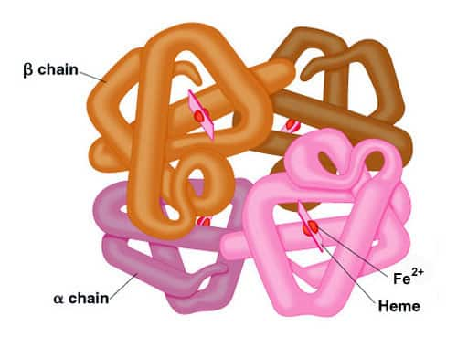
- Two polypeptides and Tertiary Structure
B) Four polypeptides and Quaternary Structure
C) Four polypeptides and Tertiary Structure
D) Two polypeptide and Quaternary Structure
ANSWER KEY
- Which of the following is the basic building block of a PROTEIN?
- GLUCOSE
- GLYCEROL
- AMINO ACID
- FATTY ACID
- NUCLEIC ACID

- Which formula below, would most likely be part of a PROTEIN?
- C₅H₁₀O₅ (carbohydrate formula 1:2:1)
- C₃H₇NO₂ (Nitrogen is in amino acids)
- C₁₇H₃₄O₂ (no nitrogen, fatty acid)
- HNO₃ (Inorganic – no carbon – nitric acid)

- Which of the following molecules would be part of an ENZYME?
Phospholipid = 2 Fatty Acids on a glycerol and one polar phosphate head

Honeycomb = Sterol Lipid

3 carbon back-bone = Glycerol

This has an Amino Group (NH₂) and a Carboxylic Acid Group (COOH) = Amino Acid. All enzymes are proteins

- The following polypeptide would have how many peptide bonds?
- 22 C) 0
This polypeptide has 22 amino acids in it. A peptide bond forms where one AA joins another. There are 21 bonds.
- 24 D) 21

- When a polypeptide starts to spiral forming an "Alpha Helix" due to weak H-Bonding down the chain, what level of structure has it reached?
- Primary C) Tertiary
- Secondary D) Quaternary

- The arrow in the picture below is pointing to what part of an amino acid?
- R-Group
- Amino Group
- Carboxylic Acid Group
- Alpha Carbon
- The picture below, shows one polypeptide at what level of structure?
- Primary Structure
- Secondary Structure
- Tertiary Structure
- Quaternary Structure

- During the synthesis of the molecule (polypeptide) below, how many water molecules were produced?
- 13 C) 6
- 3 D) 4
4 R-Groups indicates 4 AA's joined together = 3 peptide bonds formed = 3 waters synthesized.

- When excess H⁺ ions, due to a low pH, start interacting with the bonds in a protein it starts to unfold and lose its shape. This is called?
- Dehydration mutation
- Polymerization
- Hypertonicity
- Denaturation
- Helicalization

- If an amino acid has an R-Group that is not polar or ionic, it will prefer to stay away from water. That R-group is then categorized as being….
- Charged
- Hydrophilic
- Anti-hydraulic
- Hydrophobic

- How many polypeptides are found in this protein and what level of structure is this protein exhibiting?
- Two polypeptides and Tertiary Structure
B) Four polypeptides and Quaternary Structure
C) Four polypeptides and Tertiary Structure
D) Two polypeptide and Quaternary Structure

