Recap of Basic Genetics
- Remember that chromosomes are made up of DNA, and a single chromosome may have thousands of genes on it. It is these genes that code for the structural, behavioural and physiological adaptations that we see in a species of plants, animals, fungus, protists and bacteria.
- Evolution can only be properly understood when one properly understands basic genetics. During evolution the types of genes in a species gene pool and the relative number of those genes changes over time.

Basic Genetics and Heredity:
- In our species a healthy individual has trillions of cells and each body cell is diploid, so it has 23 PAIRS of chromosomes, totalling 46 chromosomes per body cell.
- During meiosis, haploid sex cells are produced. Each healthy gamete (egg or sperm) should have only 23 chromosomes.
- During sexual reproduction these haploid gametes (egg and sperm) unite to form a diploid zygote. This diploid zygote gives rise to the offspring.

Key Processes Illustrated: MEIOSIS
GENE FOR EYE COLOUR but 2 different forms (alleles)
Allow “B” = The dominant allele for eye colour (BROWN) ATC CAT GAC GGG ACC
Allow “b” = The recessive allele for eye colour (blue) ATC CAG CCC GGG ATT
Normal Diploid cell with Haploid Gametes (sperm)
pairs of chromosomes

X^{B}
X^{B}X^{b}

X^{b}

- So if an individual was Heterozygous “Bb” for brown eye colour, one “B” allele (form for the eye-colour gene) would go into one sperm cell, while the other allele “b” would go into the other sperm.
- During meiosis the maternal and paternal chromosomes segregate (separate) from each other. MATERNAL PATERNAL
X X
X X X
X X X

X X
X X
Egg #1 Etc. for all 23 pairs Egg #2
After meiosis occurs, the gametes unite. The genes that are in one egg can unite with the genes that are in one sperm.
- If a female is blue-eyed phenotype therefore “bb” genotype, each egg would get one “b” allele.
- If a male is brown-eyed phenotype and we are told that they have the heterozygous genotype “Bb”, for each sperm that receives “B” form of the gene, a second sperm will receive a “b” allele.
- If these two individuals reproduce, we can determine the chances of getting the various genotypes in their offspring.
          - FEMALE (“bb”)
Male (“Bb”) 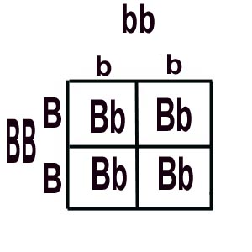
Therefore the PHENOTYPIC RATIO for the offspring will be : 50% blue eyes : 50% Brown
- The Genotypic Ratio for the offspring is : 50% Bb : 50% bb

