Student Assignment KEY

- Levels of organization are:
Chemical (atoms/molecules) Cellular Tissues Organs Organ Systems Body as a Whole

- The Axial portion of the body consists of the head, neck, and trunk. It is composed of the thoracic, abdominal and pelvic regions.
The Appendicular portion of the body consists of the upper and lower extremeties. Upper extremities are composed of arm, forearm, wrist and hands. Lower extremeties are composed of thigh, leg, ankle and foot regions.

- The principal directional terms are as follows:
- Medial – Toward the midline of the body
- Lateral – Toward the side of the body

- Proximal : more near the origin of the extremity(closer to trunk).
- Distal : further from the origin of the extremity(further out from trunk).

- Superficial – Near the outer surface of the body.
- Deep – Further away from the outer surface of the body.

- Superior- Being more above something else in the axial division.
- Inferior – Being more below something else in the axial division.

- Anterior/Ventral – being more up front or more toward belly-side than something else.

- Posterior/Dorsal – being more behind or more toward the back than something else.
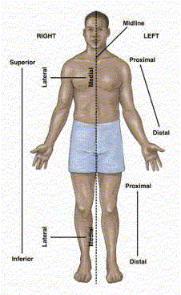

The body sections (planes) are as follows:

Midsagittal – A plane that runs down the midline to divide the body into two equal halves.

Sagittal – A plane running from front to back that divides the body into a right portion and a left portion.

Frontal - A lengthwise plane that divides a structure into an anterior portion and a posterior portion.

Transverse – A horizontal plane running from one side of the body (right) to the other side of the body (left), dividing the body into upper and lower portions.
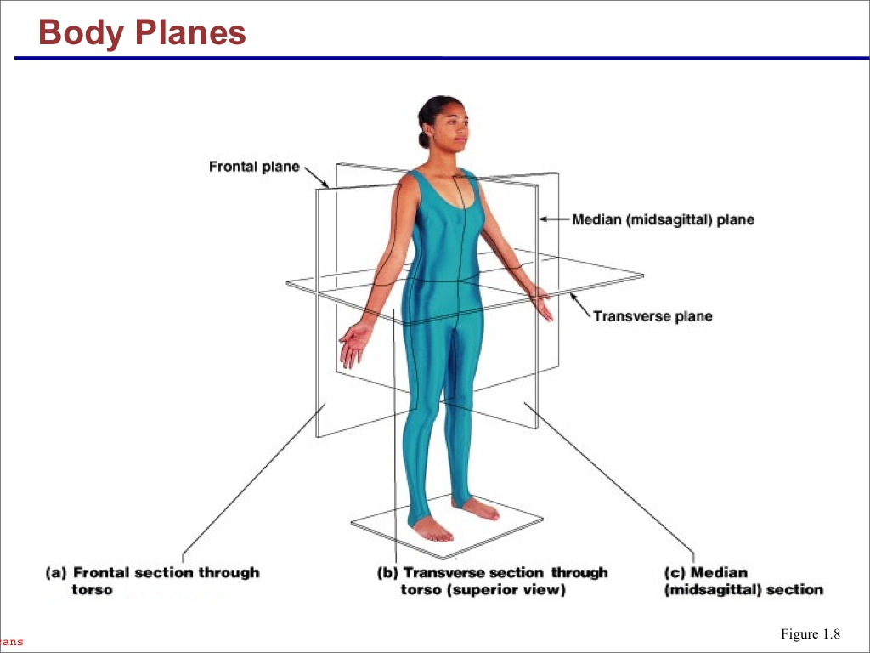

- Major Cavities:

DORSAL Cavities :
- Cranial – houses the brain
- Spinal – houses the spine

VENTRAL Cavities :
- Thoracic - including right and left pleurals and mediastinum
- Abdominopelvic – including abdominal region and pelvic region – should also know all 9 sub-regions
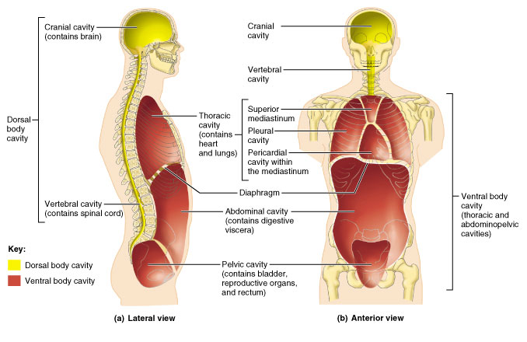

- Homeostasis is a characteristic exhibited by all life forms. It is an organism's ability to maintain a certain set of internal conditions. It literally means to keep in the "Same Standing". Factors such as blood pH, body temperature, blood sugar, hormone levels, ion concentrations in cells/tissue fluids, blood oxygen levels, etc, etc.
During a "Negative Feedback Loop" a factor/condition that is out of balance, will be brought back into balance. The unbalance is negated. For example, if your body temperature is getting too high, you need to bring it back down.
To run a negative feedback loop, you need receptors (nerves to fire when temp is too high), a control center (brain to interpret the incoming impulse) and effectors (glands and muscles to take action) to fix the condition.

Directional Terms:
- The head is SUPERIOR/Cranial/Rostral to the neck.
- The hand is DISTAL to the wrist.

- The skin is SUPERFICIAL to the muscles.

- The mouth is INFERIOR/Caudal to the nose

- The elbow is PROXIMAL to the wrist

- The lungs lie LATERAL to the heart

- The buttocks are on the POSTERIOR/Dorsal surface of the body.

MATCHING:

- Ventral = F – Front

- Skin = B –Cutaneous

- Transverse = J – Horizontal

- Anatomy = G – Structure

- Superficial = H – Surface

- Pleural = C – Lung

- Appendicular = D- Extremities

- Posterior = I – Back

- Mid-sagittal = A – Equal

- System = E- Respiratory

6. Body Cavities:

Top Diagram Key – Mid-Sagittal View
Abdominal – 2
Abdominopelvic – 4
Cranial – 6
Dorsal – 8
Pelvic -3
Spinal – 7
Thoracic – 1
Ventral – 5

Structure - Diaphragm – 9

Bottom Diagram - Frontal/Coronal View

Abdominal – 4
Abdominopelvic – 6
Pelvic – 5
Pericardial (AKA Mediastinum) – 2
Pleural – 1
Thoracic – 3
Ventral – 7

I Deleted structures from worksheet; but if curious, here are the missing structures:

- 8 – Pleural Membrane (one around each lung)
- 9 – Pericardial Membrane
- 10 - Diaphragm

