**Thyroxin and Its Role in Metabolic Rate**

***Thyroxin: (AKA “Thyroid Hormone” “Thyroxine”)***

- Thyroxin is a protein hormone that is secreted into the blood stream by cells of the thyroid gland

- The thyroid gland, which is located in the neck, accumulates iodine in order to produce the thyroxin hormone.

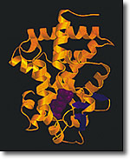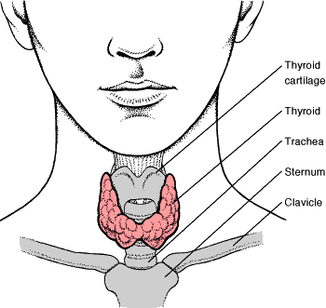

# Thyroid Hormone Structure

- Thyroxin acts by attaching to receptor sites on the surfaces of our body’s cells. When receptor sites are triggered they stimulate other chemicals in the cell to govern the rate at which the cells will consume oxygen. Thyroxin ultimately controls the body’s metabolism.

- Thyroxin does not have a target organ; but instead, stimulates most of the cells of the body to metabolize at a faster rate. It does this by increasing the production of respiratory enzymes, as well as stimulating the increase of oxygen uptake.

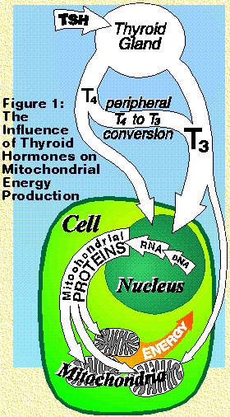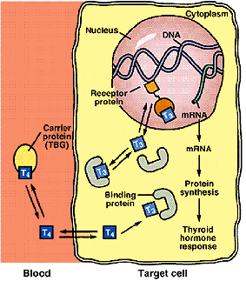

- Thyroxin not only governs metabolic rate but it also helps regulate the growth and development of an individual.

- Thyroglobulin is the storage (precursor) form of Thyroxin. Iodine is required for thyroglobulin to be made. Without the presence of iodine the thyroid gland will increase in size in an effort to produce more Thyroxin.

- Unfortunately, a lack of Iodine in the diet, results in a lack of thyroxin in the body (HYPOTHYROIDISM). This often leads to a condition known as simple goiter.

 A) *Simple Goiter*:

- A simple goiter occurs when the thyroid gland is unable to produce a sufficient amount of Thyroxin, the thyroid cannot meet the metabolic demands of the body.

-The thyroid gland compensates by enlarging, this mechanism will often overcome a mild deficiency of the thyroid hormone.

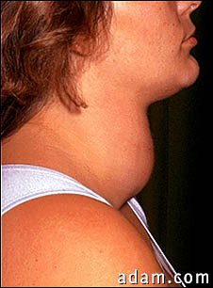

B) *Exophthalmic Goiter (*Graves' disease)

- This type of Goiter is not caused by a lack of thyroxin but rather by the excessive production of the thyroid hormone (HYPERTHYROIDISM). –

- This condition is characterized by an enlarged thyroid gland, protrusion of the eyeballs, tachycardia (super fast heart rate) and nervous excitability.

*Hypothyroidism vs. Hyperthyroidism*

- Symptoms of Hypothyroidism: Low thyroxin in the blood

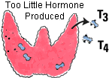

**yellowsqFatigue  
http://www.endocrineweb.com/yellowsq.gifWeakness  
http://www.endocrineweb.com/yellowsq.gifWeight gain or increased difficulty losing weight  
http://www.endocrineweb.com/yellowsq.gifCoarse, dry hair   
http://www.endocrineweb.com/yellowsq.gifDry, rough pale skin  
http://www.endocrineweb.com/yellowsq.gifHair loss   
http://www.endocrineweb.com/yellowsq.gifCold intolerance** (can't tolerate the cold like those around you) **http://www.endocrineweb.com/yellowsq.gifMuscle cramps and frequent muscle aches  
http://www.endocrineweb.com/yellowsq.gifConstipation  
http://www.endocrineweb.com/yellowsq.gifDepression  
http://www.endocrineweb.com/yellowsq.gifIrritability  
http://www.endocrineweb.com/yellowsq.gifMemory loss  
http://www.endocrineweb.com/yellowsq.gifAbnormal menstrual cycles  
http://www.endocrineweb.com/yellowsq.gifDecreased libido**

**Symptoms and signs of Hyperthyroidism (high thyroxin in the blood)**

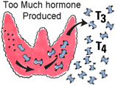

http://www.endocrineweb.com/bluesq.gif**Heart palpitations**http://www.endocrineweb.com/bluesq.gif**Heat intolerance**   
http://www.endocrineweb.com/bluesq.gif**Nervousness**  
http://www.endocrineweb.com/bluesq.gif**Insomnia**http://www.endocrineweb.com/bluesq.gif**Breathlessness**   
http://www.endocrineweb.com/bluesq.gif**Increased bowel movements**   
http://www.endocrineweb.com/bluesq.gif**Light or absent menstrual periods**http://www.endocrineweb.com/bluesq.gif**Fatigue  
http://www.endocrineweb.com/redsq.gifFast heart rate  
http://www.endocrineweb.com/redsq.gifTrembling hands**  
**http://www.endocrineweb.com/redsq.gifWeight loss  
http://www.endocrineweb.com/redsq.gifMuscle weakness  
http://www.endocrineweb.com/redsq.gifWarm moist skin  
http://www.endocrineweb.com/redsq.gifHair loss  
http://www.endocrineweb.com/redsq.gifStaring gaze**