Unit 1 – Notes #1 - Scientific Method

Scientific Method: The simplest definition was offered by biologist Claude Villee. He called it “Organized Common Sense.” That is exactly what science should be.

The basic concept is that the Scientific Method can be used to find out what is scientifically truthful and accurate vs. what is incorrect, inaccurate (Myth).
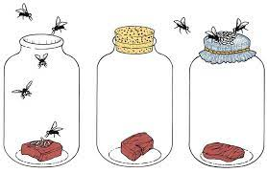
In practice, the scientific method consists of several steps.

- Observing and stating a problem and a PURPOSE for your testing

- Researching and then forming a HYPOTHESIS- An educated guess on what you think is the answer. This hypothesis needs to be testable.

- Running a valid (trusted and accurate) EXPERIMENT that then tests out your Hypothesis.

- Then recording your observations and then doing an ANALYSIS of this Data.

- Forming a CONCLUSION – This conclusion should briefly summarise your findings and then should state whether or not your findings supported or did not support your Hypothesis.

EXPERIMENT requirements:

In an experiment, only one variable (factor) can be changed and tested at a time.

For example – If we want to test how sunlight affects seedling growth, then the amount of light is the only variable that can be different among our test groups.
- All other variables must be kept the same- Types of seeds, type of soil, amount of water, growth time, environmental temperature etc. These factors are known as VARIABLES

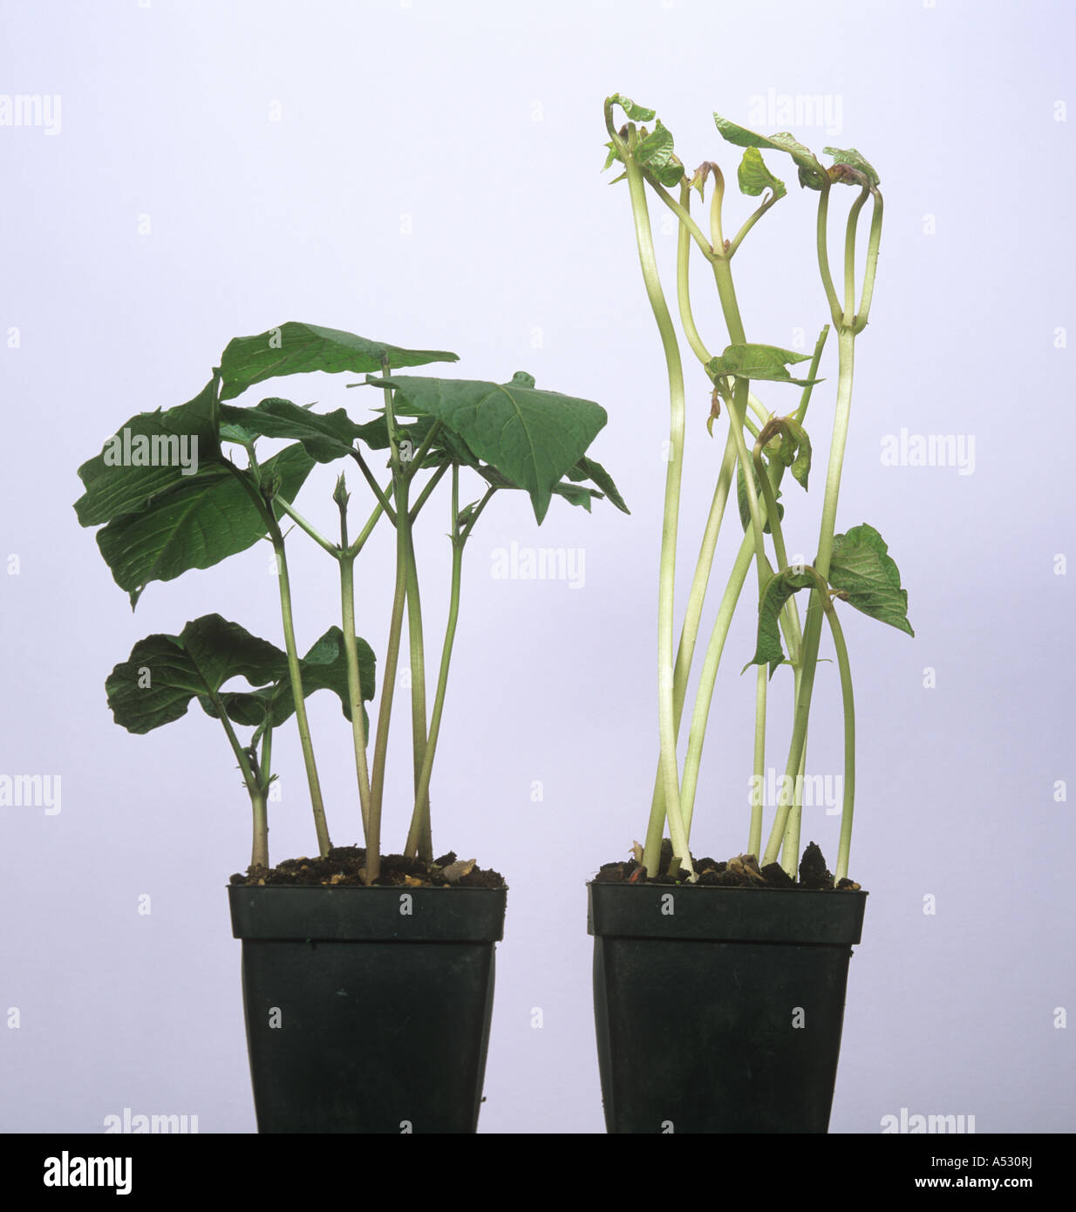
In an experiment, the following terms are used to describe these variables:

- Independent (Manipulative) Variable – This refers to the variable that is different amongst the test groups, the variable that is changed (manipulated). In the case above. The independent variable is the Amount of Light, each set of seedlings will receive. One test group may get no light, one group may get dim light, one group may get full light.
- Dependent (Responding) Variable – This is the response seen in the test groups due to the Independent variable. Example how fast did the seedlings grow, how green are they, how thick are and healthy do they look etc.

THEORIES -When a hypothesis is tested and confirmed often enough that it is unlikely to be disproved by future tests, it may become worthy of being called a THEORY.
Theories are powerful, time-tested concepts that make useful and dependable predictions about WHY things happen in the natural world.

LAWS: A law is a mathematical statement that tells HOW something happens

Some important scientific Theories and Laws:

