UNIT 1 – NOTES #3 – CELLS
- In general, cells are very small. Scientists often measure in micrometers, there are 1000 micrometers in a single millimeter. Sometimes micrometers are too large, so scientists measure in nanometers. There are 1000 nanometers in a single micrometer.
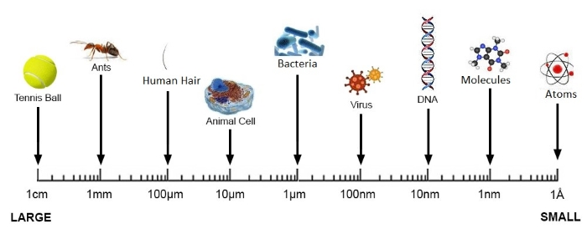
- Cells are limited in their size. They need to maintain themselves by getting rid of wastes and taking in nutrients through their cell membrane. As a cell gets bigger, its volume goes up much faster than its surface area. So large cells get stressed and to keep up with their metabolic demands, they simply divide into two new smaller cells that are now more efficient.
- There are TWO main categories of cells:
A) PROKARYOTIC CELLS: Prokaryotic = “Before Nucleus”
- Much smaller cell than Eukaryotic cells (10-100 X smaller)
- No membrane bound organelles.
- No true nucleus
- Use different ribosomes – Protein Building Factories
- Only life forms that use this type of cell are Eubacteria and Archaebacteria.
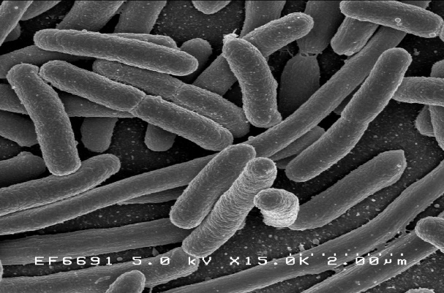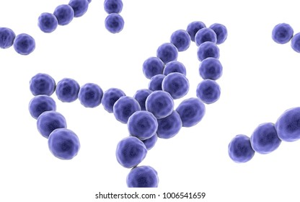
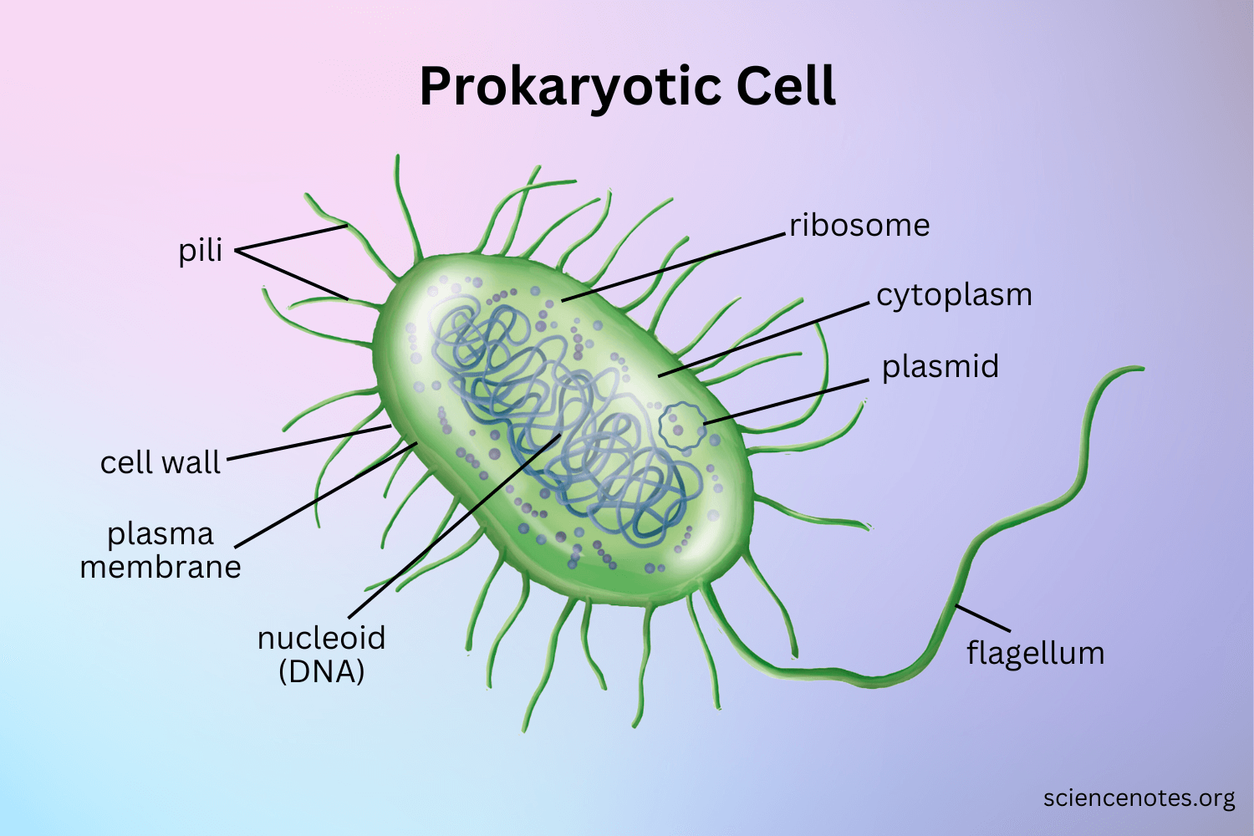
B) EUKARYOTIC CELLS: Eukaryotic = “True Nucleus/Kernel”
- Much larger size
- Various membrane-bound organelles
- A true membrane-bound Nucleus
- Much more metabolically efficient
- Used by all other life forms, Protists, Fungi, Plants and Animals.
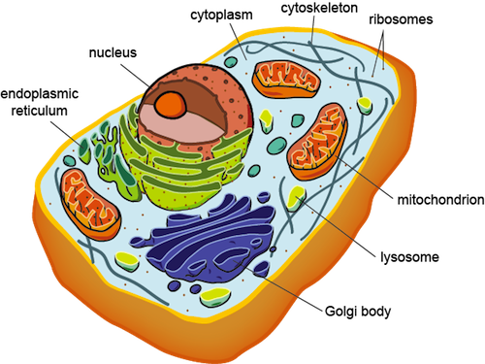
- Protist Cells – Protists, like Amoeba, Paramecia, Euglena etc. All use Eukaryotic cells, but all these organisms in this Kingdom are UNICELLULAR.
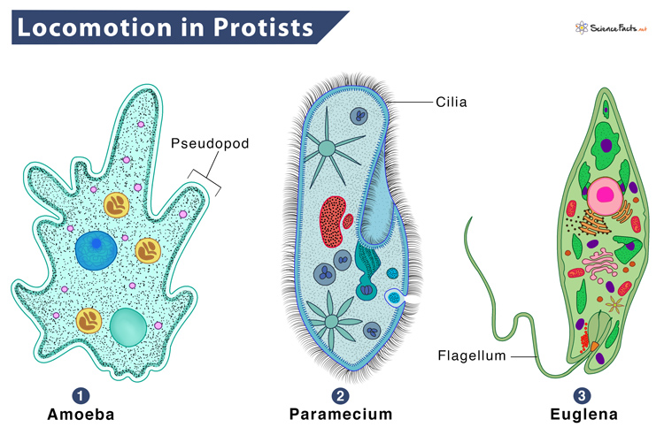
- Plant Cells:
Can be identified as being a Plant Cell in that they possess the following:
1. Cell Wall – Mostly made of Cellulose 2. Large Central Vacuole 3. Chloroplasts
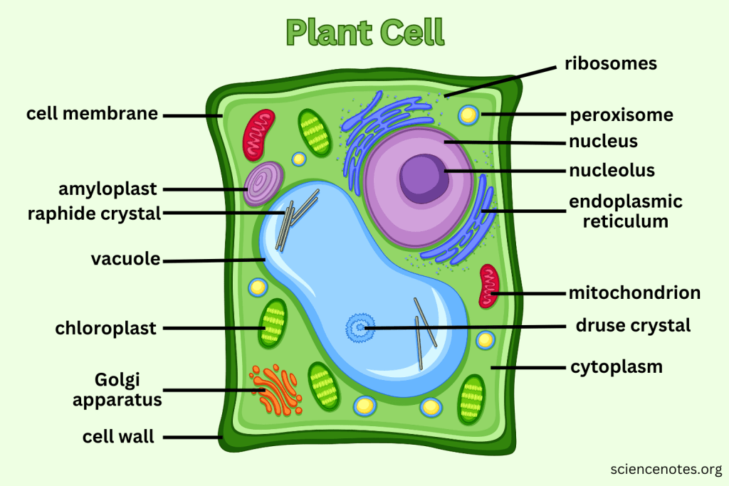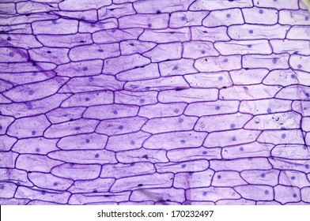
- Fungal Cells:
Fungal cells are Eukaryotic and tend to have a cell wall
Outside their cell membrane, but unlike plant cells, their wall is made out of a completely different type of complex carbohydrate called CHITIN.
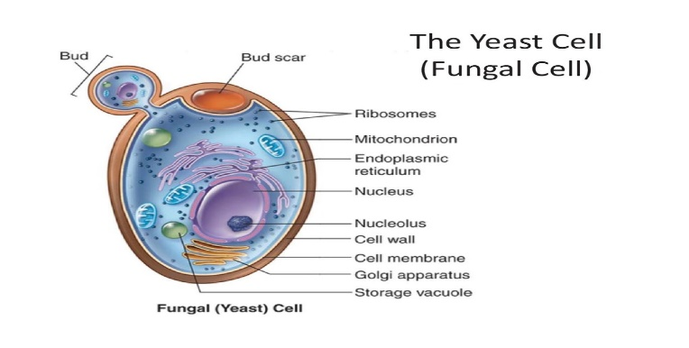
- Animal Cell
- Come in a wide variety of shapes, sizes, based on what their function is
- They do NOT have a cell wall and do NOT have Chloroplasts.
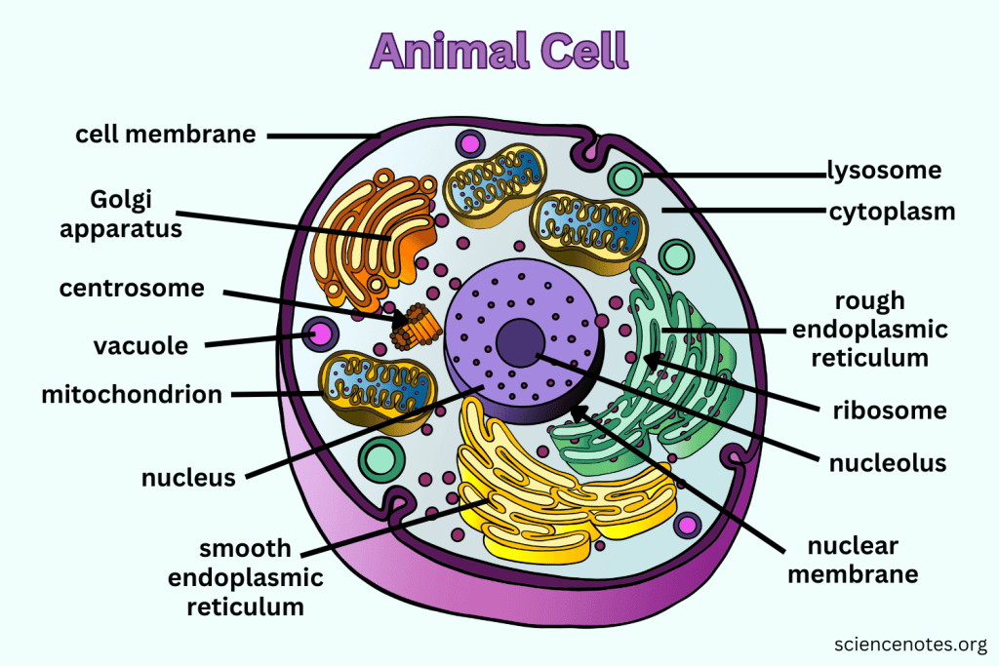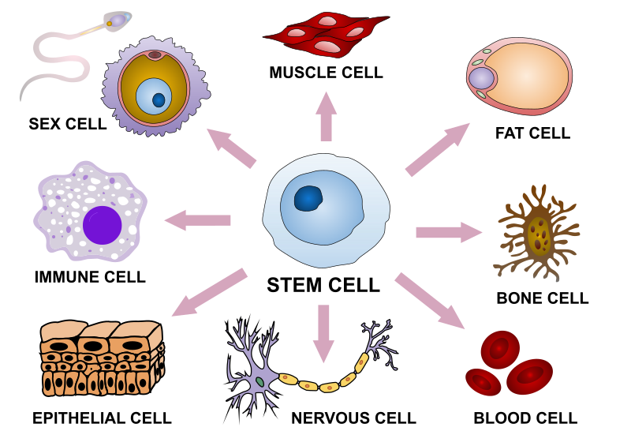

SOME KEY STRUCTURES THAT ALL CELLS HAVE:
- CELL MEMBRANE (plasma membrane) : All cells have a cell membrane. It is the lifeline for the cell it uses complex mechanisms to transport material into and out of the cell.
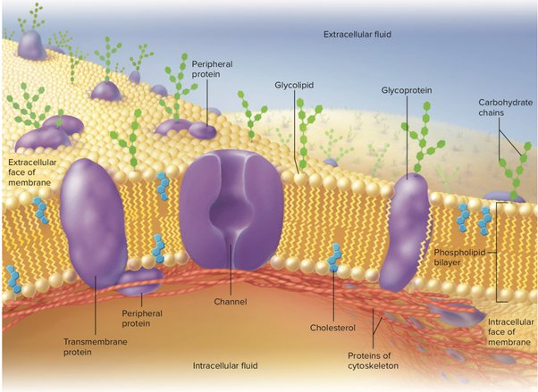 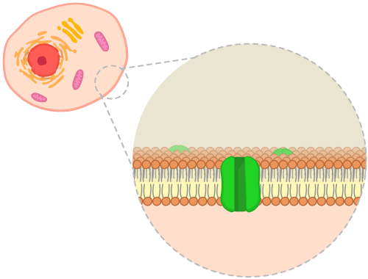
- DNA - Deoxyribonucleic Acid – This is the master molecule of life. It contains segments of unique patterns of Nitrogenous bases called genes. These genes are instructional material that tells the cell how to build proteins. Proteins have unique shapes that allow them to build special structures and run special chemical reactions.
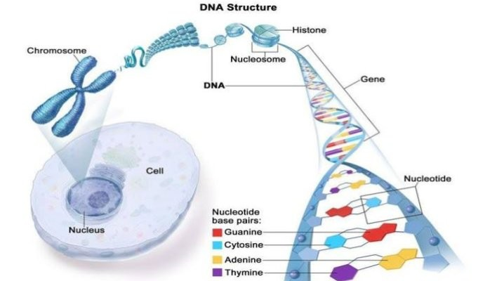
- RIBOSOMES – These are special protein building factories. They take the genetic information from the DNA and read it and assemble Amino Acids into the perfectly ordered chain of Amino Acids that will then fold over into the perfectly shaped protein that can now do its specific job.
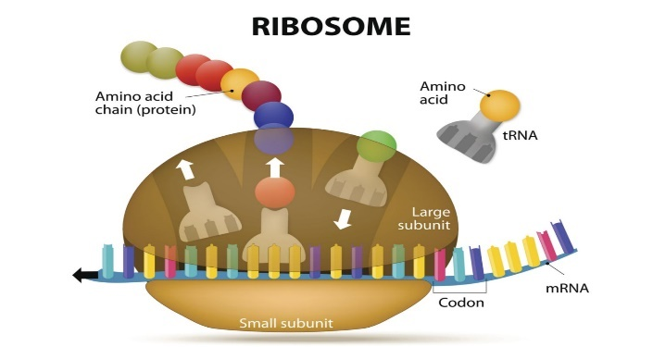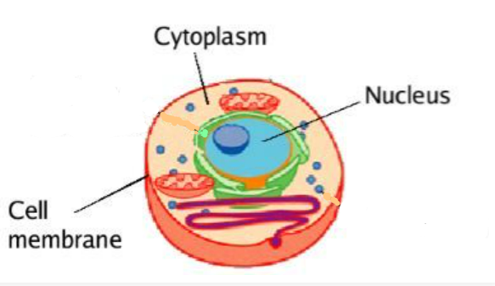
- CYTOPLASM – A gel-like fluid region found between the nucleus region (in eukaryotic cells) or nucleoid region (prokaryotic cells) and the cell membrane.

