Unit 1 Review #1 –Key
IMPORTANCE OF THE CELL THEORY
- The cell
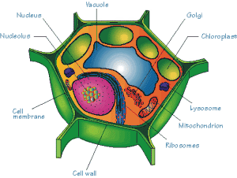
- Approximately 100 Trillion

- Muscle cell – contraction – movement
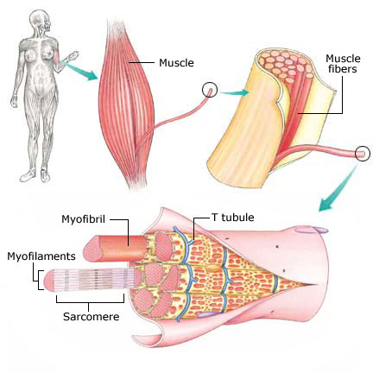
- Nerve cell – transmitting electrical impulse – communication.
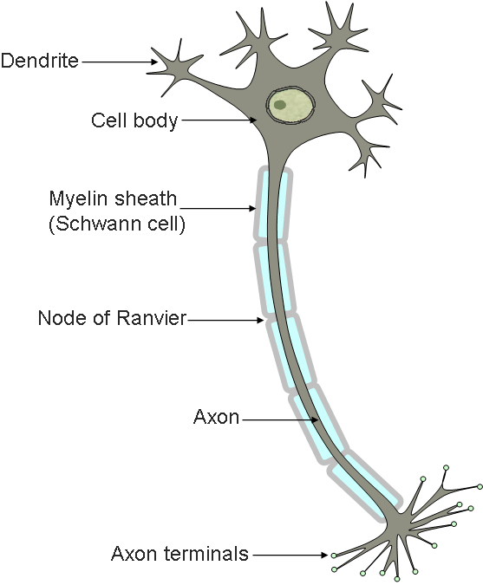
- Red blood cell – carries oxygen – transportation
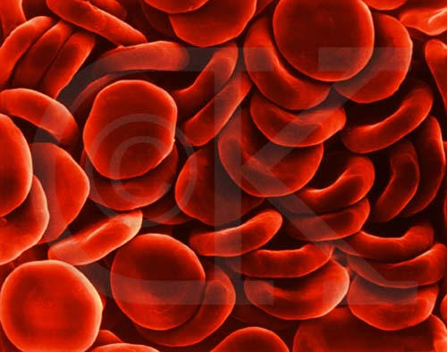
- Cells take in nutrients and run chemical reactions, most cells have the ability to grow and reproduce.
- Some untested hypothesis are :

Rain + Air + Mud = Aquatic life.
Rotting meat + air = Maggots.
Fermenting wheat + Air = Mice.

- Abiogenesis was the theory that living (biotic) things could arise from non-living things (abiotic).

- Redi took meat and placed it in open containers and another group was place in sealed containers. Maggots were only present in the open containers that flies had access to.
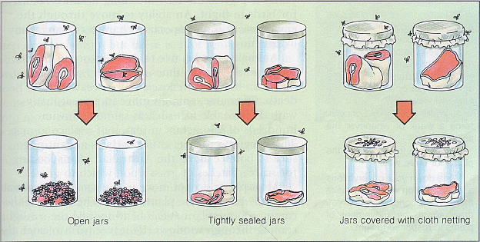
- Critics argued that fresh air is needed to mix with the rotting meat, so he repeated his experiment but placed gauze over the containers. This allowed air in, but still kept the flies out.

- Reproduce - sexually or asexually
Homeostasis – have an ability to try to maintain a set of constant internal environmental conditions. Temp, pH, blood pressure, O₂ levels etc.
Cells - Smallest unit of life
Adaptable – Have Structures/Behaviours/ Physiological mechanisms that allow them to survive in a given environment.
Example – Structural - Webbed Feet (duck)
- Physiological - Poisonous Glands (frog)
- Behavioural - Standing perfectly still while predators approach (Spruce Grouse).
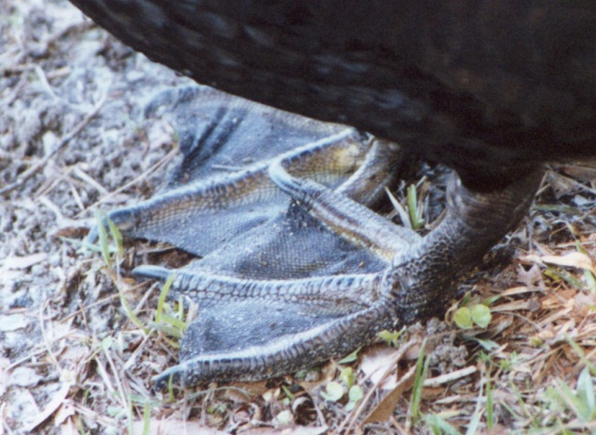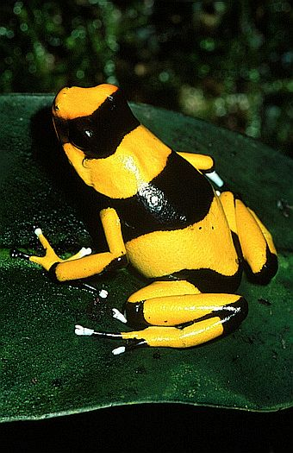
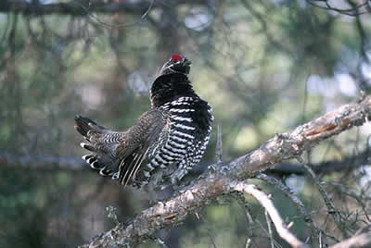
Grow and develop through cell division
Run Energy transformations - Anabolic and Catabolic
Respond- to changes in their environment.

ABIOGENESIS AND MICROBES
- The light (compound) microscope.
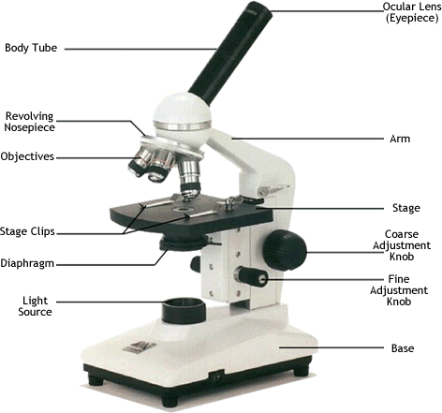
- Van Leeuwenhoek
- Even after boiling and placing in sealed containers Needham observed that the broth became cloudy and that it was full of microbes when viewed under the microscope.

- Needham then concluded that nonliving things can spontaneously give rise to microscopic living things.

- The real explanation for his findings was probably that he did not kill all the microbes/spores in the broth during the boiling, he did not seal things properly or that the flasks were not sterile.

- When Spallanzani repeated Needham’s test he made a couple of changes; he boiled the broth longer and he sealed them better in sterile containers.
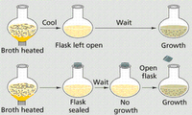

- Pasteur repeated Spallanzani’s tests, but used a swan-necked stem on top of the flask. This allowed air to circulate in and out, but it kept airborne contaminants trapped in the neck of the stem.
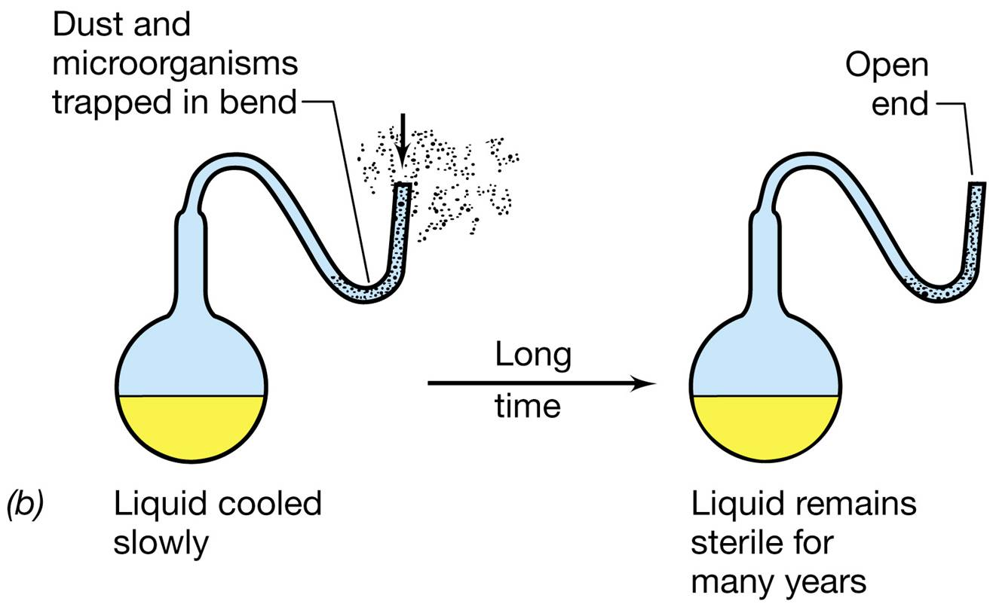
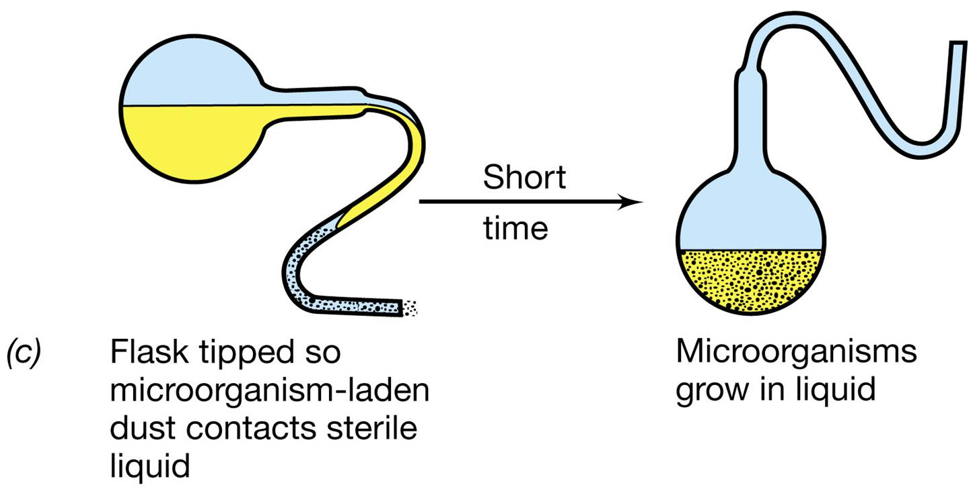
- Pasteurization is a process of Flash Heating (high temp but short duration) a substance in an effort to kill the majority of microbes. The substance is then usually sealed and refrigerated to slow down the growth of any of the remaining organisms. This significantly increases the shelf-life of the food product. Examples – Honey, Milk, Yogurt.
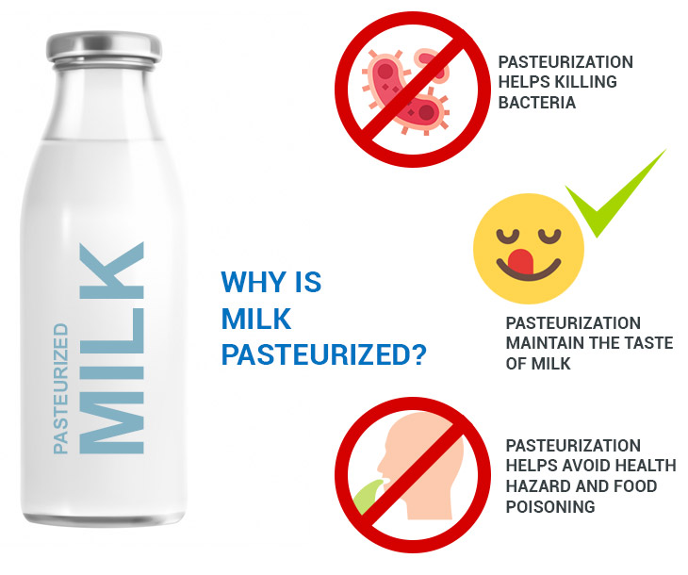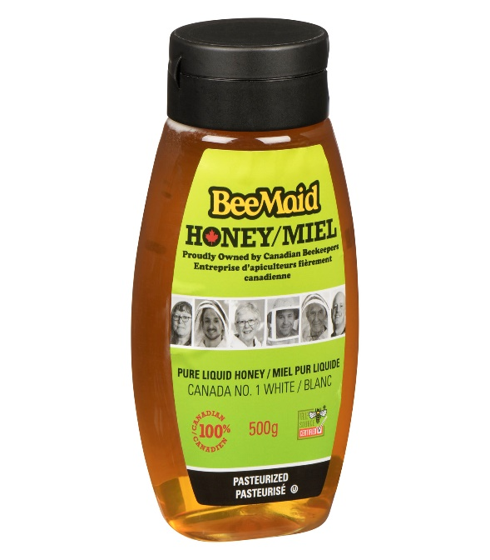

EMERGENCE OF THE CELL THEORY:
- Anton Van Leeuwenhoek- Microscopes.
Robert Hooke – Cells in cork.
Brown – Nuclei in cells.
T. Schwann (zoologist), M. Schleiden (botanist) and All life forms (plant or animal) have cells.
*Virchow - Cells only come from other cells.
- Cell Theory :

a)- Cell is the smallest entity (unit) of life
- All life forms consist of one or more cells.
- All cells must come only from pre-existing cells.

