Unit Two - Review #2 KEY

- For Frog Colour, assume that there is one Gene with two Alleles.
G = Dark Green - Dominant
g = Yellowish Green - Recessive

GG | Gg | Gg | gg | GG
GG | GG | gg | gg | GG
Gg | Gg | Gg | GG | Gg
Gg | Gg | GG | Gg | gg

- Use the data above to calculate the following:
A) Phenotypic Ratio
B) Genotypic Ratio
C) Allelic Frequency

- A) Total of 20 Frogs
16 out of 20 frogs are GREEN = 80%
4 out of 20 frogs are YELLOWISH-GREEN = 20%
B) There are three different GENOTYPES:
- GG – 7 out of 20 frogs have GG = 35%
-Gg – 9 out of 20 frogs have Gg = 45%
-gg – 4 out of 20 frogs have gg = 20%

C) Total of 20 frogs with two alleles each equals a total of 40 alleles in the sample
- 23 out of 40 alleles were G = 57.5%
- 17 out of 40 alleles were g = 42.5%

- If the allelic frequency for "g" goes from 42.5% up to 62% over a 10-year period due to Natural Selection, then the yellowish-green phenotype is more fit for survival.

- Genetic Equilibrium

- The main five conditions or requirements necessary to keep a gene pool in Genetic Equilibrium are:
- Large Population
- Random Mating
- No new Mutations
- No Differential Migration
- Equal Viability (Equal Fertility, Life Span, health etc among all members)

- The key things (Drivers) that cause gene pools to evolve are:
- Natural Selection
- Mutation
- Genetic Drift
- Differential Migration
- Selective Mating
- Isolation- Bottle Neck Effect

- Selective Mating

- Artificial Selection- Selective Breeding has been used to alter/create the following crops and domesticated animals:
- Tomatoes, Dairy Cows, Chickens, Corn, Dog Breeds, Various Livestock, also Mustard Plant to give rise to offshoot plants such as Broccoli, Cauliflower, Brussel Sprouts and Cabbage and Kale.
- The frequency of the allele that codes for the more desirable phenotype will go up due to Survival of the Fittest.
- In our original population of frogs in question #1, the allelic frequencies were "G" = 57.5% while "g" was 42.5%
For the allelic frequency for "G" to go up to 70% due to differential migration, we would have to have a fair number of yellowish-green frogs and heterozygous frogs to Emigrate out of the population, while a few Homozygous Green frogs Immigrated into the population.
Example - gg, Gg, Gg, gg, Leave
while GG and GG enter
- ISOLATION – “FOUNDER Effect” – Bottle Necking.
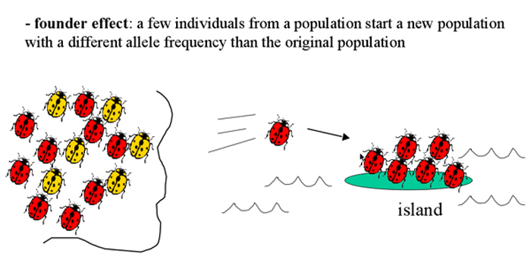

- Most mutations that arise are not ADVANTAGEOUS, because over millions of years of evolution most of the best fit (advantageous) alleles have already been selected and established.

- Random Genetic Drift is a process that drives evolution. It occurs when allelic frequencies for a gene just change by CHANCE, no natural selection is involved. Another example was the change in allelic frequencies for flipping nickles
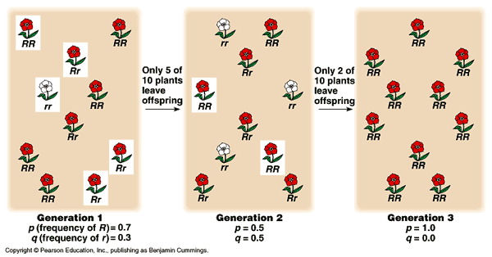
- We saw that it shifted so that the frequency of “H” change to ______% while the frequency for “h” changed ____% in one generation of change.
Results varied from one class to another
- Equal Viability, refers to when all members of a population have equal health, equal chance of mating, equal life expectancy etc.
15. The big three drivers of evolution are :
A) Natural Selection B) Mutation C) Genetic Drift

16. A POPULATION is a "Collection of individuals of the same SPECIES in a given area whose members can breed with one another"
- A GENE POOL is “A common group of genes shared by the members of a population”
- Evolutionary change involves a change in the relative frequencies of alleles in the gene pool of a population.
- A SPECIES is a group of similar-looking organisms that breed with one another and produce fertile offspring in the natural environment.
Both populations of Mule Deer belong to the same species.
